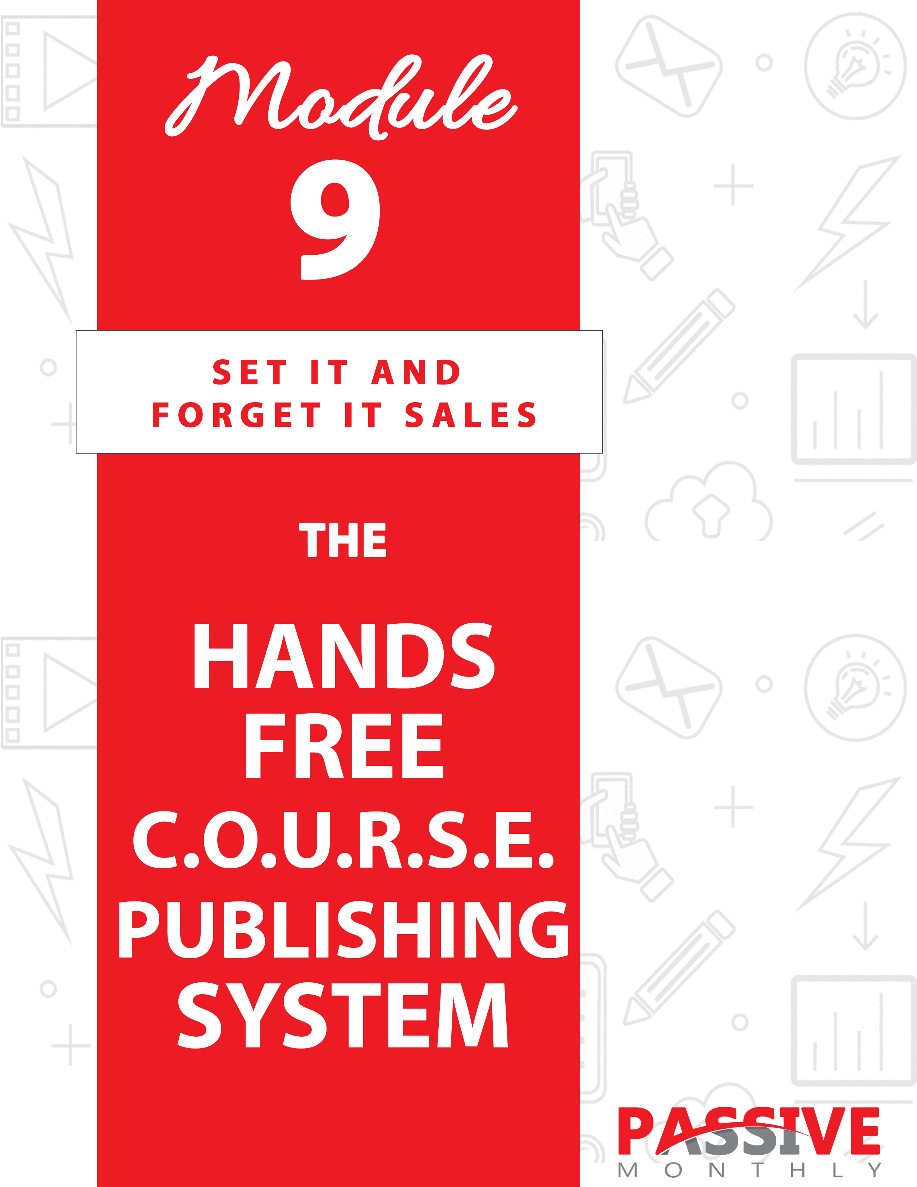

You DO NOT Have The Right To Sell Or Give Away
Any Portion Of The Content In This Document.

This Document Is For Your Personal Use Only

CLICK HERE For Additional Resources
To Help You Build Your Dream Business.

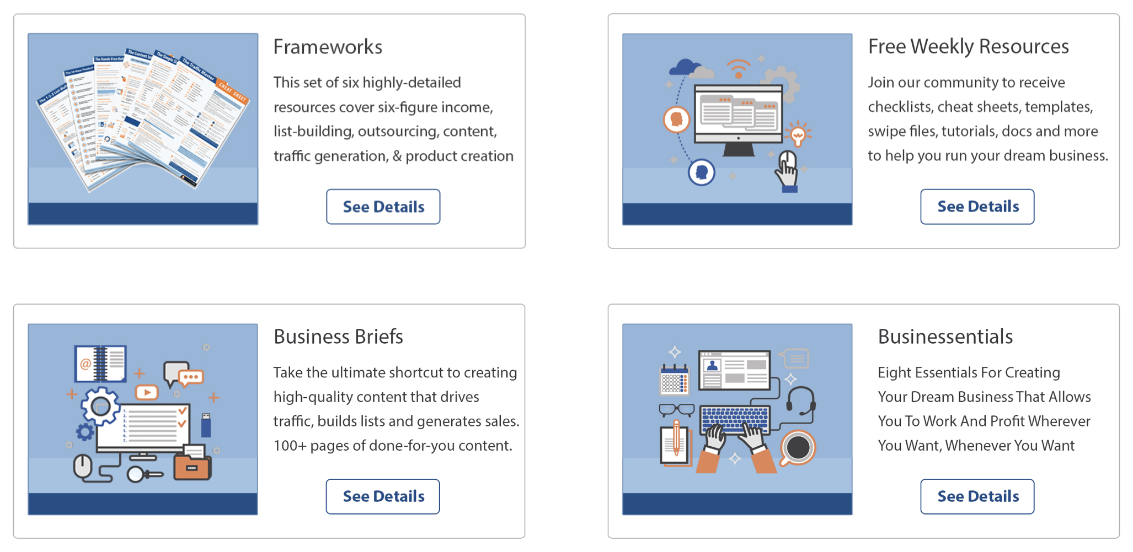

Insert Your Legal Disclaimer / Document Here

Strategy: What Is It?

You’re probably well familiar with the idea of creating your own courses or other products and selling them to people in your niche. But imagine for a moment if you could take other peoples’ knowledge and turn it into a tidy profit in your pocket. In other words, you profit off the expertise of others – and you don’t even have to know anything about the niche.

Sounds interesting, right?

No, we’re not talking about affiliate marketing. That’s a decent income stream, but the downside of it is that you don’t get to keep the most important asset: the customer list. Plus, you need to compete against hundreds or even thousands of other affiliates.

And no, we’re not talking about buying PLR. That too is a money maker, but then you find yourself once again competing against hundreds or even thousands of other people who hold the license to the same content as you. (And let’s face it, quite a few PLR sellers aren’t even experts in the topic matter they’re selling.)

What I’m referring to is you becoming a course publisher.
That means you take other peoples’ courses and handle the marketing. Both you and the expert make money – and depending on how you structure the deal, you can make a LOT of money.

Because here’s the thing…

Sometimes experts are really, REALLY good at teaching their subject matter – but they’re not good at marketing. Or they hate the marketing aspect. Or for whatever reason, they just can’t turn their expertise into money in the bank.

But their courses are really good. So if you’re a good marketer, you can acquire the rights to these courses and make a tidy profit as the course publisher. And that’s exactly what you’re about to learn how to do in this report, where you’ll discover my C.O.U.R.S.E. publishing system!

Here’s an overview:

- Choose Your Market: here you’ll look for a profitable market and topic.

- Obtain Content: There are multiple ways to acquire the rights to high-quality courses, and in this section you’ll learn three really good ways.

- Utilize a Sales Funnel: You won’t get rich from selling one course, which is why this strategy works best if you utilize a sales funnel.

- Recommend Offers: where applicable, here’s where you install your backend income opportunities into the content.

- Set Up Your Website: Here you’ll learn what you need to put into place in order to begin selling your courses.

- Establish a Sales System: At this step you’ll get advertising ideas to start making money with course publishing.

This is a proven money-maker, and now you can put it to work for you…

System: How Do You Do It?

Now that you have a good overview of how the strategy works, let’s take a closer look at each of the steps involved in the C.O.U.R.S.E. publishing system…

CHOOSE Your Market

As always, you can snap this passive-income strategy into your existing business. And indeed, that’s your best bet, as you’ll already have your audience and sales funnel in place. All you have to do is drop these other courses into your sales funnel to start making more money.

If you don’t yet have an existing business, then you’ll need to choose your market first. You may want to start off by brainstorming possible markets such as:

- Make money online.
- Small business.
- Fitness (bodybuilding, running, etc.).
- Weight loss.
- Anti-aging.
- Health (e.g., arthritis, back pain, allergies, etc.).
- Hobbies (golf, gardening, car restoration, etc.)
- Pets and animals (backyard farming, dog training, etc.).

To get more ideas for markets, browse the categories in the ClickBank marketplace at https://accounts.clickbank.com/marketplace.htm.

What you’ll want to do is look for a market with the following characteristics:

Profitable

This is really the #1 factor your market should possess – because if it’s not profitable, then there’s no reason to pursue it.

In order to determine if your market is profitable, you’ll need to do some market research. This means searching for your niche keywords (such as “online marketing”) in Google, as well as on specific platforms such as Amazon and ClickBank.

Here’s what you’re looking for:

- Evidence that there is a big, thriving market that’s willing to spend money. For example, if you see there are a lot of bestsellers and plenty of competition in a niche, that’s a sign of a healthy, profitable market. Another sign is if you see marketers investing money to advertise courses and other information products, as smart marketers don’t waste money on advertising that’s not profitable.

- Specific topics that are in-demand. For example, if you see that products on certain topics in your market almost always sell well (i.e., they’re bestsellers), that’s a sign that the topic is in-demand. You’ll want to focus on these same in-demand topics for your course publishing business.

Here’s the next characteristic…

Evergreen

Your market should be evergreen. That means that there is an eager audience who was interested in the topic a couple years ago, they’re interested in it today, and they’ll be interested in it years from now.

Need to quickly gauge if a market is evergreen? Check Google Trends to see if the topic has generated interest over time: https://trends.google.com/trends/.

And finally…

Interesting

This should be something of interest to you. Like any income stream, you’ll do better if you focus on something for which you have a passion. Be sure you pick something with enduring interest (i.e., something that will hold your interest over the long term).

Ideally, you’ll also have some knowledge and/or experience in the market, though this isn’t an absolute requirement.

Which Market?

Now that you know the characteristics of a good market, you’ll want to select a market based on it being profitable, evergreen and interesting. You’ll want to be sure to choose a niche, which is a profitable subsegment of a larger market.

For example, instead of choosing the broad “weight loss” market, you can focus on weight loss for women over 40, or weight loss with low-carb dieting.

Another example: instead of choosing the broad “make money online,” you can focus on a subsegment, such as social media marketing.

Go ahead and pick your market, and then move onto the next step…

OBTAIN Content

Now that you have a profitable market and you know which topics are in-demand in that market, it’s time for you to obtain content.

TIP: People absolutely love video content, as it is engaging and the video format lends itself to demonstrating how to perform some task. As such, whenever possible you should seek to obtain video courses.

Here are three ways to acquire content:

Hire an Expert to Create the Content

There are plenty of experts who are willing to create content for you in a “work for hire” scenario. That means that you pay them once to create the content, and then you acquire full rights to the work.

For example:

- You can hire a tax accountant (in the off season) to create a course about how to save money on taxes.
- You can hire a medical professional to talk about how to alleviate carpal tunnel syndrome.
- You can hire a personal trainer to create a course about safe and effective ways for women over 40 to lose weight.

There are a couple different ways to do this:

- The expert outright creates the content. For example, they create a video script for your video course, or even just a report that you turn into a video.

- You interview the expert. Here you outline the course content with the expert, and then get on the phone (or on a video call) and create the content on the fly. You ask questions, the expert answers. You can then edit the content in any way you like to turn it into a course.

Generally, you’ll pay more for the expert to outright create the content, as that takes the expert longer to do. However, it will take YOU longer to create a course out of the content from option #2. So, either way, you’ll be investing money or time into this project.

But the point of this is that you pay upfront for the content ONCE, and then you have full rights to it. (Be sure to have an attorney draw up an agreement that makes this deal absolutely clear.)

Team Up With an Expert

The second way to obtain content is to team up with an expert, where they create content (perhaps on a regular basis), and you market the content. Generally, you can figure on a 50-50 split of the profits. (You’ll need to negotiate this separately with each of your partners, and then have your attorney draw up an agreement.)

There are two types of partners you can look for:

- Experts who don’t currently publish course or other information products. For example, maybe you know a dog trainer who’s really good at what they do, but they’ve never even thought of publishing a course.

- Experts with under-performing products. These are experts who WANT to sell their information products – and these products are really good – but their marketing isn’t very good so the business struggles. You can find these experts on sites such as Udemy.com, Amazon.com and ClickBank.com by searching for poor-selling products on what are otherwise popular topics. (E.G., a poor-selling weight loss book.)

Which brings us to the third way to acquire content…

Acquire the Rights to Under-Performing Content

Here’s where you find under-performing products (as described above), and outright ask the content creator if you can purchase the rights to the content.

Here’s why this works: often a content creator who hasn’t been able to sell very many of his courses will jump at the chance to earn a chunk of money upfront.

For example, if a course creator is struggling to sell the course for $49, then offering ten times that ($497) for the licensing rights is going to be a very attractive offer. This is especially true if the creator will still retain his links in the course, which will give him an opportunity for a backend income.

As mentioned, you can find under-performing courses on sites such as Udemy and ClickBank.com. Here’s an example email you can tweak and send to the course creator:

Subject: [Name of the course you’d like to acquire rights to] question…

Hi [Name],

My name is [your name], and I’m writing with regards to [Name of Product].

Let me first say that I absolutely love this product. [Explain what you like about it.] And that’s why I think it would be the perfect product to offer to my audience.

What I’d like to propose to you today is for me to purchase the licensing rights to the product. Here’s my offer: [$ amount you’re prepared to pay for licensing rights – offer something lower than your top amount, as you want to leave room for negotiations].

This fee would give me the resell rights to the product. You’d not only get the large cash payment upfront, you’d also get an opportunity to make a passive income on the backend through the links you’ve embedded in the product. This could turn into quite the money maker for you – and you don’t have to lift a finger.

I know you probably have some questions. You can email me back, or call me directly at [phone number] to learn more about how this can be very profitable for you.

I look forward to hearing from you!

[sign off]

### end template

Note: You don’t need to put every last legal detail or negotiation into the initial email – and in fact, you shouldn’t. Save those for negotiating purposes later. For now, just introduce the prospect to how this deal would benefit him or her.

You can use any of the three methods above to acquire courses, or you can use some combination of all three. Pick your acquisition strategy, and then move onto the next step of the C.O.U.R.S.E. publishing system…

UTILIZE a Sales Funnel

The next thing you need to do is think about how you’re going to sell this
course. And that means you need to utilize a sales funnel.

As mentioned before, if you’re dropping this course into your existing business, then you can fit it into your existing sales funnel.

If not, then you need to plan a profitable sales funnel which includes these pieces (all of which should be highly related and naturally lead to each other):

- Lead magnet: a free product that you can offer in exchange for your prospect’s email address. This should naturally lead your prospect to your tripwire product.

- Tripwire product: this is a low-cost, high-value product that you can use to turn your prospects into cash-paying customers. This should naturally lead to your core offer.

- Core offer: this is the course to which you’ve acquired the rights to.

- Backend offers: These are products at various price points that you sell to customers who’ve purchased your course.

For example, let’s suppose you acquire the rights to a weight loss course. Here’s what your sales funnel might look like:

- Lead magnet: a tips report on how to lose weight.

- Tripwire: you splinter off one module from the core course and offer it individually for $10.

- Core offer: the full weight loss course.

- Backend offers: other helpful products such as low-calorie cookbooks, meal plans, and exercise videos.

Question is, where you get your hands on this type of content to build your sales funnel? Here are ways to do it:

- Splinter off part of the core course. These excerpts make good lead magnets and tripwire products.

- Talk to the course creator about creating additional content. E.G., ask them to create backend offers for you (work for hire, or obtain the rights).

- Acquire rights to other people’s content to fill your sales funnel. Here you ask other experts to create the content. Depending on what you’re creating, you may even simply hire a ghostwriter to create it.

- Create them yourself. (This is a last-resort option since we’re trying to make this method as hands-free as possible!)

Once you’ve planned out the products in your sales funnel, then move onto the next step…

RECOMMEND Offers

Since you’ve planned out a sales funnel, that means that you now have products that you’d like to sell on the backend of the course. And that means inserting a link and call to action within the product.

For example, let’s suppose it’s a weight-loss course, and you’re selling a low-calorie cookbook on the backend. You might include a call to action like this:

The problem with most diets is that the food is… well… bland. And if you have a family to feed, you end up cooking two meals – your diet meal for you, and something that’s actually tasty for your family.

Good news: now you can lose weight by eating delicious meals that your whole family will enjoy. They won’t even know that they’re eating healthy – they’ll just think everything is delicious. And you will too!

Introducing [Name of Cookbook], which includes over 230 quick and easy recipes the whole family will love!

Even your pickiest eaters will love these meals, so click here to download this cookbook right now!

But heads up…

You need to be absolutely sure that you have the rights to modify the content in this way. And indeed, the rights (or lack of these rights) should be spelled out explicitly in the agreement you have with your course creator. You’ll need to negotiate these rights before signing any agreements.

In general, however:

- If you’ve created a “work for hire” agreement where an expert is creating the content for you, then you’ll have full rights to the content. You can modify it as you please.

- If you’ve teamed up with an expert in a 50-50 arrangement, then you two will need to work out together how you’ll handle the backend. You may decide to each put your own backend offer into the product, OR you may insert one and split the profits on that too. Or you may come to some other agreement.

- If you’ve obtained the licensing rights to a course, then you’ll need to negotiate for modification rights to insert a backend offer. If the course creator isn’t open to you inserting your own offers, then negotiate to use your affiliate link to sell the creator’s offers.

Again, the above guidelines are general guidelines. Please talk to your attorney and refer to your agreement to find out for sure what rights you have in your specific situation.

Take note, however – even if you can’t get the rights to modify the content to include your own backend offers, there are still plenty of opportunities to include these offers in your sales funnel. This includes:

- Putting an upsell offer on the order form.
- Putting an offer on the download page.
- Sending offers to your customer list via email.
- Creating your own bonus product for the course, and including your offers inside the bonus.

There’s lots of money to be made with this strategy, so be sure to cross-sell your offers all throughout your sales funnel!

Now the next step of the C.O.U.R.S.E. publishing system…

SETUP Your Website

Your next step is to set up your website so that you can start taking orders. Here are the pieces to put into place…

Sales Letter

The first thing you’ll need is a sales letter. Chances are, if you obtained the rights to a poor-selling product, then the existing sales letter is essentially worthless to you. However, do look at it to see if there is anything salvageable – such as the graphics – and acquire rights to anything that will help you sell the product.

In most cases, you’ll need to create your own sales letter. If you don’t have any experience with writing good sales copy, then it’s a good idea to outsource this task to a professional. (Otherwise, you too will end up with a product that doesn’t sell well!)

Search for “copywriters for hire” in Google, or post a project on a freelancing site such as freelancer.com. Just be sure to do your due diligence so that you choose a qualified professional to create your letter.

Next…

Payment Processor

The next thing you need to do is choose a payment processor so that you can place an order button your website. PayPal is a good option since it’s trusted, used worldwide, and has relatively low fees. However, if you want to install an affiliate program, then go with a platform such as ClickBank.com.

Once you have your payment processor, use the onsite instructions to create a payment button and insert it into your sales letter.

Download Page

You’ll also need a download page, which is where your customers get directed after they’ve completed their payment. This page should do the following:

- Thank them for their order, and give them a way to contact you in case they need any help.

- Provide the download link (or links) for the order. Generally, you can include the product and all its bonuses in one zip file.

- Optional: insert a related offer on this page. At this point your customer is in the buying mood and they still have their credit card out, so it’s a good time to pitch a compelling offer to this warm audience.

Next piece…

Autoresponder

What makes this whole system passive is your autoresponder. Because once you get someone into your sales funnel, your autoresponder works tirelessly to sell more products to your prospects and customers.

To that end, you need to set up the following lists (or list segments):

- A prospect list. These folks entered your sales funnel by requesting your lead magnet, so you’ll send follow up emails that pitch the tripwire product.

- Tripwire list. These are folks who purchased your tripwire product, so you’ll send these customers follow-up emails that pitch your course (your core offer).

- Core offer list. These are folks who’ve purchased your course, so you’ll send these customers follow-up emails that pitch your backend offers.

In all cases, you’ll want to load each autoresponder with at least five emails. (Although the more evergreen emails you load into each autoresponder, the longer your passive-income system works to drop more money in your pocket.)

Each email should be 80% content (that solves a problem), with the remaining 20% of the email being a pitch for the paid product.

For example, if your tripwire product is a set of meal plans and your core offer is a weight loss product, then you might send out a series of emails with additional meal plans and tips. These emails should engage anyone who purchased the tripwire product, because it’s more of what they’ve already purchased. And these emails will naturally lead to the course.

E.G., “If you like these easy meals plans and effective fat-busting tips, then you’re going to love [Name of Weight Loss Course]! Over 3294 happy customers are losing weight ever day with this amazing diet – and now you can too! Click here to find out how…”

And finally, here’s the last piece of the C.O.U.R.S.E. system…

ESTABLISH A Sales System

Now that you have a course (and a sales funnel around it), it’s time to set up a sales system. In other words, you want to start advertising and selling the course.

Briefly, you already know there are plenty of ways to sell a course. For example:

- Put your video course up on Udemy.com.
- Do guest blogging on niche blogs.
- Syndicate your content.
- Use social media marketing.
- Use paid advertising (via Facebook, Google AdWords, and niche sites).
- Optimize your content for the search engines.

And so on. You can incorporate any of these methods into your overall sales system. For the purposes of this report, however, we’re going to focus on ONE method: starting an affiliate program.

The reason why is because once your affiliate program is up and running, it’s almost completely hands free. And again, that’s what makes this a passive-income, “set it and forget it” opportunity.

So let’s quickly go over the steps of setting up your affiliate program…

Step 1: Choose an Affiliate Platform

A good option is ClickBank.com. That’s because they handle everything, from cutting checks for your affiliates to refunding purchases. Their fees are a bit higher than some platforms, but it’s mostly a hands-free operation for you.

Step 2: Set Your Affiliate Terms

Next, you need to decide how much of a commission you’ll give to your
affiliates. Generally, you’ll want to give a minimum of 50% commissions, as that’s what most digital-product marketers expect. You can offer higher commissions to known super affiliates or to others who perform well.

Step 3: Create Marketing Materials

Here you’ll want to create materials to make it “copy and paste” easy for your affiliates to make money with your course. Here are the type of materials to give to your affiliates:

- Rebrandable lead magnet. This could be a report, video, tool or other valuable product that affiliates can give away for free to attract prospects.

- Autoresponder series. You can offer a series that goes along with the lead magnet, and/or offer a stand-alone series for affiliates who already have a list.

- Solo emails. These are promotional emails that affiliates can send to their lists (not part of a series).

- Social media blurbs. Both short ones for platforms like Twitter, as well as longer promotional content suitable for other platforms (such as Facebook).

- Blog posts. These can include both soft-sell articles that are part content, part pitch, as well as directly promotional posts.

- Graphical ads such as banners and ecover graphics.

Next…

Step 4: Recruit Affiliates

Once your affiliate program is all set up, then it’s time to start attracting affiliates to your program. Here’s how to do it:

- Be sure your program is listed in the ClickBank.com marketplace.

- Tell your existing marketing partners and contacts about your affiliate program.

- Include a link to your affiliate program on all major pages of your website.

- Become a contributing member of affiliate forums and groups, and advertise your program in your signature link.

- Recruit affiliates directly. This includes affiliates who are currently winning affiliate contests in your niche, marketers who are selling the top products in your niche, and anyone who has a big, responsive platform (social media, a blog, a newsletter, etc.).

If you haven’t already established relationships with top affiliates and other marketers in your niche, then you might hire a JV broker or affiliate manager to introduce you to the super affiliates. (In turn, the broker or manager will get a cut of all profits generated by the affiliates that he or she brought into your program.)

And finally…

Step 5: Motivate Affiliates

You can motivate your affiliates yourself with an autoresponder, or you can hire an affiliate manager to do it for you (which makes it more hands free). Here are the types of things you can do to encourage affiliates to do more promos:

- Hold affiliate contests.
- Offer coupons for affiliates to distribute.
- Use flash sales to stoke interest.
- Send motivational materials to affiliates, such as case studies of successful affiliates in your program.
- Send your affiliates new copy-and-paste marketing materials.

Point is, keep your affiliates motivated by staying in touch and keeping them excited about promoting your program.

Quick Recap

You’ve just learned how to put the C.O.U.R.S.E. Publishing System to work for you to make money. What you’ve learned so far will put a tidy profit in your pocket. But now it’s time to kick things up a notch…

Shortcuts: What Else Can Help?

I’m betting you’re excited to put the C.O.U.R.S.E. Publishing System to work for you. Before you do, check out these tips, tricks and shortcuts…

Give Your Course a Compelling Title

If you purchased the rights to a course, then one factor you may need to negotiate is the course title. That’s because a title can make or break a course. And if the course currently has a poor title, that may have contributed heavily to its poor performance. You don’t want to be saddled with that, so make sure you obtain the rights to change the title, if needed.

Naturally, if you’re teaming up with an expert or doing a work-for-hire deal, then you get to name the course (and test titles to see which ones perform the best).

Keep these titling tips in mind:

- Create a benefit-driven title. E.G., “The #1 Way to Train a Stubborn Dog.”

- Solve a problem the fast and easy way. E.G., “The Fastest and Easiest Way to Write a Bestselling Novel.”

- Evoke social proof. E.G., “What the World’s Best Copywriters Know About Crafting Million-Dollar Sales Letters.”

- Arouse curiosity. E.G., “The Secrets of Building a Six-Figure Business.”

- Use trigger words like “how to,” “secrets” and “you.” E.G., “How You Too Can Drop Two Dress Sizes Before Your Wedding.”

Next…

Offer Multimedia

As mentioned before, video courses are really popular right now, which is why you should seek to offer your courses in a video format. However, despite the popularity of videos, not everyone likes them. That’s why you’ll want to also offer the following:

- The text transcripts for the course. You can offer these as .PDF. You may even offer them as a printable file with room for users to take notes while they watch the video.

- The audio format. You can offer this as a downloadable .MP3 that users can listen to anytime (in the car, at the gym, while doing chores, etc.).

Next…

Create “Take Action” Tools

You can really add value to a course by offering tools that help people take action and implement the information they just learned. These tools include:

- Checklists.
- Worksheets.
- Assignments.
- Cheat sheets.
- Mind maps.
- Templates.
- Swipes.
- Planners.
- Calculators.

For example, let’s suppose you’re selling a copywriting course. You might offer the following tools:

- An assignment at the end of each module. By the time the student finishes the last assignment, they’ll have completed a sales letter.

For example, the first assignment would be to profile their audience. The second assignment would be to create a headline. The third assignment would be to craft the opener for their sales letter. This continues, with each assignment bringing the student closer to completing the sales letter.

- Headline swipes to inspire students to craft their own great headline.

- A sales letter template to make it even easier for them to complete their assignments and create their sales letter.

Another example: if you’re selling a weight loss course, your tools might include:

- Worksheets that ask students to reflect on why they want to lose weight.
- A calculator to help them determine how many calories to eat each day.
- Exercise planners.
- Meal plans and recipes.

Point is, these are simple items, but they encourage students to take action. And when students take action (and get good results), they’ll become

satisfied customers who’ll purchase from you again!

Conclusion

Congrats! You just learned my proven C.O.U.R.S.E. Publishing System, which shows you how to acquire the rights to other peoples’ courses and sell them for a tidy profit.

Let’s recap the system:

- Choose Your Market: here you’ll look for a profitable market and topic.

- Obtain Content: There are multiple ways to acquire the rights to high-quality courses, and in this section you learned about three ways. This includes hiring an expert, teaming up with an expert, and negotiating to purchase the resell rights.

- Utilize a Sales Funnel: You won’t get rich from selling one course, which is why this strategy works best if you utilize a sales funnel.

- Recommend Offers: where applicable, here’s where you install your backend income opportunities into the content.

- Set Up Your Website: Here you learned what you need to put into place in order to begin selling your courses, including the sales letter and autoresponder.

- Establish a Sales System: At this step you learned about installing an affiliate program that virtually runs on its own to generate sales for you.

This is a great system that you can snap into place in your existing business, or you can even start up a new business based around becoming a course publisher. Either way, this is an extremely profitable business model, so you’ll want to put it to work for you ASAP!

