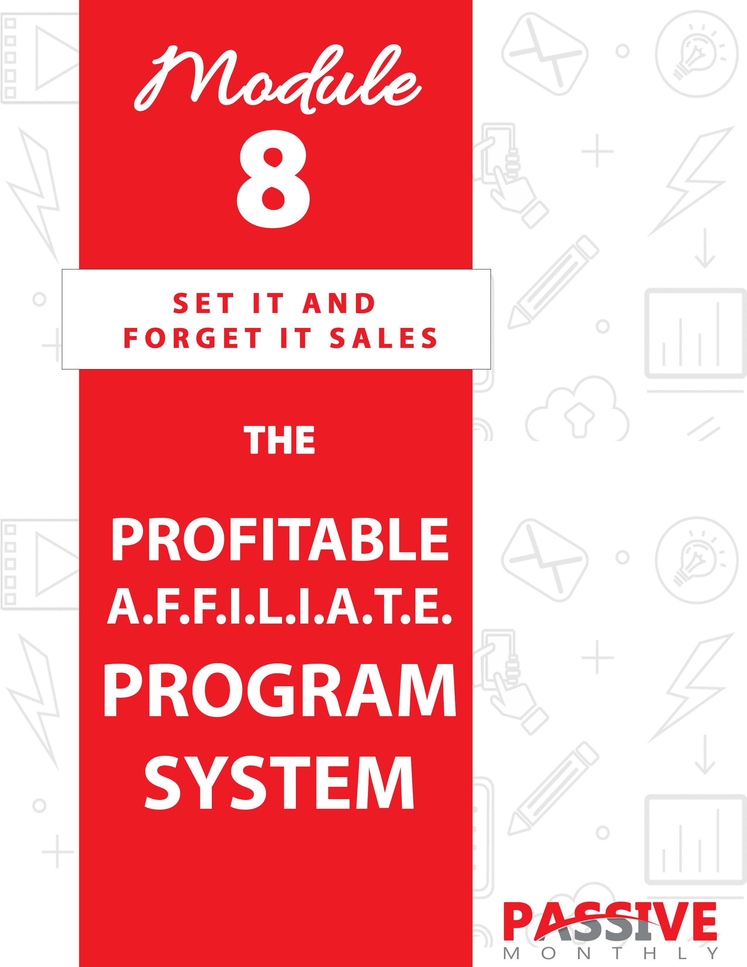

You DO NOT Have The Right To Sell Or Give Away
Any Portion Of The Content In This Document.

This Document Is For Your Personal Use Only

CLICK HERE For Additional Resources
To Help You Build Your Dream Business.

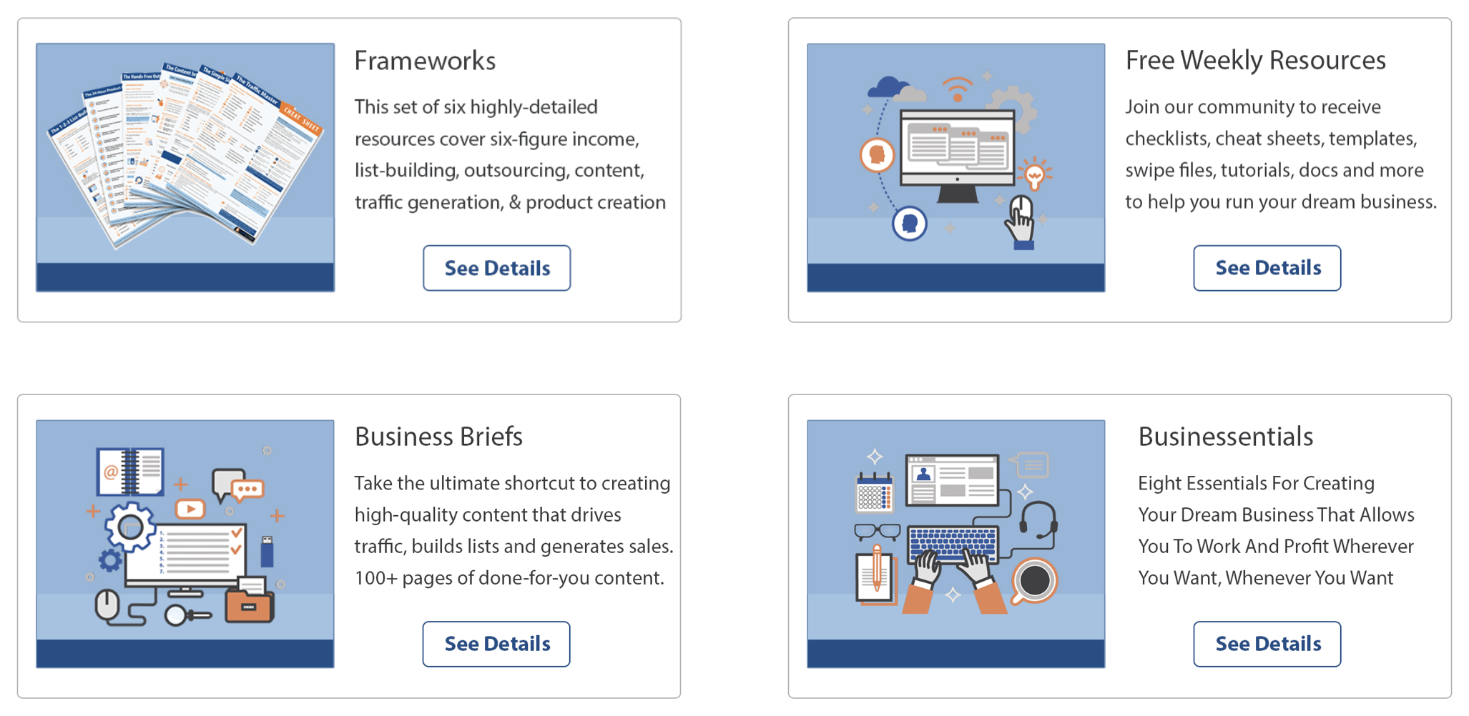

Insert Your Legal Disclaimer / Document Here

Strategy: What Is It?

Welcome to another edition of Passive Monthly, where you’re about to discover how to set up an A.F.F.I.L.I.A.T.E. system!

Just as the name implies, this system is all about setting up an affiliate program, and then finding affiliates to sell your products for you in exchange for a commission. Once you get this system all set up, it runs virtually hands-free. That’s because every time you create a new product, all you have to do is send out an email to your affiliates, and they’ll get to work making money for you!

Here’s a key to this strategy: you can offer VERY generous commissions on a frontend product, which will get your affiliates scrambling to generate sales. You’ll then build a big list of proven customers, which you can sell additional products to on the backend. (And if you set up an autoresponder for this step, this too can be hands-free!)

So, let’s take a quick look at the parts and steps of the A.F.F.I.L.I.A.T.E. system:

- ANALYZE Your Sales Funnel: here’s where you determine which products to put into your affiliate program.

- FORMULATE Your Program: this is where you decide the details of your affiliate program.

- FIND a Platform: here’s where you pick your sales platform.

- INSTALL Your Program: at this step you get your affiliate program set up, such as creating an affiliate agreement.

- LOAD the Dashboard: this is where you create and upload marketing materials for your affiliates to make it easy for them to advertise your product.

- INSTRUCT Affiliates: not ever affiliate is a pro, so here’s where you train your affiliates to make money for you.

- ADVERTISE Your Program: here’s where you let affiliates know that you have an affiliate program.

- TARGET Super Affiliates: this is where you personally recruit super affiliates and invite them to join your program.

- EXCITE Affiliates: this step is all about motivating your affiliates so that they’ll promote often.

Now that you have an overview of the strategy, let’s take a closer look at the system:

System: How Do You Do It?

You can see how setting up an affiliate program is an awesome hands-free way to make money and build yourself a big list. So, now let’s take a closer look at each step of the AFFILIATE System:

ANALYZE Your Sales Funnel

The first thing you need to do is figure out which of your products you’re going to put into your affiliate program. There are two lines of thought on this:

- Put your entry/front-end products into the affiliate program. Then you can sell additional products on the backend to your proven list of buyers. This too can be hands-free if you set up an evergreen autoresponder.

- Put most or ALL of your products into the affiliate program. That way, your affiliates can set up a sales funnel with your products. While you should obviously seek to sell products on the backend to your customers (using an evergreen autoresponder), your affiliates will be

doing the same thing.

Generally, #2 is a good option because it will allow you to attract a wider range of affiliates, since they can sell products across a variety of price points. And, in general, you’ll sell more products to your existing customers when both you and your affiliates are promoting these products!

So, my recommendation is that unless you have a valid reason to choose option #1, you should seek to put most of your products into your affiliate program. This benefits both you and your affiliates.

Now the next step…

FORMULATE Your Program

The next step is that you need to decide on the details of your affiliate program. Here are the main issues for you to consider:

What is your frontend commission rate?

Most affiliates are going to expect 50% for a digital product, so don’t go lower than that. However, you can certainly go higher, as that will help you attract more affiliates. But while you’re setting your basic commission, you’ll also need to consider this next issue…

Will you offer special commissions or bonuses to top affiliates?

Super affiliates are used to getting higher commission rates, so it’s a good idea to work in bonuses or bumped up commissions for those who generate a lot of sales.

Now, there are two ways to approach this (and you can do both of them):

- Offer a bigger commission for known super affiliates. If you’re recruiting affiliates personally, then you might offer (for example) 50% commissions to the public, and 75% commissions to those who are known super affiliates. This extra perk will help persuade super affiliates to join your team.

- Offer bonuses or bigger commissions for those who cross a specific threshold. The idea here is to bump up commissions for those who prove that they know how to sell. You can do this on a monthly basis (where everyone starts at the basic commission at the beginning of the month and get higher commissions if they cross a certain threshold), or you can do it on a lifetime basis where the affiliate gets higher commissions forever once they cross a sales threshold (such as 100 sales).

Next…

Will you offer commissions on upsell/downsell offers?

If you have upsells, downsells and/or cross-sells on the order form, it’s a good idea to offer commissions for these items too. Generally, you can offer the same commission rate as the frontend commission, such as 50%.

NOTE: Some marketers like to offer a really high commission rate on the frontend (such as 75% or even 100%), and then a 50% commission on upsells.

Next issue…

How often will you pay your affiliates?

In part, the answer to this is going to depend on what sales platform you choose, which we’ll be talking about just a little later on. But the most common options include:

- Instant commissions, which are only suitable for affiliates you know and trust.
- Weekly commissions.
- Commissions paid every two weeks.
- Commissions paid monthly.

Paying once weekly or once every two weeks tends to be fairly common and a good choice. Instant payments are risky, and monthly payments may seem a bit long to some affiliates.

Will you withhold commissions in case of returns?

Again, this is going to depend on the sales platform you choose, as some platforms (such as ClickBank) handle this completely for you, while with other platforms it’s up to you. For example, you might opt to withhold 10% of commissions on a rolling basis to help cover refunds.

Will you refuse to admit some affiliates into your program?

Again, partly this depends on the platform, as platforms such as ClickBank don’t give you the option of approving or refusing affiliates. However, if given the option, you may develop a due diligence process that includes asking the potential affiliate questions (e.g., “How do you intend to promote this product?”), researching the affiliate’s name in Google, and checking out their website to see if they have a high-quality, well-established site.

Now, as mentioned, the answers to some of these questions depend on which sales and affiliate platform you choose. Which means now is a good time to turn our attention to this next step…

FIND a Platform

Your next task is to find and select an affiliate and sales platform. Generally, you have two main options:

- Select a self-hosted platform. This is where you select and install an affiliate script on your own website. In this case, you’ll handle absolutely everything, from database maintenance to refunds and beyond.

Generally, this is only desirable if you’re already well-known in your niche. That’s because affiliates would rather not risk spending a lot of time promoting a product if they’re not 100% sure they’ll get paid –
and when it comes to self-hosted platforms, there is no guarantee. (Unless you are doing instant commissions, which again is not recommended.)

- Select a third-party hosted platform. This is the option I recommend, especially if you choose a well-known platform that most affiliates are already familiar with. These platforms include:

- ClickBank.com: One of the most well-known platforms where the company takes care of everything for you (including refunds and cutting affiliate checks). Fees tend to be higher on this platform than other platforms, but this well-established platform is well-known and liked by affiliates because they are guaranteed to get paid.

- JVZoo.com: Popular platform that’s most widely known among the “make money online” crowd. Payment options include PayPal, Stripe and Authorize.net.

- Zaxaa.com: A feature-rich platform that’s growing in popularity. Features include sales funnels, free products, two-tiered affiliate systems and more.

Go ahead and check out these platforms to determine which one best meets your needs. When in doubt, ClickBank.com is a good option due to its popularity and trustworthiness among affiliates.

Then move onto the next step…

INSTALL Your Program

Your next step is to install and set up your affiliate program based on the platform you selected. This includes:

Get Set Up With the Platform

How you complete this step varies depending on which platform you chose. For example, with some platforms you need only create an account and then follow the onsite instructions for setting up your product.

If you selected ClickBank.com, then you’ll need to take additional steps. That’s because you’ll need to pay a fee to get set up, and then the company needs to approve your product and sales page. As long as you follow their terms of service, this tends to be a pretty painless process.

Regardless of the platform you chose, you’ll also need to set up a payment button. Most third-party platforms have excellent onsite instructions for this process. You’ll need to know the URL for your sales page, download page link, and the product download link.

Finally, many platforms have a marketplace where they’ll list your product. You’ll need to fill in the product title, description and/or other information as required. Take your time with this step, as these listings will help you attract more affiliates.

Once you’ve set up your account, your product and your payment button, then move onto the next step…

Create a Terms of Service

Some platforms, such as ClickBank.com, come with their own terms of service which your affiliates must agree to while registering their account. If your chosen platform does NOT have an affiliate terms of service, then you’ll need to create one. This agreement will cover items such as:

- Commission rates.
- When and how affiliates will be paid.
- How affiliate links are tracked. (E.G., cookies? First or last?)
- Activities that are prohibited (such as spamming).
- How refunds are handled.

And similar issues.

It’s a good idea to look over other peoples’ terms of services to get an idea of what all you want to include. Then draw up a draft document and have your attorney create the final copy. (And that’s all I’ll say about this, since I’m not a legal professional! )

Now the next step…

LOAD The Dashboard

Once you have your affiliate program all set up, then it’s time to load the affiliate dashboard. This means uploading materials that will help your affiliates promote your products.

NOTE: Some affiliate platforms give you a place to upload these materials. If your chosen platform doesn’t have a built-in dashboard, no problem – you can just upload these materials to any page of your website that is accessible to affiliates. In other words, you can create your own affiliate center.

Here are the different types of materials you can upload to your affiliate dashboard:

Rebrandable Report

This is a report that’s highly related to your paid offer, so that anyone who wants your free report will naturally want your paid product too.

For example, perhaps you’re selling a copywriting course. Your free report might focus on how to craft compelling headlines for sales letters. This report would naturally lead to your sales page (and of course affiliates can insert their affiliate links into the report).

Tools

Instead of a report, you might offer a set of tools for your affiliates to give away. Let’s stick with the example from above, where you’re selling a copywriting course. Here you might offer one or more tools for affiliates to
rebrand and give away, such as:

- A sales letter template.
- A set of headline swipes.
- A sales letter checklist.
- A profiling worksheet.

And similar items which are designed to help prospects create better sales letters more quickly and easily.

Email Series

Here you create a set of three to seven emails which your affiliates can rebrand with their affiliate links and upload to their autoresponder.

For example, you might create a five-part series called “The Five Secrets of Writing Million Dollar Sales Letters.” Each email would be part content, part pitch.

TIP: If you offer a report, tools or other valuable resource, then affiliates can use that product as a lead magnet, and use these emails to close the sale.

You can also create directly promotional emails. For example, you might offer a Fear-Logic-Gain set of promotional emails. Or if you’re doing promos for a product launch, then you might upload a set of emails that your affiliates can use to build anticipation before the launch, and drive sales during the launch week.

Solo Emails

While a well-done email series tends to produce higher conversions when compared to individual emails, not every affiliate wants to load a series. That’s why you’ll also want to prepare at least five different solo emails, each of which can stand alone and be sent at any time.

Examples of the types of solo emails you can create for the affiliate dashboard:

- A direct, hard-sell promotional email.
- A case study.
- A FAQ about the product.
- An informational article (such as “how to” article) with a soft-sell at the end.
- A product review.

And speaking of articles…

Blog Articles

You should also have a set of articles prepared for your affiliates to use on their blogs. To save yourself time, you can tweak your email series and standalone emails to turn them into blog articles.

Social Media Blurbs

Here you’ll want to prepare a variety of materials for your affiliates to use, including:

- Very short blurbs for use on Twitter.
- Other blurbs for other platforms – generally, these will still be short, directly promotional pieces.
- Rebrandable viral content, such as infographics.
- Videos.

Naturally, your affiliates can use this content on other platforms too, such as posting videos or infographics on their blogs.

Graphic Ads

You should create a variety of graphic-based ads, such as banners and boxes that your affiliates can copy and paste to their websites. It’s also a good idea to offer graphics (such as ecover graphics) that they can use to create their own banners and/or to use in paid advertisements, if they’re so inclined.

Text Ads

Some of your affiliates may want to insert text ads on their own sites, such as in the sidebar of their blog. Other affiliates may want these text ads for paid advertising campaigns, such as a Facebook ad. Either way, you should provide a variety of text ads (of different lengths)

As you can see, there are quite a few materials that you need to create for your affiliate center.

The good news is that you don’t need to upload every single suggested piece of content from the list above before you launch a product or add it to your affiliate program. You can start with just a few pieces, and add promo materials over time. For example, you might start with:

- A rebrandable report.
- A set of promo emails.
- A few social media blurbs.

You can start your affiliate program with these items, and add to the marketing arsenal over time.

TIP: If you’re launching a product, then your marketing materials may be slightly different since they’ll likely refer to things such as “introductory discounts” and “launch week” and so on. Be sure to turn these marketing materials into evergreen content after the launch is over, by eliminating any references to discounts, launches or even the newness of the product.

Now let’s look at the next step of our A.F.F.I.L.I.A.T.E. system…

INSTRUCT Affiliates

Your next step is to create materials that train your affiliates on how to
make more money with your affiliate program.

You see, not every affiliate who joins your program is an experienced affiliate. That’s why you need to provide some guidance. If you can help a new affiliate make money with your program, you can bet they’ll become loyal affiliates who generate sales for you over the long term.

So, how do you help affiliates make sales?

Simple: you provide them with a report or even an instructional video that teaches them how to build a list, drive traffic to their opt-in page, and promote your affiliate offer on the backend. Your instructions can also include guidance on specific topics such as paid advertising, social media marketing and blogging.

But heads up: just tossing an affiliate marketing guide in front of your affiliates may overwhelm some of them. They’ll read (or watch) the content, but then be lost as far as what to do next.

The solution?
Create a 30-day action guide for your affiliates.

This is where you give them a planner that tells them exactly how to promote your affiliate offers over the next 30 days.

Be specific. E.G., “Day 1… Use the lead magnet, lead page, and emails included in the affiliate center to set up lead page…”

The more specific your plan, the more likely it is that your affiliates will use it – and that means the more likely it is that you’ll increase the number of affiliates who are making sales. That’s a win-win, because you’re both making money.

In addition to offering an affiliate marketing guide and a 30-day planner, you might also consider other ways to offer your affiliates support. Here are two examples:

- Offer a private group. You can set this up as a private forum on your website, or you can set it up as a private group on Facebook. Either way, you can share information about how to promote your products, and answer any questions your affiliates may have.

- Provide monthly webinars. The idea here is to pick an affiliate topic (such as adding value to an offer), and hold a short 30-minute or so webinar on the topic. You can invite your affiliates to attend the webinar and ask questions, and you can make the replay available for those who were unable to attend.

So the point is, you’ll make more money if you instruct your affiliates on how to promote your offers.

Now the next step of the A.F.F.I.L.I.A.T.E. system…

ADVERTISE Your Program

Now that your affiliate program is all set up, all you have to do is wait for hordes of eager affiliates to find it, join it, and start promoting your offers… right?

Wrong. That’s wishful thinking that happens entirely all too often.

Truth is, you need to advertise your affiliate program so you can start attracting marketers who’ll help you make money. Here’s how to do it…

TIP: Before you promote your affiliate program, be sure to create a sales letter that highlights the benefits of the program. This includes your commission rate, how much money affiliates can earn on the frontend and backend, and what the conversion rate is for the sales letter. You’ll also want to tout other perks, such as all the copy and paste marketing materials you provide to make promoting the program easier than ever.

Advertise On Your Site

The first place you need to promote your affiliate program is directly on your site. There should be a link to your affiliate page on every page of your website, with the possible exception of your sales pages. You can put this link in your main navigation menu, as well as advertising the link in prominent places on your site, such as your blog’s sidebar.

NOTE: If you include a link to your affiliate program on your sales pages, keep in mind that this outside link will likely reduce conversions. You’ll want to test it to find out for sure. In addition, it’s a good idea to remove this link from any pages that your affiliates are promoting.

Next…

Put Your Offer in the Platform Marketplaces

Many third-party affiliate directories (such as ClickBank.com) have built-in marketplaces. Check your platform’s instructions to find out how to get your program listed in this marketplace, as it will help you attract qualified affiliates.

Tell Your Contacts

Spread the word about your affiliate program by telling both your prospects and customers about it. You can do this by:

- Blogging about your program.
- Telling your newsletter subscribers.
- Sharing the benefits on social media.
Next…

Insert Links in Products

Some of your biggest advocates are your customers, which is why you’ll want to encourage them to join your affiliate program. To that end, spend a little time at the end of your product sharing the benefits of your affiliate program, along with a link to your affiliate page and a call to action.

E.G., “Click here to find out how you too can earn up to $100 per sale just by telling your friends about this awesome product!”

Spread the News in Marketing Groups

If you’re a member of any marketing or affiliate forums or social media groups, spread the word about your affiliate program. Just be sure to check the group’s terms of service to be sure that advertising is allowed, even if it’s just in a signature link.

Hire an Affiliate Manager

Don’t want to do the work of attracting affiliates yourself? Then you might consider hiring an affiliate manager or joint venture broker, both of which take a commission for any sales that your affiliates make (as they’re the ones who advertised your affiliate program).

In many cases, affiliate managers and JV brokers directly recruit affiliates, which brings us to the next point of the A.F.F.I.L.I.A.T.E. system…

TARGET Super Affiliates

While advertising your affiliate program is a great way to attract new affiliates, the truth is that you will rarely bring a super affiliate into your program using that method. That’s because super affiliates rarely go looking for products to promote. Instead, vendors typically seek out and recruit the affiliates. And if you want to get super affiliates on your team, that’s what you’re going to need to do too.

As mentioned in the last section, you do NOT need to do this yourself. Instead, you can hire an affiliate manager or JV broker to find and recruit affiliates in exchange for a cut of the profits.

NOTE: An affiliate manager generally handles all parts of your program, such as creating marketing materials and motivating affiliates. A JV broker, on the other hand, usually only deals with affiliate recruitment. Usually brokers have already developed relationships with top affiliates in your niche, so they can recruit fairly quickly.

If you decide to target the super affiliates on your own, you’ll need to take the following steps

Find Super Affiliates

You can do this by:

- Checking affiliate contests in your niche to see who won them.
- Keeping tabs on the bestselling vendors in your niche (as they make good super affiliates too).
- Searching for people in your niche with big platforms, such as popular blogs and social media pages.

Next…

Develop Relationships

Once you find these affiliates, you’re likely to get more “yes” responses if you develop relationships with them first. That’s because the top affiliates have dozens of offers hitting their inboxes every week – and they’re going to trash most of them. You can bet they’ll pay attention to offers from people they already know, like and trust.

If you don’t have time to develop relationships with super affiliates, once again I suggest that you look into hiring someone to recruit affiliates for you – especially JV brokers in your niche, who’ve already spent years developing relationships with these affiliates.

Offer Extra Perks

You want to give your super affiliates better benefits than regular affiliates receive. This may include:

- Bigger commissions.
- Instant commissions.
- First dibs on promoting new products.
- Personalized landing pages.
- Co-promotions (meaning you promote your super affiliate’s offers).

In short, bringing top affiliates on board is all about seeking them out rather than waiting for them to come to you. It’s a good idea to give them extra perks to persuade them to join your program.

Now the final step of the A.F.F.I.L.I.A.T.E. system…

EXCITE Affiliates

When your affiliates first join your program, they’re going to be excited. And when they’re excite, they’ll promote your offers.

But with time, that excitement is bound to wane. And that means sales and revenues are going to drop. That’s why you need to reignite the excitement – not just when you see it visibly drop, but every week.

Here are three solid ways to keep affiliates excited and promoting…

Send Out Emails

You should be sending these out on a weekly basis. Send out a variety of materials, and see what kind of emails work best to get your affiliates promoting. Here are examples of the types of materials to send:

- Motivational emails. For example, you might interview one of your successful affiliates, and then spotlight them in an email to motivate other affiliates.

- New marketing materials. Drop an email to your affiliates and include copy and paste swipes directly inside the emails – all they have to do is insert their affiliate links and they can promote your offer in minutes.

- Announcements about upcoming launches. This also includes any relaunches, such as when you update a product and relaunch.

Of course announcing a sale is also motivating, which is why that’s the next method we’re going to look at…

Offer Sales

You can do one-day flash sales, or multi-day fire sales. But whatever you choose, be sure to give affiliates a heads-up well ahead of time. Affiliates tend to love sales events and coupons, simply because customers love them and flock to them – and that means they’re very profitable.

TIP: You can help your affiliates make more money during these sales by giving them marketing materials such as emails, social media posts and blog posts to help them promote the offer.

Next…

Run Contests

Another good way to motivate affiliates is by running affiliate contests. This especially true if you do two things:

- Offer really good prizes, such as attractive cash offers.
- Run customer sales simultaneously to make it easier for affiliates to generate sales.

So as you can see, there are several steps required in setting up and running a successful A.F.F.I.L.I.A.T.E. program, but none of these steps are particular difficult. At this point you now know enough to get your program up and running.

But if you want to run a really successful program, then you’re going to want to keep reading…

Shortcuts: What Else Will Help You?

Once you get your affiliate program up and running, and you recruit your team of affiliates, it becomes virtually hands-free. That’s because your affiliates will take over and start generating plenty of sales for you.

However, you can make your affiliate program easier and more profitable by using these tips and tricks…

Use PLR to Create Training Materials

As you recall, part of the A.F.F.I.L.I.A.T.E. system involves instructing and training your affiliates on how to make more sales for you.

Here’s a way to make this step quicker and easier: Don’t create these materials from scratch. Instead, use PLR (private label rights) content to create these training materials.

All you have to do is start with a good affiliate marketing guide, and then tweak it to suit your needs. Be sure to make the training specific to your products and niche.

Now let’s look at another way to make this system easier…

Create a Motivational Autoresponder Series

As mentioned, it’s a good idea to send out weekly motivational materials to your affiliates. However, this doesn’t mean you need to be at your desk every week cheering your affiliates on in real time. Instead, you can motivate your affiliates in a hands-free manner by setting up a motivational autoresponder series.

Now here’s the key: be sure this autoresponder series is evergreen. If you make references to dates, events, product launches, or anything else that dates the content, your affiliates will discount it. They’ll know it’s “old,” so they’ll ignore it.

But make it evergreen, and you’ll keep your affiliates engaged and reading week after week. And if they’re eagerly opening your motivational emails, then you can bet they’ll be eagerly promoting your products, too.

And finally…

Nurture Relationships With Top Affiliates

You may have already identified some of your top affiliates, because you (or your JV broker/affiliate manager) was the one who originally invited them to join your affiliate program. However, you also need to identify your other top affiliates. This includes:

- The affiliates who seem to always win your affiliate contests.
- The affiliates who don’t win the contests, but they make a steady stream of sales.
- The affiliates who promote constantly (long after others have moved onto something else).

These types of affiliates are some of your greatest assets. Even the loss of one really good affiliate could affect your bottom line to the tune of thousands of dollars. That’s why you’ll want to nurture the relationship with these affiliates so they’ll remain a part of your team.

Here’s how to do that:

- Start up a personal relationship. In other words, email these affiliates so you can start getting to know one another. Ask them how you can help them make more money. Let them know you appreciate their efforts.

Which brings us to the next point…

- Send thank you notes in the mail. That’s right, handwrite an actual thank you card and send it via postal mail. This is a small gesture that takes just a few minutes, but it leaves a positive and lasting impression on your top affiliates.

- Support them. Your job is to make it easier for your affiliates to do their jobs. So be sure to support your top affiliates in whatever way you can. This includes letting them promote new products first, sending them review copies well before a product launches, and giving them access to you (such as doing webinars with them).

- Surprise them. Show your appreciation for your top affiliates by surprising them with unadvertised bonuses for a job well done. This could take the form of any of the following:

- A one-time monetary bonus. For example, you might send a 25% bonus to an affiliate who had a particularly good month.

- A permanent increase in commission rates. Here you bump a good affiliate up to a higher commission level, such as from 50% to 75%.

- A gift card. This could be an Amazon gift card, or a gift card to a favorite restaurant.

Now let’s wrap things up…

Conclusion

Congratulations – you just learned all about another passive-income strategy that’s very profitable! Let’s quickly recap the A.F.F.I.L.I.A.T.E. system:

So let’s take a quick look at the parts and steps of the A.F.F.I.L.I.A.T.E. system:

- ANALYZE Your Sales Funnel: here’s where you determine which products to put into your affiliate program.

- FORMULATE Your Program: this is where you decide the

details of your affiliate program.

- FIND a Platform: here’s where you pick your sales platform.

- INSTALL Your Program: at this step you get your affiliate program set up, such as creating an affiliate agreement.

- LOAD the Dashboard: this is where you create and upload marketing materials for your affiliates to make it easy for them to advertise your product.

- INSTRUCT Affiliates: not ever affiliate is a pro, so here’s where you train your affiliates to make money for you.

- ADVERTISE Your Program: here’s where you let affiliates know that you have an affiliate program.

- TARGET Super Affiliates: this is where you personally recruit super affiliates and invite them to join your program.

- EXCITE Affiliates: this step is all about motivating your affiliates so that they’ll promote often.

So now that you’ve got a proven blueprint for getting your own affiliate program up and running, it’s time to get started. Because the sooner you take action and set up your affiliate program, the sooner you’ll start pocketing the cash from this extremely profitable strategy!

