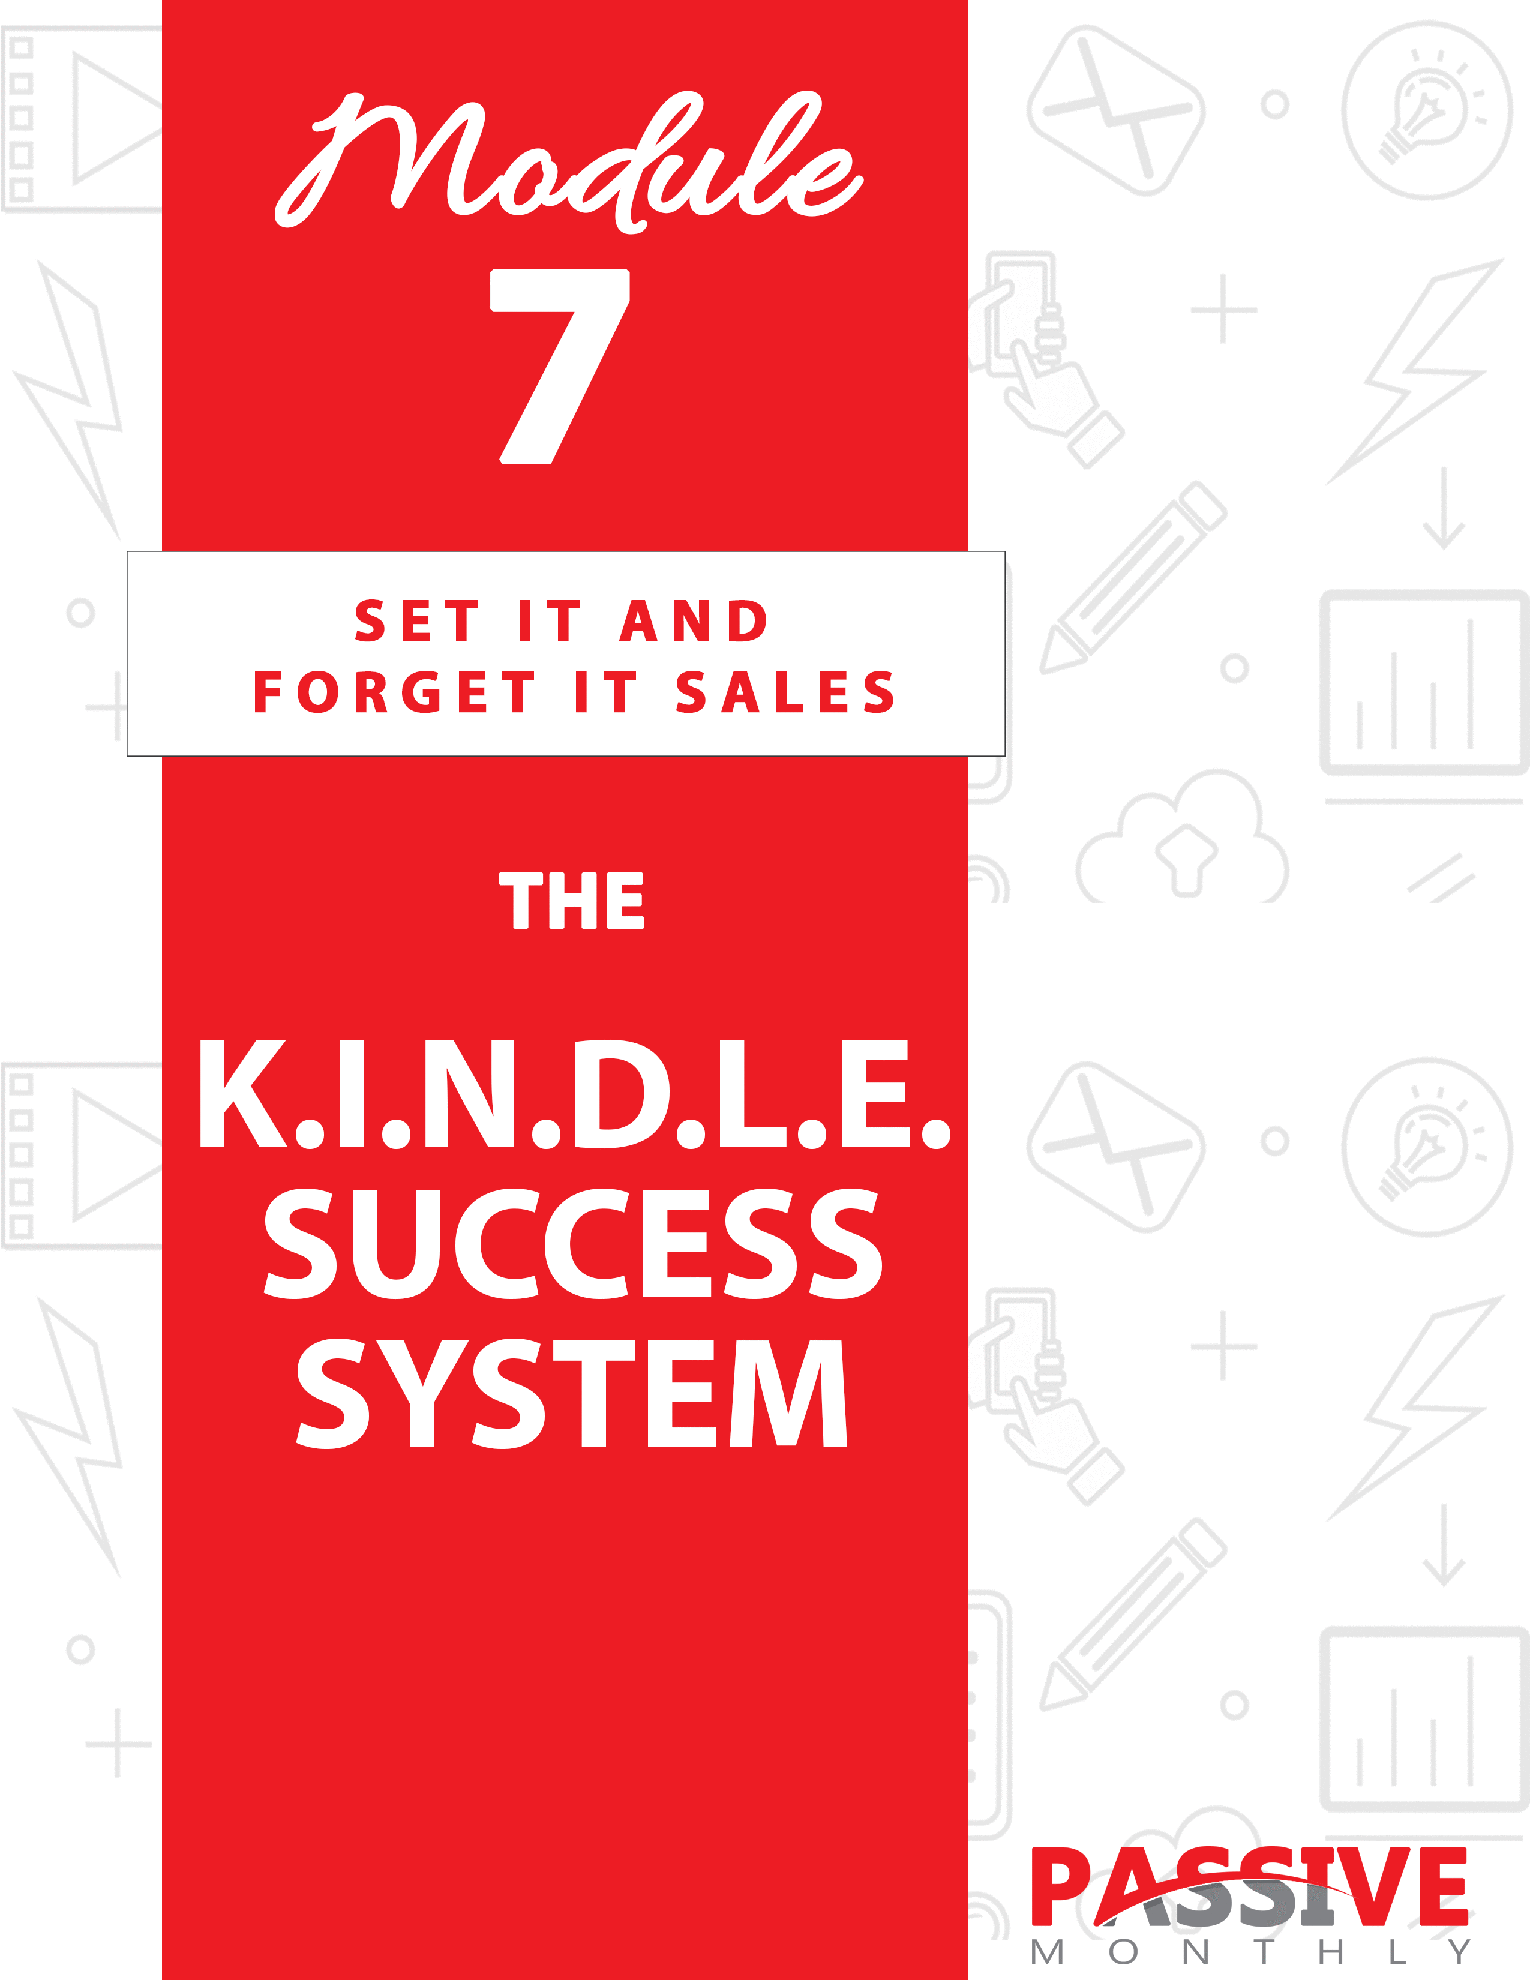

You DO NOT Have The Right To Sell Or Give Away
Any Portion Of The Content In This Document.

This Document Is For Your Personal Use Only

CLICK HERE For Additional Resources
To Help You Build Your Dream Business.

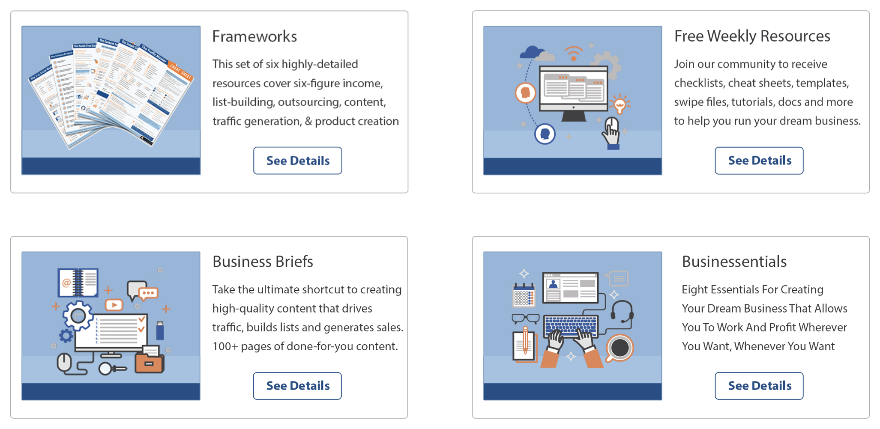

Insert Your Legal Disclaimer / Document Here

Strategy: What Is It?

Welcome to this issue of Passive Monthly, where you’re about to discover the K.I.N.D.L.E. Success System!

You’ve probably heard the stories about people making a lot of money using Amazon’s Kindle platform. It’s true. And you’re about to find out the same tips, tricks and secrets these authors use to sell a lot of ebooks on Kindle – just think of what these strategies will do for you!

Now heads up…

A lot of the success stories you hear about come from fiction authors. What you’re going to learn about is how to use the Kindle platform to support your non-fiction works. You’re going to learn how to turn a Kindle book into a passive income that grows over time.

How does it work? Well, let’s take a look at this overview of the K.I.N.D.L.E. System:

- Know Your Audience: The first step to creating a bestseller is to pick a topic your audience wants, which is what you’ll learn to do here.

- Improve Existing Products: You don’t need to create something that’s never been seen before, but you do need to create something that’s better than what’s currently on the market.

- Name Your Book: Your title can make or break your book, which is why you’ll find out how to craft a great title in this step.

- Develop the Backend: You don’t get the customer list when you sell through Amazon… but there are ways to make money on the backend. This is one of the keys to turning this into a passive-income system, which involves inserting links and calls to action inside your book.

- Launch Your Book: In this step you’ll discover how to get your book onto the Kindle platform so you can make those first sales.

- Expand Sales: Here you’ll get the tips and tricks for creating more sales – because if you can create more sales, then not only do you make more money on the frontend, you also have an opportunity to make more money on the backend too!

Plus, at the end of this issue you’ll also get the top shortcuts to make it easier and more profitable for you to sell your non-fiction Kindle book!

System: How Do You Do It?

As you’ve seen from the overview above, this system is all about loading one or more non-fiction books onto the Kindle platform and taking advantage of backend sales opportunities. So, let’s now take a closer look at how to put the K.I.N.D.L.E. system to work for you…

KNOW Your Audience

Before you can even think about creating your Kindle book, you need to first determine what your audience wants.

If you’re already selling information products in your niche, great! Then you have a good idea of what’s selling well. In fact, you might even consider taking one of your popular products, expanding it/updating it, and selling it as a new product on Kindle.

If you’re just getting started in your niche, however, then you’ll need to find out what people want. Here’s how to do that…

Check the Kindle Marketplace

The first thing to do is check the very marketplace on which you’ll be selling your book. Simply go to Amazon and search for your keywords in the Kindle marketplace. Then pay attention to the following:

- What are the bestsellers in your niche?
- What products have multiple books on the same topic?

Both of these are evidence that a particular topic in your niche is popular and profitable.

Next…

Review Other Amazon Products

Don’t stop your research on the Kindle platform. You’ll also want to expand your search to Amazon books. Again, look at the bestsellers in the niche, as well as topics with competition (as that’s a sign that the topic is in-demand).

Do a Google Search

Now expand your search outside the Amazon marketplace. Search for your niche keywords (such as “car restoration” or “online marketing”), and check what your top competitors are selling. Be sure to also check the paid (sponsored) ads alongside the regular search results, as marketers don’t pay money to advertise products that aren’t selling.

Take notes and move onto the next step…

Search Keyword Tools

The next step is to find out what your audience is searching for in the search engines. Use your favorite keyword tool (such as MarketSamurai.com or WordTracker.com), and insert your niche keywords. Then take note of what specific topics your audience is searching for.

TIP: Pay particular attention to keywords that indicate the audience is searching for a book or other paid infoproduct. E.G., “dog housetraining book” or “buy housetraining book.”

Next…

Ask Your Audience

Finally, you can get a feel for what your audience wants by surveying them, particularly with open-ended questions. Your questions might include:

- What are your biggest niche-related stumbling blocks?
- What sort of information do you need to move forward?
- What solutions have you tried?
- Why haven’t these solutions worked for you?
- What would you like to see covered in a [niche topic] book?

Just be sure you don’t use this method in isolation, however, as what people say they want and what they actually buy can be two different things. So, use your survey data to confirm what you’ve learned in your other research.

What’s Popular?

Now that you’ve done your research, review it to look for patterns. What you’re looking for a topic in your niche that is consistently popular across all forms of your research. If you see a particular type of product being advertised everywhere –and you see evidence that people are buying – that’s the type of product you’ll want to create too.

You can also look for gaps in the Kindle marketplace. This is where you notice that a particular topic is popular across all your other research venues except for the Kindle platform. These sorts of gaps are exceedingly rare at this point, but from time to time in certain niches you may still find them. Point is, if a product is popular everywhere else but there isn’t much competition yet on Kindle, that’s a topic you’ll want to pursue.

So, go ahead and walk through the above steps to pick your topic, and then move onto the next step of the K.I.N.D.L.E. Success System…

IMPROVE Existing Products

As you discovered in the last step, one good way to predict what people will buy tomorrow is to find out what they’re buying today. In other words,
you’re almost guaranteed success if you pick a topic that’s in high demand.

But heads up…

This doesn’t mean that you copy other peoples’ products. Not even close.

Instead, what you do is write your own completely unique product on the same topic. You share your unique viewpoint. You share your unique step-by-step process. You share your unique examples, stories, tips and tools.

In other words, you’re not writing a “me too” book. If you do that, you’ll never stand out from the crowd of other books on the same topic. And that means you need to create something that’s BETTER than the existing products.

Here’s how to do that…

Determine the Bestsellers’ Strengths and Weaknesses

First, you need to actually read and use the top products in your niche. That way, you can see for yourself what all topics are covered, plus you can determine for yourself the product’s strengths and weaknesses. Ask yourself what features and benefits of these products you’ll like to retain for your own product, and in what areas you could improve upon these products.

For example, let’s suppose you’re looking to create a copywriting guide. You may notice that the competitors’ products give extra instruction and emphasis on writing great headlines, so you decide that’s a feature you want to keep in your product too.

On the other hand, you may notice that there aren’t a lot of examples or templates, so users are left to their own devices after they finish reading these competitors’ books. You determine that to be a flaw in these products, and you’ll improve on that flaw by including plenty of examples, swipes and templates.

Secondly, look at the reviews on these top products. Many times reviewers will tell you what they like and don’t like about a product, so this will clue you into what your audience wants. And in many cases what you determined to be a strength or weakness will match up with the audience’s perception, which confirms you are on the right track.

Decide What Topics to Include

Now that you’ve reviewed the top products in your niche, it’s time to start planning your own. Here’s an overview of what to do next:

- Review the table of contents. This will help you decide what all topics to include in your product. (Take note that you’re NOT copying someone else’s product – you’re merely looking at the table of contents for the top sellers in your niche to decide what topics to include.)

- Incorporate your benefits and improvements from the previous step. Decide which topics are essential and which ones aren’t by looking at the research you did in the previous step. Be sure your end product is going to be better than everything that’s currently on the market.

- Decide how to create something “fresh” for your audience. What tips (or even topics) can you provide that the other products don’t have? Is there a way you can teach the content in a fresh way?

For example, this issue you’re reading right now shares with you my K.I.N.D.L.E. Success System. I’ve taken a step-by-step process and turned it into a system/formula. Look at your own how-to process and see if you can turn it into a memorable, fresh formula.

- Create a detailed outline. Now that you know your unique approach to the product as well as what topics to include, you can create a detailed outline. The more detailed your outline, the easier it will be to create the product (or to have someone else create it for you). Which brings us to the last step…

And finally…

Develop Your Product

Here you have a choice:

- You can create the product yourself. If you have the skills, time and inclination to create an informative, engaging piece of writing, then you may choose this option.

- You can outsource it to a competent writer. If you choose to outsource, be sure to do your due diligence so that you end up with a good writer who’ll produce a high-quality product for you.

TIP: While I often suggest that you use PLR content to create products, here’s one case where you should NOT use PLR. That’s because Amazon doesn’t want a bunch of similar products being sold in their marketplace, so using PLR could get your publisher’s account shut down.
Bottom line? Create original content for Kindle.

Regardless of whether you do it yourself or outsource, follow these tips:

- Proof the final product. You may hire a professional proofreader to do this. If you do it yourself, read your product out loud (as it will help you catch places that need to be smoothed out).

- Be sure it’s engaging. Your product needs to “edutain” readers – educate them while entertaining them. To that end, tell stories to engage the reader’s emotions, inject humor (where appropriate, and sparingly), and use a light, conversational tone.

- Ensure it’s easy to read. Write with short sentences, words and
paragraphs. Don’t try to impress your readers with high-level writing, because in most cases that just slows readers down and frustrates them. If they’re faced with big walls of text or big words that they don’t know, they’ll probably stop reading.

- Add value to the product. Where appropriate, add photos, illustrations, infographics, charts, tables and other graphics to break up the text and simplify complex concepts.

Once you (or your ghostwriter) have created a solid product, then move onto the next step…

NAME Your Book

The very first thing your potential buyer is going to see is the title of your book (and the cover). And many buyers will make their decision right then about whether to purchase your book just based on the name alone. That’s why you need to spend time developing an eye-catching name.

Here are tips for creating your title:

- Create a benefit-driven name. E.G., “How to Win Friends and Influence People.”

- Use known “power” words. These words include you, how to, amazing, secrets, discover, guaranteed, free, fast, quick, simple, easy, little-known, revealed, new, proven, surprising, startling, and shocking.

- Craft a title and subtitle. Your title can be short and powerful, with your subtitle offering more description and benefits. E.G., “The Four-Hour Workweek: Escape the 9-5, Live Anywhere and Join the New Rich.”

Now let’s put these tips to work. Use the following templates to start brainstorming your own benefit-driven title:

- How to [Get a Benefit]. E.G., How to Get Rid of Belly Fat for Good!

- The Secrets of [Getting Some Benefit]. E.G., The Secrets of Creating Million-Dollar Sales Copy

- The Quick and Easy Way to [Get a Benefit]. E.G., The Quick and Easy Way to Get Out of Debt

- What [Type of Experts] Know About [Topic]. E.G., What Personal Trainers Know About Losing Weight Fast

- A Surprisingly Easy Way to [Get a Benefit]. E.G., A Surprisingly Easy Way to Start a Six-Figure Business.

- What Every [Type of Person] Ought to Know About [Topic]. E.G., What Every Competitive Bodybuilder Ought to Know About Muscle Symmetry.

- How to [Get a Benefit] Even If [You Don’t Have Some Special Skill, Experience, Trait, Etc.]. E.G., How to Land a $100,000 a Year Job Even If You Don’t Have a College Degree

- The #1 Way to [Get a Benefit]. E.G., The #1 Way to Find Your Soul Mate

- How to [Get a Benefit] In [Some Relatively Short Amount of Time]. E.G., How to Start a Church in Just 30 Days

- The Lazy [Person’s] Way to [Get Some Result]. E.G., The Lazy Dieter’s Way to Lose 10 Pounds Fast

Go ahead and continue to brainstorm as many titles as you can think of. Then move to the next issue…

The name of your book, of course, is going to be prominent on the cover of your book, and the cover design is also very important. Just like the name, the cover can make or break the success of your book in the Kindle
marketplace.

Amazon provides extensive guidelines on how to create a cover that shows up well in the Kindle marketplace. You can find those guidelines here: https://kdp.amazon.com/en_US/help/topic/G200645690

However, the bigger issue is whether your cover will attract prospective buyers. And this factor is so important, that unless you’re a professional designer, I suggest that you outsource this task to a good designer who’s well-versed in creating stunning ecover graphics.

You can start by searching Google for a “book cover designer.” Be sure your designer knows how to create Kindle covers. Check over your designer’s portfolio to ensure he or she knows how to create an eye-catching cover that captures the “mood” of a book. Do your due diligence to be sure this designer has a long-established, good reputation in the field.

Once you’ve selected your name and hired someone to create the cover, then move onto the next step…

DEVELOP the Backend

When you upload your book to the Kindle marketplace, Amazon does a great deal to help you market it. That is, in part, why this system is such a great way to make a passive income.

However, there is one downside…

And that downside is that you do not get the customer list.

You have no idea who is buying your book. All you get is a report with the number of people who’ve purchased your book (or borrowed it, where applicable) – but you have no idea who they are, you don’t know their email addresses, and you can’t follow up with them.

So, here’s what you need to do…

You need to encourage everyone who reads your book to join your mailing list. Sure, you won’t get every single customer on your list using this method, but you WILL build a responsive list this way. That’s because only the most engaged and interested buyers are going to click on the links in your book.

Now before we talk about how to do this, let me share with you a quick heads up…

Do NOT stuff your Kindle book full of links and ads! Readers hate that. Amazon hates that. You’ll lose buyers, destroy your reputation, and your book may even be removed from the Kindle marketplace.

Instead, what you’re going to do is place two or three links and calls to action in your book, all of which point towards the same page: your lead page.

Why not just put a link to a product and enjoy passive income via backend sales?

Here’s why: because a much smaller number of people will buy your product as opposed to joining your mailing list. And when you build your list, then you have an opportunity to follow-up repeatedly with your subscribers, build trust, and close more sales. In other words, your conversion rate (and your profits) will be bigger if you build a list.

So, here’s what you need to develop this backend system…

Step 1: Offer an Enticing Lead Magnet

You’ve got an engaged audience reading your book. So, what you need to do is offer them something for free that’s a natural extension of your book.

For example:

- Offer “Volume 2” for free. If someone just purchased a cookbook from you, then offer Volume 2 for free in exchange for an email
address.

- Offer the next step. For example, if someone purchased a book on how to write a novel, then offer the next step – how to market a novel – for free to those who join your list.

- Offer a tool. For example, if someone purchased a diet guide from you, then offer a meal-planning app as a lead magnet.

- Offer access to a group. For example, if you’re selling a marketing guide, then offer a private group where customers can get group coaching and peer support.

Next…

Step 2: Promote Your Offer

The next step is to promote your offer both in your Kindle book, as well as on the lead page (which is where your readers will land when they tap on your link).

TIP: Your lead page doesn’t need to be long. A headline with the main benefit of your free offer, your top four or five benefits in a bulleted list, and a call to action where you tell people to join your mailing list.

Need help with designing the page? Try LandingPageMonkey.com.

Need help with crafting the copy? Look for a professional copywriter at UpWork.com.

Let me give you an example of how to pitch the free offer from within your Kindle book. For this example, let’s say the Kindle book is a diet guide, and you’re offering a meal-planning app.

If you’re like a lot of people who are trying to lose weight, you find it time-consuming and even tedious to count calories and balance your meals. And when dieting is tedious, guess what happens? That’s right, you quit. You gain the weight back… and then some.

The good news is that we’re going to make sure that doesn’t happen to you. Because if you act now, you can get a meal-planning app for FREE.

No more manually counting calories. No more balancing meals. All you have to do is enter in your meals, and the app makes suggestions, counts calories, and keeps track of your progress.

If you want a quick, easy and FREE way to lose weight faster, then click here now to get your free meal-planning app!

Step 3: Upload an Engaging Autoresponder Series

We’ve talked about how to create an engaging autoresponder series elsewhere in Passive Monthly, so I won’t repeat myself here. But just keep these points in mind:

- Create emails that are part content, part pitch. Each email should solve part of your prospect’s problem, while pitching a product to solve the rest of their problem.

- Write evergreen emails. That way, your autoresponder series will create a passive income for you over the long term.

Next…

LAUNCH Your Book

Your book is done. Your backend system is in place. Now it’s time to upload it to the Kindle marketplace and launch it.

Follow these steps, tips and best practices…

Make Sure Your Book is Formatted Correctly

Your book needs to be formatted in a certain way in order for it to look good when it’s converted to a Kindle book. Amazon provides extensive instructions here on how to format it: https://kdp.amazon.com/en_US/help/topic/G201723130.

TIP: Don’t feel like doing this task yourself? You can outsource this task. Simply search Google or post a project on UpWork.com to find someone to format a Kindle book.

Next…

Get an Amazon Publisher’s Account

You’ll need this in order to upload your book to the marketplace. Get it here: https://kdp.amazon.com.

(If you already have an Amazon account, then you’ll be using the same login and password information.)

Once you are ready to upload your book to the marketplace, simply log in at the link above and follow the directions in your dashboard for getting your book into the marketplace. You’ll need to upload information such as your title, price (more on that in a moment), ecover graphic, and your book blurb.

NOTE: Your book blurb is another important piece that affects sales. If someone likes both your title and ecover graphic, then they’re going to read your book blurb. If they like it, they’ll buy. That’s why you need to create a benefit-driven blurb that gets people excited about your book.

Your blurb is a piece of sales copy. If you’re not familiar with how to write good copy, then do one of two things:

- Learn copywriting. You’ll also want to read blurbs of successful books, particularly in your niche, to get a feel as to how to create benefit-driven pieces of copy.

- Hire a professional copywriter. You can search Google or go to a freelancing site such as UpWork.com.

Next…

Choose Whether to Use Kindle Select

If you choose to enter your book in the Kindle Select program, then you’re agreeing to publish your book exclusively on Amazon for a set period of time. In exchange, you get higher royalties as well as

Decide on a Price

What you’re looking to do is choose a low price that generates a lot of sales while also putting a nice royalty in your pocket. If you’re in the Kindle Select program, then $2.99 is that price. You’ll want to start there, but it’s a good idea to do pricing research in your niche, and test prices to see which one produces the highest conversions for you.

Now the final step of the K.I.N.D.L.E. Success System…

EXPAND Sales

Once you upload your book to the Kindle Marketplace, you’re likely to get sales organically. That’s because Amazon helps you promote by promoting your book as a related item across their platform and even within emails that they send to customers.

But here’s the thing…

The more sales you make, the more Amazon promotes your book. And the converse is true too – the fewer sales you make, the less visibility you’ll get on the Amazon platform.

That’s why it’s a good idea to promote your book outside of the platform so that you can increase sales… which in turn gets Amazon promoting your book even more (which boosts visibility and further increases sales – you
can see where this cycle is going!).

Here’s how to do it…

Tell All Your Contacts

As soon as your launch your book – and whenever you run a free promo – tell your contacts about it via a series of promos over several days. This includes:

- Emailing your lists.
- Blogging about it.
- Posting on social media.
- Asking your joint venture partners to promote.
Next…

Use the Kindle Select Tools

When you enter your book into the Select program, you get two promotional tools:

- The ability to have countdown promos, where your book goes up in price during each day of the promo. This is a great way to create a sense of urgency.

- The ability to make your book free for five days every 90 days. Giving your book away for free is a good way to generate publicity, get new readers, build your list, and get some good reviews.

Because there are so many benefits to giving your book away for free, you’ll want to combine #2 above with this next promo method…

Advertise When Your Book Goes Free

When you do a free promo, you’ll want to advertise this promo. The more people who see it, the more people who’ll download your book – and in turn,
your book will rise up the “top free” lists for that day.

There are a lot of sites that are happy to advertise your free Kindle book at no charge, because their readers are looking for freebies. You can find a list of these sites – and submit your book to them – by clicking here: http://authormarketingclub.com/members/submit-your-book/

Promote Using Paid Advertising

Whether your book is free or paid, you’ll want to place paid ads to get more exposure. Here’s where to place these ads:

- Check for book-listing sites in your genre. Many of them have advertising packages for banner ads, email ads and social media ads.

For example, “self help book advertising” (or “self help book Kindle advertising,” which narrows it down to those who promote Kindle books).

- Promote on Facebook. Be sure to use Facebook’s ad editor to select a narrowly targeted market. For example, if you’re selling dieting information, then choose an audience who’s already shown an interest in dieting, nutrition and exercise.

- Use Google AdWords. Again, select a targeted market by using targeted keywords.

- Promote using Amazon’s marketing service. You can learn more here: https://kdp.amazon.com/en_US/help/topic/G201499010.

So, now that you know what the K.I.N.D.L.E. Success System is all about, let’s turn our attention to how to make this system even better. Take a look…

Shortcuts: What Else Will Help You?

What you’ve learned so far will go a long way in helping you create and market a successful Kindle book, which in turn will generate a passive income for you.

But now it’s time to kick things up a notch. Check out these tips and shortcuts for making Kindle publishing and sales quicker, easier and more profitable….

Use a Conversion Tool or Service

When it comes time to convert your Word processing document into a Kindle book, you may get left scratching your head. You’ll see people claiming that you can upload HTML files or use any number of ways to turn your text document into a Kindle book.

Now if you’ve ever attempted this on your own, then you know it’s not the easiest thing in the world. Your formatting can get messed up so that your book doesn’t display the way you wanted it to display. Worse yet, you may end up with errors and have your book rejected completed.

The solution? Make it easy on yourself by using a conversion app or service.

Here’s an app: http://kinstantformatter.com

And here’s a service: http://www.formax.us/XML-Conversion.html

To find other services and apps, search Google for “Kindle book conversion.” You can also check the list that Amazon maintains here: https://kdp.amazon.com/en_US/help/topic/G200634410. (Though take note that Amazon doesn’t recommend or endorse any of these services.)

Create a Series

If you want to up your revenue with this passive-income strategy, then create a series of books and upload them to Kindle. Then offer the first book
in the series for free.

You see, people are constantly looking for new authors to try. But there are so many free books on the Kindle marketplace, that it’s difficult to get noticed if you’re a no-name author.

So, here’s the solution: give your first book away in the series, which completely removes the risk for customers. And then watch as satisfied customers seek out your other books. Not only will customers seek out other books from you, but Amazon will cross-promote your titles. And of course you can cross-promote them from within all your books.

TIP: This strategy taps into people’s natural desire to collect items in a series. If you give the first book away for free and they like it, then they’ll check out the second book. Once they have two or three of your books, then they’ve started a collection – and their psychological need to continue collecting your books kicks in, and sales get even easier.

Just be sure every book in your series is high-quality, engaging and useful. Don’t be like Hollywood and create “sequels” that stink!

And related to this…

Use Pen Names for Different Genres

If you’re writing books on even slightly related topics, then yes… definitely use the same author name for these topics.

But if you’re writing in different genres – especially ones that are completely unrelated or even could raise an eyebrow among members of one of your audiences – then use pen names for the different genres and topics.

For example, if you’re writing books on marketing, small business, copywriting, and computer security, then you can write all these books under the same name. Though they don’t go out to the exact same audience, there is enough overlap that it’s beneficial to have these
books under the same name.

On the other hand, let’s suppose you’ve written several books that generally appeal to a female audience. If you then decide to write books that mainly appeal to a male audience, you may want to take on another pen name. That way, your “Author Page” on Amazon can appeal to the genre and audience for which you’re writing.

TIP: A pen name needn’t be a fictional name. For example, you might use your full real name in one genre, and use your first initial and last name in another genre. (E.G., “John Doe” versus “J. Doe.”)

Now let’s wrap things up…

Conclusion

If you’ve ever wanted to gain some respect from your friends, family and colleagues--PLUS make install another passive income stream into your business—then you’re going to want to put the K.I.N.D.L.E. Success System to work for you.

Here’s a quick recap of the system:

- Know Your Audience: The first step to creating a bestseller is to pick a topic your audience wants, which is what you learned to do here.

- Improve Existing Products: You don’t need to create something that’s never been seen before, but you do need to create something that’s better than what’s currently on the market.

- Name Your Book: Your title can make or break your book, which is why you’ll find out how to craft a great title in this step.

- Develop the Backend: You don’t get the customer list when
you sell through Amazon… but there are ways to make money on the backend. This is one of the keys to turning this into a passive-income system, which involves inserting links and calls to action inside your book.

- Launch Your Book: In this step you’ll discover how to get your book onto the Kindle platform so you can make those first sales.

- Expand Sales: Here you’ll get the tips and tricks for creating more sales – because if you can create more sales, then not only do you make more money on the frontend, you also have an opportunity to make more money on the backend too!

It’s a proven and a profitable system. There are a lot of authors making a whole lot of money on Kindle – shouldn’t you be one of them? So, put this system to work for you today!

