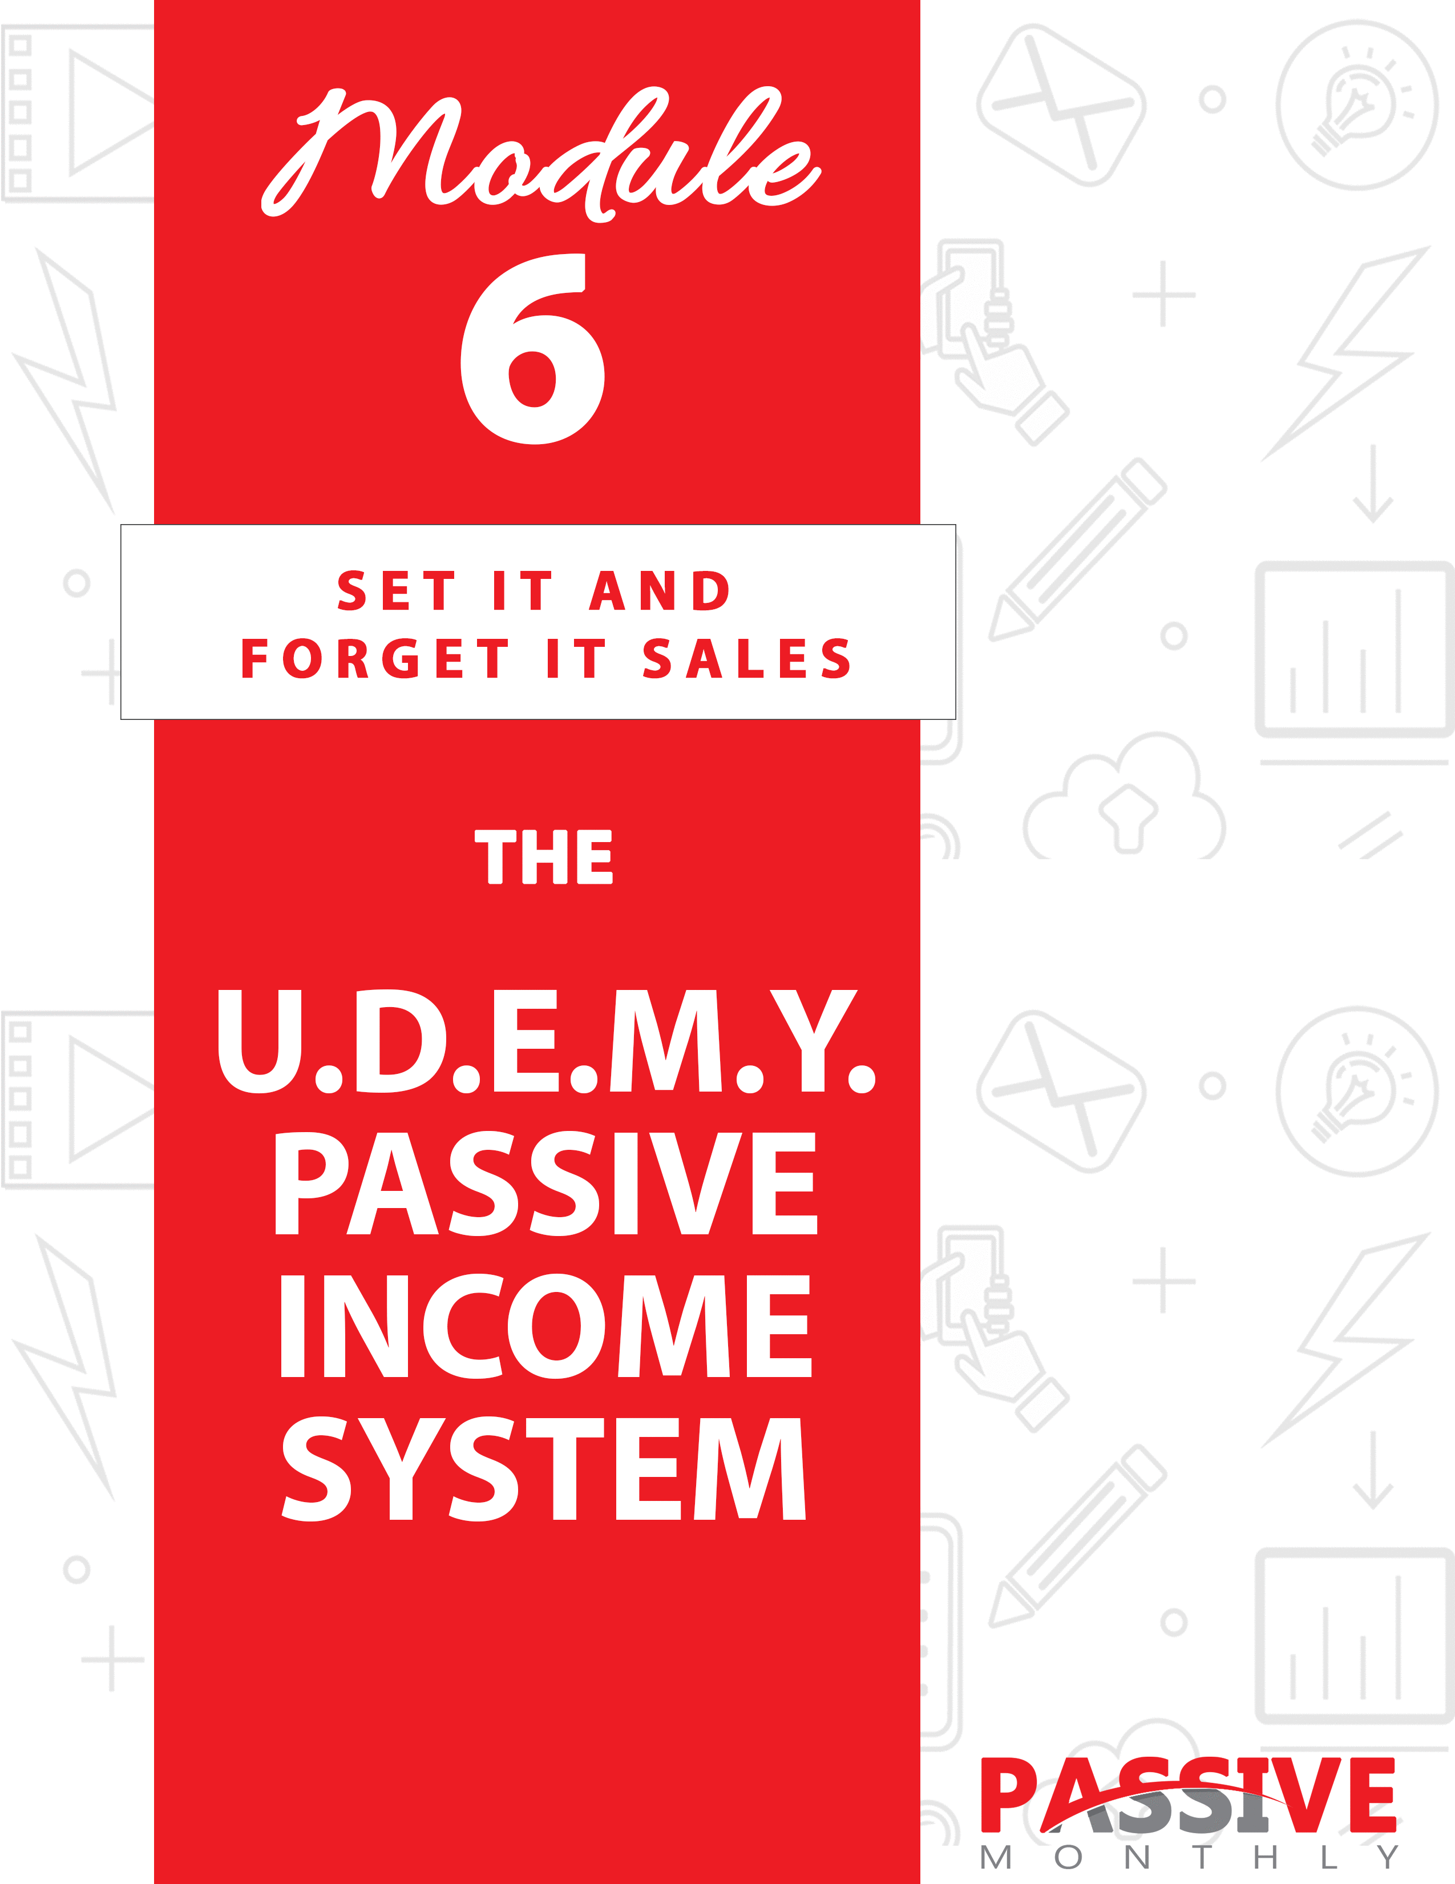

You DO NOT Have The Right To Sell Or Give Away
Any Portion Of The Content In This Document.

This Document Is For Your Personal Use Only

CLICK HERE For Additional Resources
To Help You Build Your Dream Business.

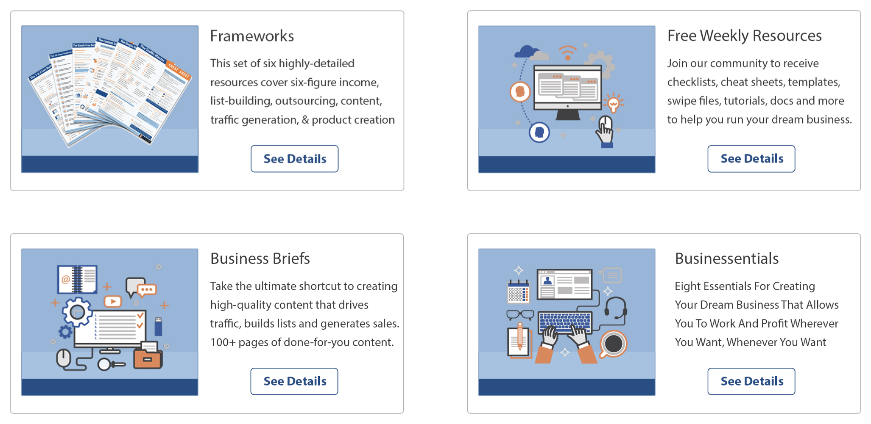

Insert Your Legal Disclaimer / Document Here

Strategy: What Is It?

Welcome to this issue of Passive Monthly!

Today you’re going to learn about a passive-income strategy that will appeal to anyone who recognizes the power of videos. And that’s because you’re about to learn about the U.D.E.M.Y. Passive-Income System!

First off, are you familiar with Udemy?

This is an online platform where you can sell your video courses across a variety of niches and topics. Prospects actually go to Udemy to seek out new courses. And Udemy is also ranked highly in the search engines, so people who are seeking information in Google or elsewhere often end up at Udemy – maybe even on your course information page!

So, that means that Udemy gives you a great deal of help when it comes to marketing your course. That’s part of what makes this a passive income strategy. You create your course, upload it, and profit – it’s a set it and forget it system, as Udemy handles most everything else.

Naturally, you’re going to have a backend system in place. Once you get your backend up and running, this becomes the second part of the passive-income strategy!

Sounds good, right? So you’re probably wondering: How do you set this all up?

The answer: by using my U.D.E.M.Y. Passive-Income System! Here’s a quick overview:

- Understand Your Market: Here’s where you do some market research so that you know what sort of course will best appeal to your audience.

- Develop Your Course: Here you’ll get tips and tricks for creating a course that will engage your audience and keep them coming back for more.

- Establish a Backend: This is where the passive income comes in, as you’ll insert offers into your course to generate a backend income.

- Market Your Course: Here you’ll find out how to sell more courses, which gives you the opportunity for more income both on the frontend and backend.

- Yield Results: Here you’ll get tips and tricks for optimizing your marketing to generate even more sales.

So now you have a good overview of how this all works, let’s take a closer look at each step…

System: How Do You Do It?

The U.D.E.M.Y. Passive-Income System is all about creating high-quality courses with compelling calls to action so that you can make money on the backend. Now let’s walk through each of the steps of this system…

UNDERSTAND Your Market

I’ll assume at this point that you already have a niche market picked out. Now your next step is to figure out what your market wants. And not just what they WANT, but what they’re actually willing to pay for.

Hint: the best way to find out what your market is willing to pay for is to find out what they’re ALREADY buying. And a good place to start that is right on the Udemy marketplace (at www.udemy.com).

What you’ll want to do is search for your niche’s general keywords (such as “dog training” or “online marketing” or “bodybuilding”). Then take note of the following:

- The types of courses that are bestsellers in your niche.
- The types of courses where there are multiple courses on the same topic.

Both of these are evidence that a particular topic is selling well in your niche. These are the sorts of topics you’ll want to pursue, too.

You can further validate that you’ve chosen a profitable topic by looking for interest (and sales) outside of Udemy. This includes:

- Seeing what topics are popular on YouTube.com.
- Checking to see what types of courses your competitors are selling on their websites.
- Viewing paid ads (such as Google sponsored results) to see what topics your competitors are paying money to advertise.

TIP: You can look at general information products (such as books) on marketplaces like Amazon.com and ClickBank.com just to gauge interest in a particular topic. However, if you can’t find videos on these topics, there may be a reason for it. That’s why you need to make sure that your audience not only has an interest in the topic, but they’re also willing and eager to watch VIDEOS on that topic (hence your research on Udemy itself).

Once you walk through all the above steps, it should become pretty clear to you which topics are popular in your niche. You’ll want to pick one that has enduring popularity (e.g., one that isn’t related to any fads, but rather is evergreen). You can check that a topic has enduring popularity by searching for the keywords in Google Trends (https://trends.google.com/trends/).

NOTE: Udemy requires that you create a course that has at least five “lectures” (modules) and 30 minutes of content. As such, make sure you choose a topic that fits these requirements.

Now you may be thinking, “But hang on, how am I going to compete if I choose a topic that’s so popular?”

There are two things you need to know:

- If you choose a topic that is NOT popular, then you’re going to have an uphill battle. Simply put, if a topic isn’t popular, then people aren’t interested, and that means they’re not going to pull out their cash to buy your course. Point is, choosing something popular is going to be profitable.

- In just moments, you’re going to learn how to stand out from the competition. As such, competition isn’t a hindrance when you know how to beat it.

Now the next step of the U.D.E.M.Y. system…

DEVELOP Your Course

Now that you know what topics are popular, it’s time to develop your course. Here are the steps you need to take next…

Step 1: Draft Your Outline

Generally, what you need to do is create a series of lectures (AKA modules) that are five minutes or less each. As mentioned before, Udemy requires that you create a course with at least five lectures (modules) and 30 minutes of content. So be sure your outline reflects these requirements.

Next, you’ll want to decide on the primary goal of your course. In other words, what do you want your users to learn or be able to do once they’ve completed your course?

In order to determine exactly what to put in your course, take these steps:

- See what subtopics similar courses contain (check sales pages on Udemy and other platforms).

- Read user reviews to see what topics/features in the course users really like, and which ones they reviewed unfavorably.

- Review the top products in your niche for yourself in order to determine the strengths and weaknesses of these courses.

The idea behind all this research is so that you make a popular course that’s BETTER than anything on the market right now. That is, you improve on the weaknesses of the current products, while retaining the strengths.

For example, if an online marketing course is knocked by reviewers for not including example ads or templates, then you know to improve your product by including these examples and templates.

NOTE: Part of your outline is going to center on getting viewers to follow a link at the end of your course and take advantage of an offer. This is how you generate money on the backend. We’ll talk about how, exactly, to do this in the “Establish Your Backend” step. For now, focus on creating a course that naturally leads to the action you want people to take when they get to the end of the course.

Go ahead and draft your outline using your market research as a guide. Be sure to split your course into a series of related lectures that are five minutes or less in length. Then move onto the next step…

Step 2: Determine How to Set Your Course Apart

While you’re doing your research on competing courses, you’ll also want to take note of what makes each of these courses different than the other courses. (In some cases, this difference may be the course’s USP, or unique selling proposition.)

What you’re going to do is determine how to create a course that’s different from these competitors. What will make YOUR course stand out?

Ask yourself the following questions:

- Are you in some way uniquely qualified to teach this course? E.G., do you have unique credentials, such as an advanced education, several years spent in the field, or verifiable results for yourself or your clients?

- Are you teaching some tip or subtopic that no else is teaching? It’s a good idea to provide information that your viewers can’t find anywhere else, otherwise there’s not really a good reason for users to buy your course.

- Will you include tools or other features not found in similar courses? For example, if you’re teaching a copywriting course, you might include a full set of sales letter templates. If no one else on Udemy is including these items, then you now have a way to set yourself apart.

- Are you targeting some subsection of the market that your competition has overlooked? For example, perhaps you’ve created a weight loss course for “busy moms” (which includes information about how to exercise and eat right when you’re juggling a family – e.g., such as by cooking healthy meals that the whole family will enjoy, so that the mother doesn’t need to make separate meals for herself and her family).

Go ahead and spend some time brainstorming features and benefits that will set you apart from all your competitors. Then move onto the next step…

Step 3: Decide Your Format

Now you need to decide what type of video course you’re going to create. Your options include:

- Talking head video.
- Screen share presentation (good option if you’re doing something such as showing viewers how to install a WordPress blog or create a JVZoo payment button).
- Slide-share presentation.
- Animated video.
- White board/doodle video.

Note: For best results, you may combine these different presentation styles. This helps keep users engaged and entertained.

For example, you might share tips in your video in a slide-share format. Then when you discuss exactly how to do something, you might switch to a talking head video so that you can demonstrate how to actually perform a task (such as building a raised flower bed).

As such, go through each of your lectures and decide what format will help you best get your information across to viewers while also keeping them engaged and entertained.

Then move onto the next step…

Step 3: Develop Your Course

Now it’s time to develop your actual course.

The first thing you’ll want to do is submit a short test video to Udemy. This is a one to three-minute video that lets you check that your video and audio recording are up to Udemy’s standards. Click here to submit your video: https://support.udemy.com/hc/en-us/articles/229604128-How-to-Create-and-Submit-a-Test-Video

TIP: It’s a good idea to invest in good video, audio and backdrop equipment in order to create a polished presentation. That’s because users WILL judge your course by the quality of the presentation. Check out this page, which shows you Udemy’s recommended equipment: https://teach.udemy.com/wp-content/uploads/2016/01/RecommendedEquipmentList.pdf.

TIP: Are you considering that you may not have the skills, inclination or equipment needed to produce a high-quality video? No worries – you can outsource this task to a professional. Post a project on a site like UpWork.com, or search for a freelance video producer using Google. Just be sure to do your due diligence so that you select a competent professional.

Once your test video has been evaluated by Udemy, then make any improvements as required or suggested. Then you can get down to the task of creating your own video. Keep the following tips and best practices in mind:

- Create a script. Be sure your script sticks closely to the goals for your overall course. Your job is to convey the information in a succinct, useful and entertaining way.

- Be sure you offer high-quality visuals. For example, if you’re doing a slide share video, then be sure to insert professional graphics to make the video more aesthetically pleasing. Or if you’re doing a talking-head video, then be sure both you and your backdrop radiate professionalism.

- Insert practice activities into your course. In other words, assign tasks that help students evaluate themselves or take action. This could be a test that quizzes viewers on what they’ve learned so far, or it could be an assignment to help them put what they’ve learned into action.

- Practice. Before you actually start shooting, spend some time practicing your script, along with any other activities you may do during the video (such as a demo of how to perform some task). You want to be able to deliver the information smoothly without making it sound like you’re robotically reading your script.

- Be prepared to reshoot and edit. Most people can’t do a completely polished lecture in one shoot, which is why you’ll need to be prepared to shoot each lecture multiple times. You’ll
also want to use Camtasia or another video editor to edit the course as needed, so that each lecture is as professional as possible.

- Check Udemy’s guidelines checklist. You can view it here: https://s3.amazonaws.com/udemy-images/support/Course+Quality+Checklist+EN.pdf.

Now the next step, which you actually do simultaneously with the current step…

ESTABLISH a Backend

What makes this is a passive-income system is the fact that you set up an opportunity for yourself to make money on the backend of this course.

Let me make an important note here: Udemy doesn’t hand your customer’s information over to you. Instead, they’ve set up an internal system where they allow you to email your students. However, this opportunity comes with restrictions, including:

- You are limited to only two promotional emails per month. What’s more, the ONLY thing you can promote are your own courses on Udemy. You cannot promote external links, and Udemy doesn’t even want you to promote courses from other instructors.

- You may send educational emails. These are non-promotional, and generally used to engage students, announce an update to the course, or otherwise reactivate them. These are useful for building a good relationship with your students.

Point is, you can’t build an email list of customers directly, since technically your students are actually Udemy’s customers, since they own the platform. And that means you need to find another way to reach your customers.

The solution?

At the end of your course, you’ll want to offer your students a very valuable (and related) resource for free in exchange for their email address. In other words, you’ll direct your students to a lead page. You can also put this link in any text-based course handouts you offer.

For example, if you have a weight loss course on Udemy, then you might offer a low-calorie cookbook and an additional set of meal plans to anyone who gives you their email address.

Another example: your course is about how to create an impressive resume. You might offer a set of resume templates and examples as a freebie to anyone who joins your list.

Now, the key to a passive backend income is to set up an evergreen autoresponder series. Initially, this series should promote something highly related to the course. It might be a tool or service that people need, or even “Part 2” of the course.

For example, if your course is about setting up a blog, then you might sell a WordPress plugin in your autoresponder series.

Your initial series should be three to five emails, with each one focused on selling the paid product. In sticking with the previous WordPress plugin example, you might create a five-part email series called “The Five Success Secrets Every Blogger Ought to Know.” Each email would share one secret, along with a pitch for your plugin at the end of the email.

Of course, you’ll want to add more evergreen emails to your autoresponder series beyond those first three to five. For example, if you upload (over time) an additional 52 emails that go out on a weekly basis, you’ll have a full year’s worth of content going out automatically. This is a completely hands-free way for you to make money on the backend of your Udemy course!

So, let me give you one more example to show you how it all works…

You’re selling a Udemy course on the topic of organic gardening.

You offer a free pest identification video to anyone who joins your list.

Your autoresponder series focuses on how to get rid of the most common pests, such as aphids.

You then sell a pest-control book on the backend via this autoresponder series.

In future emails, you sell physical items such as pest-control sprays, plant disease identification and prevention courses, and general tips for creating healthier gardens.

Now the next step…

MARKET the Course

Now it’s time to begin marketing the course, which you begin doing right at the moment you’re uploading the course to Udemy. Put these tips and best practices to work for you:

Create Attention-Getting Titles

This not only refers to a creating a compelling overall title for your course, but also titles for each lecture in your video. That’s because many prospects are going to decide whether to purchase your course or not based almost entirely on these titles alone.

Take note, however, that Udemy prohibits salesy, hyped-up titles. You can read more about their title guidelines here: https://support.udemy.com/hc/en-us/articles/229232467-Course-Title-Quality-Standards.

What they’re looking for are titles that tell viewers exactly what the course is about and, whenever possible, which audience it’s suitable for.

For example: “The Dog Training Course.”

That’s somewhat descriptive, but boring.

Slightly better: “The Beginner’s Guide to Dog Training.”

That’s a little better because it addresses the audience (beginners).

Better yet: “The Beginner’s Guide to Turning a Stubborn Dog Into a Charming Houseguest.”

This is more compelling, because your customers don’t want a dog training course. Instead, they want the end result, which is a well-trained dog. That’s what this course title promises.

Likewise, you’ll want to create benefit-driven lecture titles and descriptions.

Craft a Compelling Udemy Landing Page

Your Udemy landing page is your sales page. This too needs to be compelling, as it’s going to do the bulk of the heavy lifting when it comes to selling your course. That’s why copywriting rules apply here.

TIP: If creating strong, benefit-driven and succinct sales copy isn’t your strong suit, this is a task you can outsource to a qualified copywriter. Search Google for copywriters for hire, or post a project on a site like UpWork.com or Freelance.com.

Your course description should answer the following questions:

- Who is the course for? What niche, and what level (beginner, intermediate, advanced)?

- What is the specific topic of the course? What problem does your course solve?

- What is required for students to view the course? In other words, are there any prerequisites, such as having a familiarity or background in some topic?

- How is the course taught? (E.G., what format for the presentation.)

- What, specifically, will students learn in each lecture? (Be sure to follow Udemy’s quality standards, which you can find here: https://support.udemy.com/hc/en-us/articles/229604848-Lecture-Descriptions-Quality-Standards.)

- How is your course different from and better than other courses? This is the unique selling proposition we talked about before. This is what makes your course standout from similar courses on the same topic.

As always, Udemy is strict about how you present your course. They do not want salesy, hyped-up language here either. Before you submit your course description, be sure it follows Udemy’s quality standards (as they can and will turn down your course if your landing page doesn’t follow their guidelines). Here are the standards you’ll need to adhere to in order to pass their quality review: https://support.udemy.com/hc/en-us/articles/229232407-Course-Description-Quality-Standards.

Advanced Tip: If you know how to research keywords and optimize content for the search engines, then be sure to optimize your Udemy course description for the search engines!

Next…

Advertise the Course

One of the benefits of uploading a course to Udemy is that the platform will help you advertise the course. That’s where another facet of the passive income comes from, as an unique, useful, in-demand course can make plenty of money on the frontend from course sales.

However, Udemy wants to focus on promoting popular courses. And that means it’s a good idea to make your course popular yourself through your own advertising, which in turn will get you good reviews and a good sales ranking, which results in Udemy promoting your course more often.

So, to raise your sales and boost reviews, do the following:

- Tell your mailing list about your course.
- Blog about it.
- Do guest blogging.
- Tell your social media contacts.
- Purchase advertising on Facebook and Google AdWords.
- Ask your joint venture partners to help you promote (and in return, promote their products).

TIP: An advantage to selling the course yourself (without Udemy’s help) is that you make more money for those courses you sell yourself. When Udemy sells one of your courses through their promotional platforms, they take an extra cut of the profits themselves. (Which is fair, but something you should be aware of.)

Related to this…

Make Use of Udemy Promotional Tools

Udemy offers you tools to help you generate more sales, including:

- The ability to distribute discount coupons for your course. You can offer steep discounts to generate interest, especially if this is your first course.

- The ability to offer free courses. This is another good way to bring people into your sales funnel.

- The ability to send a promotional email to your students about your other Udemy courses. This is a good way to generate sales of new and related courses.

Which brings us to the next point…

Create Multiple Courses

Once your students see that you offer high-quality content that solves their problems, they’ll be eager to take more courses from you. And since Udemy lets you email ALL your students with promos for your related courses, this is a great opportunity to make more sales.

The key to success is to create courses that are all highly related to each other. For example, you might create a beginner, intermediate and expert level courses on one topic. For example, you might create beginner, intermediate and expert courses on the art of writing a romance novel.

Or you may create a series of courses on related subtopics. For example, if your main market is online marketers, then you can create a series of topics on traffic-generation strategies (e.g., paid advertising, guest blogging, joint venture marketing, social media marketing, etc.)

And finally…

YIELD Results

Now it’s time to kick up your income-generating potential. Here are tips for doing that:

Test Your Titles

Remember, the title of your course is going to have a major impact on sales. That’s why you’ll want to test your titles.

Since Udemy isn’t your own platform, you obviously can’t test the titles directly on Udemy (at least not by doing a traditional split test with any level of confidence). What you can do is set up a test on your own website with two identical sales pages about your course, with the ONLY difference being the course title. You can then judge interest by how many people click
through.

TIP: You can gather your results fairly quickly by using paid advertising, such as Facebook. You may even use the title of the course as part of your ad copy, and then track clickthroughs on your ad to get an idea of which titles create better conversions for you.

Next…

Collect Reviews

As mentioned, Udemy likes to promote its most popular courses – and that means the platform prefers to promote highly rated courses. That’s why you’ll want to be sure you collect a lot of good reviews.

Here’s how to do that:

- Be sure you’re offering a high-quality course. You may want to enlist the help of beta users during the production phase to offer feedback so that you can improve your course.

- Get your course in front of as many people as possible. This includes you heavily promoting it, of course. However, you may also decide to initially offer the course for free in order to get more buyers (and thus more reviews).

- Specifically ask for reviews. You can do this at the end of your course, as well as in emails you send to your students.

Next…

Build Relationships With Other Instructors

You join forces with instructors who serve the same niche as you. This can be as easy as co-promoting each other’s courses on your respective platforms (newsletter, blog and social media). You might even decide to
work with another instructor to co-create a course.

One good way to meet other instructors is by joining Udemy-related Facebook groups. One example is the Udemy Studio Facebook Group at https://www.facebook.com/groups/427365844137526/.

Quick Recap

You just learned how to put the U.D.E.M.Y. Passive-Income System to work for you. Now that you know the system, let’s take a look at the shortcuts you can use to make even more money. Read on…

Shortcuts: What Else Will Help You?

If you’ve been paying attention to this course, then you can see how selling (or even giving away) courses on Udemy is a great way to bring people into your sales funnel, make money from the sale of courses, and make a passive income on the backend too. Now let me share with you tips to make this system faster, easier, and more profitable for you.

Take a look…

Add Related Content to YouTube

YouTube is the biggest video-sharing platform, so you can bet your audience visits YouTube often and looks for videos on the same topic as your course.

You can take advantage of this. Simply create related videos for YouTube, and offer a strong call to action at the end of the video that points people towards your Udemy course. Better yet, point them towards a lead page where you offer a five-part autoresponder series on the same topic, and pitch your Udemy course at the end of each email. That way, you build a prospect list and market your course to them all hands-free.

For example, let’s suppose you’re selling a course on copywriting on Udemy. You might upload the following types of videos to YouTube:

- An overview video, which shares an outline of your Udemy course without the in-depth instruction.

- A tips video showing people how to improve their sales copy.

- A sales letter critique video, which helps people improve their copy by seeing common mistakes.

- An in-depth video that delves into one subtopic, such as how to open a sales letter in a way that holds interest and engages prospects on an emotional level.

Point is, share free content on YouTube, and you’ll automatically attract the part of your niche audience that really likes watching videos.

Next…

Provide Supporting Material

Udemy lets you share course “handouts” and other supporting materials for students to download (aside from your video course). These files include video files, audio files, image files and text files (such as .PDF).

NOTE: Udemy states that these materials cannot be promotional in ANY manner. As such, you’ll want to offer these materials as a way to create satisfied students who’ll not only leave you a good review, but they’ll also purchase related courses from you.

Here are examples of supporting material you can offer to raise the perceived value of your course and over-deliver to students:

- Offer tools to help students take action. You might offer checklists, templates, planners, cheat sheets, worksheets and similar items. For example, if you’re teaching a Facebook marketing course, then you might offer a set of Facebook advertising templates and a graphics pack that people can use to create their ads.

- Provide supporting videos. For example, if you’re offering information to personal trainers, you might create a video exercise library to refresh their memory on how to do a variety of exercises.

- Offer course transcripts. Some people prefer to follow along when they’re watching a video. Others will simply appreciate having the course content in text form for easy reference.

Next…

Price Your Course High

Udemy students tend to be bargain hunters. What’s more, Udemy will often authorize steep discounts. As such, if you price your course too low (and you’re not using it as a tripwire product), you’re going to practically price yourself right out of a good commission.

Of course your pricing should factor in your sales funnel strategy. In other words, entry level products should carry lower prices. However, your flagship offers (core offers) should carry price tags that match value. For example, if you have an in-depth course that’s an hour or two long, don’t be afraid to price it at $97 to $197. This conveys value – and the discounts offered will create urgency. Together, these factors will lead to sales.

Next…

Copy Your Own Success

Occasionally you’re going to have a course take off in a way that even you didn’t expect. When this happens, reverse engineer your own success. Look at factors such as:

- The topic.
- How you positioned the course in the market.
- The price.
- The title and lecture titles.
- The course descriptions.
- The presentation style.

When you hit a home run with one course, copy your own success and try to replicate it across other similar courses.

And finally…

Build Your Brand

It’s a good idea to create a strong brand, and then integrate this brand across your courses. It should appear on your landing page as well as within each lecture (such as your logo in the corner).

This is important, because a strong brand will build top of mind awareness and trust. Together, these two factors lead to more sales in the long run.

Now let’s wrap things up…

Conclusion

And there you have it – you just found out how to take advantage of the U.D.E.M.Y. Passive-Income System!

As you discovered, you make money passively both on the frontend (since Udemy helps you market your course) as well as on the backend. Here’s a quick recap of the system:

- Understand Your Market: Here’s where you do some market research so that you know what sort of course will appeal to your audience.

- Develop Your Course: Here you received tips and tricks for creating a course that engages your audience and keep them coming back for more.

- Establish a Backend: This is where the passive income comes in, as you’ll insert offers into your course to generate a backend income.

- Market Your Course: Here you found out how to sell more courses, which gives you the opportunity for more income both on the frontend and backend.

- Yield Results: Here you learned tips and tricks for optimizing your marketing to generate even more sales.

So now that you have this system in hand, your next step is simple – take action on what you just learned! I suggest you go to www.udemy.com, familiarize yourself with the site, and start doing your market research as soon as possible!

