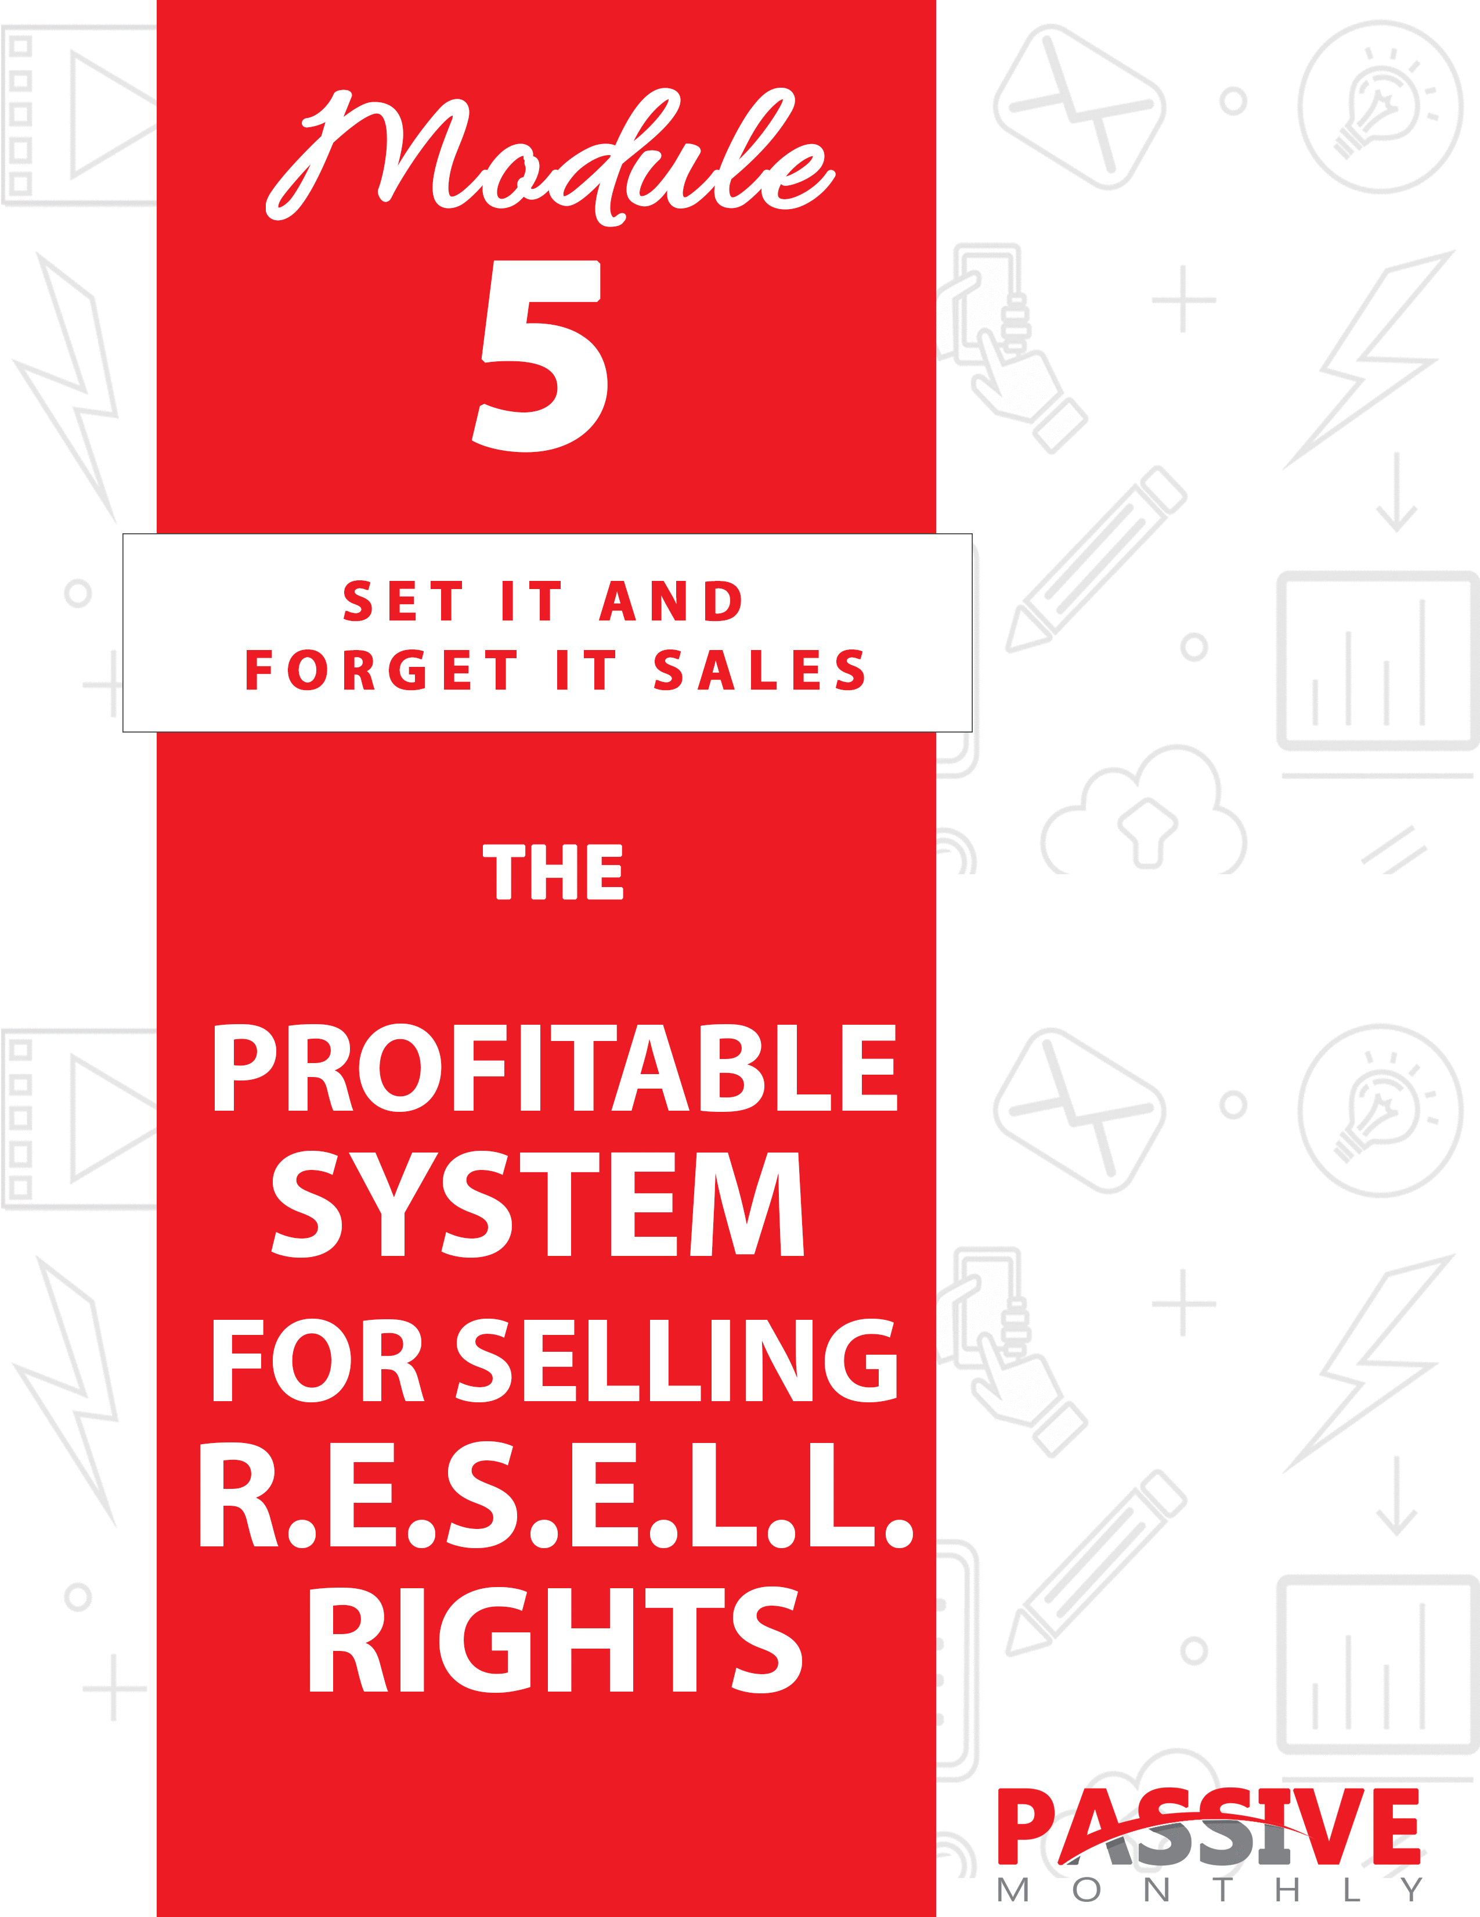

You DO NOT Have The Right To Sell Or Give Away
Any Portion Of The Content In This Document.

This Document Is For Your Personal Use Only

CLICK HERE For Additional Resources
To Help You Build Your Dream Business.

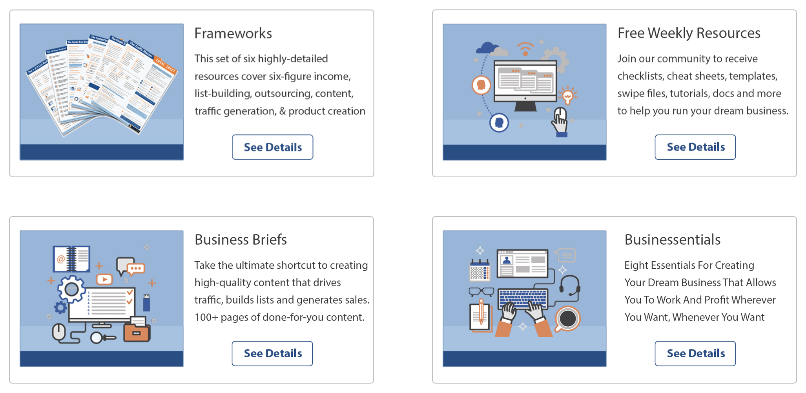

Insert Your Legal Disclaimer / Document Here

Strategy: What Is It?

You’ve been learning about different ways to generate a passive income from the same business. And now in this issue you’re going to learn all about the R.E.S.E.L.L. Rights System! What is it?

The R.E.S.E.L.L. Rights System is where you evaluate your existing products, choose a popular one, and license other people to resell that product.

The benefit for you is that you generate money in two ways:

- You generate money on the frontend through the licensing of the product. And because you’re selling resell rights to a proven product, you generally can charge a premium for these licenses (especially if you put a cap on the licenses you sell).

- You generate a passive income on the backend. Since you’re selling resell rights and NOT modification rights (PLR), the links inside your product remain intact. That means you’ll continue to make money on the backend whenever someone purchases an offer from the links within your product.

You can see why this is such a profitable system both on the frontend and backend of your business. Let’s take a closer look at how it all works…

System: How Do You Do It?

Let’s start with an overview of the R.E.S.E.L.L. Rights System:

- Review Sales: here’s where you determine which products to license.

- Evaluate Content: at this step you tweak the content to update it, ensure it’s evergreen, and polish your backend offers.

- Streamline Selling: here’s where you make it easy for your buyers to sell your product.

- Elevate Value: this step is all about making your resell rights package more attractive to prospective buyers.

- Limit Your Licenses: this is where you decide whether to cap the total number of licenses, as well as what terms to include in your resell rights licenses.

- Launch Your Offer: once you’ve completed all the above steps, then you can focus on marketing your resell rights offer.

Now let’s look at each of these steps in more detail…

Review Sales

Sometimes marketers offer the resell rights to their products that aren’t selling all that well. They figure it’s one way to make money from the product (by selling resell rights licenses) before they retire the product from their own lineup.

However, for this particular strategy, you want to choose products in your sales funnel that ARE selling well – really well. And that’s because this strategy hinges on your license buyers selling a lot of products, which in turns means the backend links within your products get a lot of exposure (and generate a lot of sales for you).

As such, the first thing you need to do is review your sales records for your products. Ask yourself the following questions:

- Which of your products are bestsellers? Again, you want to choose products that are proven sellers so that your backend links get as much exposure as possible. In addition, products that are proven sellers are also more attractive to your prospective license buyers – and that means more brisk frontend sales for you (and premium prices for licenses).

- Which of your bestsellers generate the most sales on the backend? Sometimes you may have a product that sells well, but it doesn’t generate many sales on the backend. If you have a bestseller that does this, you’ll want to consider why that is. Specifically, are you not promoting the right offers? Is the sales copy within the product not strong enough? It’s worth tracking, testing and tweaking these factors to determine if you can boost the backend income.

- Can you bring up the performance of products that aren’t selling as well? Sometimes you may have a product that doesn’t sell particularly well—meaning you don’t get much exposure for those backend links—yet you’re getting good conversions for the small amount of exposure. In those cases, you want to look at whether you can boost the sales of the product.

How? You’ll need to determine why the product isn’t selling. Possibilities include:

- There is no demand for the product. You’ll need to do your market research in order to determine if this is true.

- The product title isn’t appealing. People often make decisions about whether to purchase a product based largely on the title. You’ll need to test and track a variety of titles to see which ones produce the most sales.

- The product isn’t at the right price. If it’s too high, prospects may think they can’t afford the product. If it’s too low, people may think the product is junk. That’s why you need to test prices to see which ones produce the best conversions for you.

- The sales copy could use some work. You could have the best product in the world, but sales might be crawling if your sales letter doesn’t do an effective job of conveying the benefits. Your headline is going to be one of the bigger factors to affect conversions, but you’ll also need to look at your benefit list, call to action, guarantee, whether you handled objections effectively, whether you built value for the product, and your overall positioning and offer. Because the sales copy has such a big impact on conversions, you may want to enlist the help of a professional copywriter to get it right.

- The sales page design needs to be improved. Sometimes the sales copy may be compelling, but the design is causing people to click away. Be sure the design looks professional, and that it matches the overall “feel” of your product.

- The sales funnel as a whole could use some work. For example, maybe your lead magnet isn’t doing a good job of selling your tripwire product. If you improve the call to action inside the lead magnet, then perhaps you’ll increase sales on the tripwire product.

These are just some of the factors that can affect conversions, sales and backend profits. It’s your job to ferret out which factors you can tweak to improve conversions both on the frontend and backend. Then choose which of your better-selling products you want to license to others.

Now the next step of the R.E.S.E.L.L. Rights System…

Evaluate Content

Now that you’ve selected one or more product that you’d like to license to others, your next step is to evaluate the content to be sure it’s updated, evergreen, and does a good job of selling your backend offer.

Let’s look at these three items in more detail…

1. Update the Content

First things first: you need to be sure that your content and links are up-to-date. Check for the following:

- Are all links in working order? First, you want to double check that you’ve typed in the correct link and that it goes through to the right web page. Secondly, you want to be sure that you still WANT to point readers towards that particular web page. If you’ve found a better resource, product, etc., then you may want to change links. (More on that in a moment.)

- Do third-party links redirect through your own site? Sometimes third-party links change or go to 404s (page not found). Sometimes you simply don’t want a particular link in your product anymore. As such, that’s why you’ll want to redirect all third-party links through your own website. That way, you can change a link through your own website, rather than having thousands of copies of your product floating around with dead or unwanted links.

TIP: The other advantage of having links redirect through your own website is that it allows you to track how many times people are clicking on those links.

- Do you want to change any of your product recommendations? Since you first created your product, other recommended products and services may have entered the market – and these products may be superior. As such, consider if you want to change any recommendations.

TIP: One way to keep your options open is to send visitors to a page on your website where you list your recommendations. That way, you don’t need to list a product or resource recommendation directly in your
product (which you may want to change in a year or so from now). This is part of making your product evergreen, which we’ll talk about in more detail shortly.

- Do you need to update any of the content? Take a good read through the content and determine if anything needs to be updated.

Now, keep in mind that “updated” content does NOT mean you fill your content with “fads” or other information that’s likely to be outdated in the future. Which brings us to the next point…

2. Ensure the Content is Evergreen

You want to make sure your content is “time tested” and proven, meaning it’s relevant today, it will be relevant tomorrow, and it will remain relevant for months and years to come. That way, the resell rights product will keep generating an income for you on the backend.

Here are tips and tricks for ensuring the content remains relevant:

- Don’t specifically name offers or recommendations, especially from third-party vendors. That way, you haven’t tied yourself down and you’re free to change the link (via a redirect through your own website). This applies whether you’re promoting an affiliate link or a direct link.

For example, let’s suppose your content is talking about how to set up a mailing list. And let’s further suppose that you want to recommend an autoresponder. Within your content, you may simply say something such as, “Click here to see which autoresponder I recommend.” You don’t name the autoresponder in case you change your mind later, and you run a redirect link through your own website so that you can change the link at any point.

- Remove any references that date the content. For example, if
you talk about a historical event (such as a specific presidential election) as if it happened recently, people will know when you created the content. And if the event happened some time ago, your readers may then assume the content is outdated.

- Remove pop culture references. Certain music, movies, TV shows, celebrities and other pop culture references may be really hot right now, but adding them to your content will date the content (and cause the content to become outdated). So be sure to avoid these references.

- Be wary of stating statistics/data. For example, if you talk about what percentage of people exhibit some behavior or characteristic, it’s possible that data will change over time – and then your content will become outdated. And if you state the year the specific data was collected, then you’re further dating the content. That’s why it’s best to avoid this sort of information if possible.

- Avoid references to untested strategies, products or services – and stick to time-tested ideas.

For example, let’s suppose you’ve created a dieting guide. You’ll want to avoid any mention of fad diets, while sticking to advice that’s scientifically proven to work (such as reducing calories and upping exercise).

In short, comb through your product carefully to determine if there is anything that either dates your content, or could become outdated at a later point. Remove those references, replace them with evergreen content and recommendations, and then move onto the final point…

3. Sell the Backend Offer

Finally, as mentioned before, you need to determine if your backend offers are selling well from within the product. Check these points:

- Have you selected the right offer? You may want to do some testing to see which offers your audience responds to the best. One quick way to do this is by split-testing via email – you can send two offers to see which ones perform the best.

- Are you doing a good job selling that offer? Again, you may need to do some testing in order to sharpen your sales copy and call to action. You can do your preliminary testing via email, or even through a paid advertisement on Facebook or Google AdWords. Once you’ve improved conversion rates, then you can copy your winning ad directly into the resell rights product.

Now that you’ve evaluated your content and tweaked it as needed, let’s look at the next step of the R.E.S.E.L.L. Rights System…

Streamline Selling

Your next step is to determine how to make it easier for your license buyers to resell the product. There’s a twofold reason for this:

- The easier you make it for license holders to sell the product, the more attractive the resell rights license becomes. Many of your buyers are going to be a bit on the lazy side. So, when they have the choice of buying a resell rights product with or without a sales letter and other materials, you can bet they’re going to pick the one with the materials. That way, they can start selling the product immediately after the purchase their license.

- The more products your license holders sell, the more YOU benefit. Again, keep in mind that this strategy is all about pulling in a passive income from the links embedded in your products.

So, with these benefits in mind, here’s how to streamline the process of selling the product for your license holders:

- Provide a professional, proven sales letter. Offering a sales letter is great – but offering a PROVEN one is even better. This means you should track and test your sales letter to optimize conversions, and let prospective buyers know what sorts of conversion rates the letter pulls.

- Provide a sales page design. In other words, provide the layout, design and graphics for the sales letter so that all people need to do is insert their own order button, upload the page, and they can start taking orders.

The above two items are really the bare minimum to provide to your license holders. You might also offer the following:

- Autoresponder emails. Here you might create a three to five-part autoresponder series that’s designed to sell the product.
For example, if the resell rights product is a Facebook marketing book, you might offer a series called “The Seven Secrets for Selling Loads of Products on Facebook.” Each email would include one “secret” plus a pitch for the product.

Just as with the sales letter, this autoresponder is going to be even more valuable to the resell rights license holder if it’s a proven series. In other words, test it out yourself, tweak the subject lines and calls to action for maximum conversions, and then offer it in your resell rights package.

- Social media blurbs. These might include short, medium and long pieces of content for buyers to post on Twitter, Facebook, LinkedIn and other platforms.

- Blog articles. For best results, offer a proven series of articles that are designed to boost conversions on the paid product.

- Videos. Here you can provide slide-share videos, demo videos or other content for your license holders to load to their blogs and
other platforms to help them sell the product.

- Lead magnet(s). You can offer one or more lead magnets to attract people into the sales funnel and promote the resell rights product.

- Ads. Generally, these are short ads that your license holders can place in emails, on blogs, on even on pay per click platforms like AdWords. As always, these will be more valuable if they’re already proven to work.

Again, not all of these items are absolutely necessary in order to sell your resell rights package. But they DO streamline selling for your license holders – and even better, these items elevate the value of your overall resell rights package.

Which brings us to the next step of the R.E.S.E.L.L. Rights System…

Elevate Value

As mentioned above, providing sales materials (especially proven sales materials) elevates the value of your overall offer. That means you can charge a premium price for your package if you so choose. Certainly, providing a valuable package will create satisfied customers who’ll come back to you again and again.

However, adding proven sales materials isn’t the only way to elevate the value of your resell rights offer. Consider these options as well:

- Add bonus materials. Here you offer products (also with resell rights) that your license holders can use as bonuses when they’re selling your main product. A good bonus tends to boost conversions, plus these products give you another backend income opportunity.

- Let buyers change links in your products. If you’re selling your
own products via the links inside your resell rights products, then one way to make your valuable more offer is to let license holders change these links to their own affiliate links. That way, both you and your license holders passively make money on the backend.

- Provide your product in multiple formats. For example, you might offer a video version, an audio version and a text version. Your license holders can offer all versions in one package to boost the value of the offer, or they may decide to offer the video and/or audio versions as upsells.

- Create upsells. Here you offer a related resell rights product for the specific purpose of giving license holders an order-form upsell. For example, if you’re offering the rights to a dieting guide, then you might offer the rights to a low-calorie cookbook as an upsell.

- Offer backend products. Same idea as above, except here you’re offering related products for license holders to sell on the backend to their customer mailing list. If you do offer this, then be sure to include follow-up emails to sell the offer, as well as a sales page.

- Offer other bonus services. For example, if you’re able to offer web hosting, then you might offer free sales page and download page hosting to all of your resell rights holders.

- Provide instructions for your buyers. The idea here is to provide marketing instructions for your buyers so that they’ll maximize sales. For example, you might provide a 30-day plan that gives them a new traffic-generation and marketing task each day over the course of a month.

These are just a few ideas of the most popular ways to boost the value of your resell rights package. At a minimum, it’s a good idea to include the proven sales materials and a bonus product to boost conversions. Depending on your audience and the price of your resell rights package, you may offer some of these other perks to elevate value.

Once you’ve decided what all to include in your package, then move onto the next step of the R.E.S.E.L.L. Rights System…

Limit Your Licenses

Your next step is to decide the following:

- How many licenses you’ll sell, and for what price.
- What terms to include in your licenses.

Let’s look at these separately…

How Many Licenses? What Price?

A general rule of thumb is that a license costs around five to ten times the value of the product.

For example, let’s suppose you’ve been selling a product for $20. You can then sell the resell rights license to that product for around $100 to $200. That’s five to ten times the cost of the product.

Another example: for a $50, you’d sell licenses for between $250 and $500.

This is just a rough guideline, however. What also comes into play is how many licenses you intend to sell. If you’re capping the licenses to just a couple hundred, then you can command a higher price per license. That’s because the smaller number of competitors makes the resell rights license more valuable.

For example, if you have a $50 product that is proven to sell well, and you’re capping licenses to 100 buyers, then you can sell these licenses on the upper end of the price range (closer to $500).

On the other hand, if you sell several hundred or more licenses, then you’d sell them for a lower price. For example, you might sell 500 of these licenses for a $50 for as little as $100.

So, how do you know which price to pick?

Answer: do your market research. Find out how much similar resell rights packages cost in your niche, paying special attention to how many licenses are being sold. Keep in mind too that your goal is get exposure to the links inside your products, so selling a bigger number of resell rights licenses is more beneficial to you.

Now the next point to consider…

What Terms?

The terms for your resell rights license is actually a legal matter, which is why I can’t offer you specific advice about what to include in your license. However, I’ve provided you with a list of questions to answer that will help you shape your license with the help of your attorney.

Ask yourself the following:

- What is your suggested minimum price for the product? Generally, you can’t enforce a specific price, but you can suggest one. Have your attorney craft this statement in a way that doesn’t get you into legal trouble.

- Can license holders edit the links in the product?

- Can they edit anything else within the product?

- Can license holders:

- Give the product away?
- Include the product in a membership site?
- Bundle the product with other similar products?
- Offer the product as a bonus alongside another paid product?

- Can license holders edit the marketing materials you provide?

- Can license holders edit the cover graphics?

- Can license holders sell a physical version of the product?

- What else can license holders do with the product? What else are they prohibited from doing?

Consider these different options, then consult with a lawyer to draw up your license. Then move to the final step of the R.E.S.E.L.L. Rights System…

Launch Your Offer

Now you’re ready to launch your offer. What you’ll need to do is create a sales letter for this offer, and then you can start promoting it. Here’s how:

1. Start an Affiliate Program

This is a good way to sell resell rights offers, particularly if you’re selling several offers. You can quickly and easily launch your offers on platforms such as ClickBank.com or JVZoo.com, both of which have affiliates who actively scour the sites looking for new offers.

However, in order to make the most of your affiliate program, follow these tips:

- Provide swipes and marketing materials. Make it “copy and paste” easy for your affiliates to advertise your offers.

- Offer minimum 50% commissions. This helps you attract the most affiliates, since 50% is generally considered the minimum commission rate for most digital products.

- Advertise your affiliate program. Blog about it, tell your social media followers and subscribers, include it in signature files, and so on. Be sure to also include a prominent link to your affiliate program on most pages of your website.

- Nurture relationships with top affiliates in your niche. Give them extra perks (such as higher commissions and co-endorsements) in exchange for promoting your resell rights offers.

Next…

2. List in Resell Rights Marketplaces/Groups

Another way to sell your product is by listing it in marketplaces that accept resell rights. Generally, these are online marketing forums and similar places where your target market tends to congregate.

Here are a few examples:

- Facebook groups that accept selling. Search for terms such as “business” and “online marketing” to uncover groups, and then check that the groups allow selling.

NOTE: Another idea is to start your own “swap and shop” marketing group!

- The “Marketplace” section of WarriorForum.com.

- The TradeBit.com marketplace. (This is a selling platform, so if you choose to sell on the platform, then your product will be listed in the searchable marketplace.)

- List on eBay.com. Take note that resell rights tend to be quite cheap on this site, so think carefully before listing (as your product may be devalued). If, however, you’re looking for maximum exposure, then this is one more platform in which you
can get that exposure.

Next…

3. Place Other Paid Ads

You can also place paid ads (either graphical ads or text ads) on other sites. These include:

- The Facebook ad platform, which lets you zero in a targeted market.

- Google AdWords, which is where you can show your ad to people who search for a specific keyword (e.g., “buy resell rights ebooks”).

- Ads on marketing-related subreddits on Reddit.com. Here you can get relatively inexpensive advertising on a large site. Just be sure to pick the correct subreddit in which to advertise.

- Ads on niche sites. Here you’ll search for sites that focus on resell rights which also accept advertising. Do a Google search for “resell rights” to find these sites.

In all cases, be sure to start small and scale up only once you’ve discovered whether a specific venue produces results for you. Be sure to also test and track your campaigns so that you know what really works.

Now that you’ve gotten a good look at this overall system for selling R.E.S.E.L.L. rights products, let’s take a look at how to kick things up a notch…

Shortcuts: What Else Can Help You?

Are there ways to make the whole R.E.S.E.L.L. Rights System faster, easier and more profitable?

You bet. And that’s exactly what this section is about. Check out these shortcuts and other ideas…

Splinter Products

Do you have a large product (such as a course) that sells really well, but you don’t really want to sell the resell rights to this product?

Here’s an idea: splinter the product, and then license that smaller portion to be resold.

For example, let’s suppose you have a 10-module course. You can splinter off one of the most popular modules, license it to be resold, and then include links inside that module for people to purchase the full course.

Your resell rights buyers will love this, because you can let them use their affiliate links inside the splintered portion of the product. And both you and your licensees will love the big conversions. That’s because anyone who purchases and loves the splintered product will be very eager to update to the full version of the course.

Sell Your Sales Funnel

Now here’s the flip side of the above strategy. Instead of licensing a small portion of a larger product, you may instead decide to license the whole shebang – in other words, license your entire sales funnel.

Your license may include:

- The lead magnet.
- The tripwire product.
- The core offer.
- Bonus products to go with the paid products.
- The email content to send follow ups to both prospects and customers.
- The lead page and sales letters.

Now, typically, your lead magnet would sell your tripwire product, and your tripwire would promote the core offer, and the core offer would promote other backend offers.

In this case, you’d insert OTHER offers into all of these products so that you’d profit when someone purchased an offer though any of these products. Naturally, you’d let your license holders insert their affiliate links so that they can make money on the backend too.

The advantage of this sort of system is that buyers get a complete “done for you” package that they can put to work in their business immediately. And the advantage for you is that your proven sales funnel gets widely distributed, which means more people seeing your backend links.

And finally…

Create Products With Resell Rights in Mind

You can save yourself a lot of time in the future by planning to sell resell rights to a product while you’re still in the product development stage.

Does this mean that you’ll want to license every product you create? No, of course not. You may decide for a variety of reasons to NOT sell the resell rights to some products. For example, you may decide that you don’t want to license one of your best and most profitable products, simply because licensing can at times devalue a product slightly – and you lose control over distribution.

However, it’s still a good idea to at least consider that you may sell resell rights to a product even while you’re still in the development phase. Here’s how this saves time:

- You can be sure to promote the right offers. Since you want your resellers to make money on backend offers, you can choose to promote your own offers (and let resellers insert their own affiliate links). If you promote affiliate offers, look into two-tier affiliate programs, which means you make money whenever an
affiliate in your downline sells a product.

- You can craft a sales letter that’s suitable for resellers. For example, you don’t want the sales letter to be from YOU. Sure, to a degree it’s about you because it’s your product, so your name will be on it. But prospects expect the sales letter to be from the reseller, so you’ll need to keep other personal references out of the letter.

- You can create other marketing materials with your resellers in mind. For example, if you intend to include a series of emails for resellers to use, then you’ll want to craft emails that don’t sound like they’re coming directly from you. In essence, you want them to be more generic so that any reseller can copy, paste, and use them immediately.

In short, you’ll save time (and money) if you expect that you might license a particular product in the future.

Now let’s wrap things up…

Conclusion

You made it to the end, and I’m guessing your head is swimming with ideas. This is a pretty exciting way to make a passive income, especially since we’re talking about your existing products. That means you’ve done the vast majority of the work already!

Let’s quickly recap the R.E.S.E.L.L. Rights System:

- Review Sales: here’s where you determine which products to license.

- Evaluate Content: at this step you tweak the content to update it, ensure it’s evergreen, and polish your backend offers.

- Streamline Selling: here’s where you make it easy for your buyers to sell your product.

- Elevate Value: this step is all about making your resell rights package more attractive to prospective buyers.

- Limit Your Licenses: this is where you decide whether to cap the total number of licenses, as well as what terms to include in your resell rights licenses.

- Launch Your Offer: once you’ve completed all the above steps, then you can focus on marketing your resell rights offer.

That’s all there is to it. This is such a simple system that you could be up and running with it in as little as a day or two from now. So go ahead and get to work putting this system in place – because the sooner you do, the sooner you’ll start reaping the profitable (and passive!) rewards!

