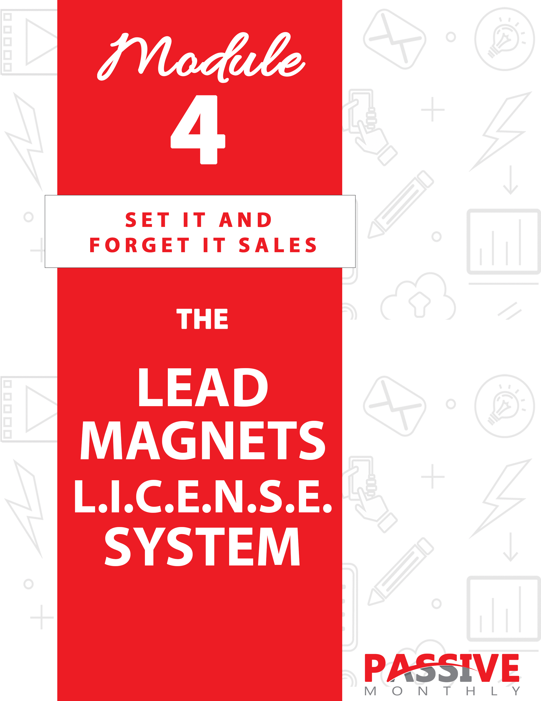

You DO NOT Have The Right To Sell Or Give Away
Any Portion Of The Content In This Document.

This Document Is For Your Personal Use Only

CLICK HERE For Additional Resources
To Help You Build Your Dream Business.

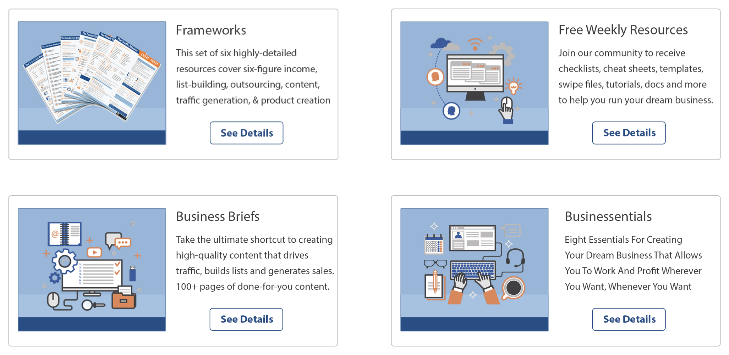

Insert Your Legal Disclaimer / Document Here

Strategy: What Is It?

Welcome to another passive-income strategy! This time we’re going to talk about lead magnets licensing.

So, first things first: you’re probably wondering what this strategy is all about. Let me give you a quick overview…

Lead magnets licensing is where you sell the giveaway rights to lead magnets such as reports, infographics, checklists, worksheets, templates, swipe files, planners and similar tools. That way, your buyers can give these products away to build their mailing lists.

This is a profitable strategy, because online marketers have a constant need for lead magnets and other freemiums. Most marketers aim to create new lead magnets on a monthly basis – some aim to create them on a weekly basis. Either way, marketers have a consistent need for more lead magnets. And it’s a job that not everyone wants to do.

The benefit of this strategy for you is that you profit in two ways:

- You make money on the frontend. You’ll make a chunk of change every time you sell a license to another marketer or other business owner.

- You make money passively on the backend. That’s because you’ll embed your offers in these lead magnets, so you’ll make money whenever someone buys one of your offers. And since you’ll have dozens or hundreds of marketers distributing your lead magnets, you’ll get a much bigger distribution than you’d be able to achieve yourself.

Bottom line: once you license and sell lead magnets, you’ll have a whole lot of them floating around making money for you… completely hands-free. This is a “do it once and profit for years to come” type of model.

So, how do you do it? That’s what you’ll learn next. Read on…

System: How Do You Do It?

What you’re about to discover is the Lead Magnets L.I.C.E.N.S.E. system for creating and selling the licenses for these products. Here’s an overview of the system:

- Learn About the Market: You can’t create good offers unless you know what the market wants.

- Investigate Options: Here’s where you decide what type of lead magnet to create. E.G., checklists, worksheets, planners, etc.

- Create Your Lead Magnet: Here we’ll talk about some of the different ways you can create your lead magnets quickly and easily.

- Embed Offers: This is where your passive income comes in, so we’ll focus on how to create offers that are sure to sell like crazy inside your lead magnet.

- Name Your Terms: In this step you’ll consider what terms to include inside your license.

- Sell Your Lead Magnet: Here’s where you’ll get tips and tricks for selling your licenses.

- Evaluate Follow Up Offers: Once you have a list of buyers, you’ll want to send them follow-up offers. Here’s where we’ll discuss this part of the strategy.

Let’s take a closer look at each of these steps…

Learn About the Market

For this step, you need to choose a target market. What you’re looking for is a large, popular, evergreen market. You need to find a market with a lot of
customers AND a lot of marketers serving those customers. That’s because these marketers will become YOUR customers (they’re the ones buying your licenses), and their customers are going to buy your offers on the backend.

Big markets include all the usual suspects, such as:

- Online marketing/make money online.
- Weight loss.
- Fitness.
- Travel.
- Health and beauty.
- Pets.
- Hobbies.
- Weddings/marriage.
- Relationships/family/kids.

… And so on.

Chances are, you already have a market selected (as you’re setting up other passive income streams within your existing business). So, what you need to do is discover what your market wants.

Specifically: you need to find out what your customers’ customers want – in other words, what the end market wants. These are the people who will be reading and using the lead magnets. Because once you determine what they want, then you’ll know what YOUR customers (the license holders) want. (Your license holders want popular lead magnets within their niche.)

How do you figure all of this out?

Simple: you find out what sorts of products are already popular in your niche, and then you just create something similar yet better.

The #1 way to figure this out is by finding out what the market is ALREADY buying. So, when you’re licensing products, you’re actually going to be looking at two things:

- What the end users are buying. If they are buying products on a particular topic, then you know they’ll be interested in lead magnets on that same topic. So all you have to do is go to marketplaces such as ClickBank.com and Amazon.com and search for your niche keywords to see what sorts of products are selling well in your niche.

- What your license holders are buying. Generally, once you know what the end users are buying, then that’s what your license holders will be interested in too. But you can do some research on ClickBank.com, JVZoo.com and similar sites to see what types of resell rights in your niche are selling well. Pay attention not only to the topic, but also the format (reports, tools, etc.). We’ll talk more about this in just a moment.

Once you’ve completed this research, then move onto the next step.

Investigate Options

At this point you’ve definitely selected a topic for your lead magnet, and you may have notes about what sorts of formats are popular (e.g., checklists, templates, etc.). Now it’s time to investigate your options and make a final decision about the format.

Here are the most popular formats for lead magnets:

- Reports. E.G., “The 7 Psychological Sales Triggers Every Copywriter Ought to Know.”

- Cheat sheets. E.G., “How to Set Up and Customize a WordPress Blog.”

- Checklists. E.G., “What to Pack for Your European Vacation.”

- Worksheets. E.G., “How to Create a Budget and Get Out of Debt Fast.”

- Templates. E.G., “A Proven High-Converting Sales Letter Template.”

- Swipes. E.G., “101 Surefire Sales Letter Headlines.”

- Planners/Calendars. E.G., “The Professional Blogger’s Publishing Calendar.”

- Gear lists. E.G., “Ten Tools Every Social Media Marketer Ought to Use to Boost Profits.”

- Infographics. E.G., “The Ins and Outs of Creating a Bestselling Romance Novel.”

If it’s not clear from your research which of these formats is most desirable in your market, then you’ll determine which one to choose based on what you’re selling on the backend. In essence, you’ll pick the format that most naturally flows to the paid product.

Let me give you a few examples:

- You’re selling a resume-writing course. You can license a resume template as a lead magnet for your customers to give away to their customers.

- You’re selling a copywriting course. You can license a set of headline swipes to give away.

- You’re selling a book on blogging. You can license a toolkit of blogging tools such as a blogging checklist and publishing calendar.

So the point is, figure out what you’re selling on the backend FIRST – and then use that information to decide which lead magnet will best help you sell that product.

Which brings us to the next step of the L.I.C.E.N.S.E. system…

Create Your Lead Magnet

Now it’s time to get down to the actual work of creating the lead magnet that you’re going to license to others to giveaway. Here are your options:

- Do it yourself.
- Start with PLR.
- Outsource it.

Let’s look at these three options more closely…

Do It Yourself

This is exactly what it sounds like: you create the product you intend to license yourself.

This is a great option if you know you can create a high-quality end product, and you have the time and inclination to do so.

However, if you intend to create multiple lead magnets for your customers to give away, then doing it all yourself can quickly become time consuming. This passive-income strategy suddenly doesn’t seem so passive. And that’s why you’ll want to consider the next two options mentioned below…

Start With PLR

The idea here is to save yourself some time and/or money by starting with private label rights content, tweaking it to fit your needs, and using the end product as your licensed lead magnet.

Before we jump into details, here’s one very important note: Make absolutely SURE that you’re getting “unrestricted” private label rights. By unrestricted, I’m referring to PLR content where you are clearly allowed to pass the rights onto others. You simply cannot use this method unless the PLR’s license terms CLEARLY allow you to do this.

Point is, check and double check the PLR license to ensure that you’re able to pass along the giveaway rights to this content to your customers.

Once you’ve found an unrestricted license that allows you to do this, then you’re good to go. But before you select some content, keep these tips and best practices in mind:

- Check out the vendor. Plug the vendor’s name, business name and website into Google to help ensure you’re only dealing with established, reputable and professional PLR vendors. If your research creates any doubts, move on – there are plenty of other upstanding vendors from which to choose.

- Choose a package of content. That way, you can create multiple lead magnets on the same topic. And since they all come from the same PLR vendor, they’ll have the same basic “voice.”

- Create something unique. Even if the PLR content includes the exact lead magnet you’d like to offer, you should still tweak it to make it unique. Here are ways to do that:

- Create a new introduction and conclusion (where appropriate).

- Combine multiple pieces to create something new. For example, compile multiple articles to create a report.

- Take an excerpt out of a larger piece of PLR content. For example, take a chapter out of an ebook to create an infographic.

- Change the format. For example, turn a PLR video into a text product.

- Strip out the main points of content to create a tool. For example, pull the main points of a PLR ebook to create
a checklist.

- Consider outsourcing the tweaks. You don’t have to do these tweaks yourself – instead, outsource them to qualified professional.

Which brings us to our next method for creating lead magnets…

Outsource It

If you’re looking to make this process as hands-free as possible (especially if you plan on licensing multiple lead magnets), then you’ll want to consider outsourcing the task. You can find plenty of potential freelancers using these methods:

- Searching Google for writers. You can search for terms such as “hire freelance writers” and “best freelance ghostwriters.” Be sure to check both the sponsored results and the organic results.

- Use a freelancing platform. Popular examples include upwork.com, guru.com and freelancer.com.

- Ask around for recommendations. Ask your colleagues, post a request on a business forum or in a group, and blog about it.

But heads up: the key to this strategy is to invest time upfront finding the best freelancer to meet your needs. This will save you time and money in the long run.

The point here is to do your due diligence. Thoroughly research every potential freelancer by searching their name in Google, reviewing their portfolio, checking references, and looking at their feedback and ratings on freelancing platforms. Once you find a good fit, then hire one or more freelancers to do small jobs for you to see if you work well together.

At first, you may need to communicate with your freelancer a lot in order to
turn your vision for lead magnets into a reality. However, the longer you work with a freelancer, the less time the two of you will need to spend discussing what you want in a project. As such, as times goes on, outsourcing will become more and more of a hands-free task.

Bottom line: pick the method that works for you, and then move onto the next step of the L.I.C.E.N.S.E. system…

Embed Offers

As mentioned before, the goal of your lead magnet is to naturally lead users towards a paid product. Indeed, your lead magnet should be built around that goal. And anyone who is interested in your lead magnet should be naturally interested in your paid offer as well.

For example, if you’re selling a dieting guide, then you might license a set of meal plans as a lead magnet. You’d then embed your offer inside this lead magnet.

Here’s how to think of it…

The lead magnet should be useful yet incomplete. It’s useful in that it solves part of a problem, yet its incomplete (meaning it doesn’t solve the prospect’s entire problem). That’s why the lead magnet naturally “flows” to the paid product, because the paid product solves another part of the prospect’s problem.

For example, a checklist shows a prospect how to set up a WordPress blog. However, this checklist doesn’t give prospects the details of how to monetize and run a successful blog, so you can sell a course on a backend that does exactly that.
In addition to the fact that your lead magnet should naturally flow/lead to your paid product, keep these two points in mind:

Offer rebrandable links. The best way to entice people to purchase the license to your lead magnet is by offering rebrandable links inside the lead
magnet. In other words, you should be selling your OWN paid product from within the lead magnet, and allow your license holders to use their affiliate links. That way, both of you make money when someone buys the product from within the lead magnet.

Provide a call to action. It’s not enough to just drop a link at the end of the lead magnet. Instead, you need to provide a call to action, which is where you specifically tell people what to do next. Ideally, you should also tell them WHY they should take that action (which you can do by providing the benefits of that action).

Now, depending on what sort of lead magnet you’ve created, there might not be much room for a call to action (CTA). For example, a cheat sheet may have a simple one or two-line CTA. Meanwhile, inside a report you may create an entire paragraph or even a page where you presell the reader on your offer before dropping your call to action.

Let me share with you a few examples of calls to action:

- If you liked this set of headline templates, then you’ll love this package of 10 sales letter templates for every occasion. Don’t struggle to create your next sales letter. Instead, click here to start creating high-converting sales pieces the fast and easy way!

- Losing weight just got a whole lot easier. Click here to discover the top 10 foods that rev up your metabolism!

- Who else wants to turn back the hands of time and look 10 years younger? Click here to discover how to get rid of those fine lines and wrinkles!

- Now you too can double your conversion rate in as little as 10 minutes from now. Click here to find out how!

- Are you making one of these top ten bodybuilding mistakes that could cause you to lose a competition? Find out what these
mistakes are and how to avoid them by clicking here now!

Now the next step of the L.I.C.E.N.S.E. system…

Name Your Terms

Once your lead magnet is complete, your next step is to create a license which tells license buyers exactly what they can and cannot do with the content.

Now, this is actually a legal document. And since I’m not an attorney (nor do a I play one on TV), I cannot give you legal advice. So what I’m going to do instead is offer you a few different points for you to consider, and then you can enlist the help of a legal professional to construct your actual license terms.

Here are questions to ask yourself (and question that your license terms should answer):

- Can license holders edit the content? In other words, are you going to offer PLR (private label rights) to these lead magnets? (Generally, for this particular strategy you really don’t want people to edit the content, as you’ll be setting it up in a way to naturally lead to the paid product – if people edit it, it may not flow quite as nicely.)

- Can license holders edit links within the content? Generally, you absolutely SHOULD allow license holders to use their affiliate links to promote your products. This is going to be one of the selling points of your licensing terms.

- How may license holders use this content? While the intended purpose is for license holders to give this content away to build their mailing lists and start making sales on the backend, you need to consider other way that license holders may want to use the content. Ask yourself whether you’ll allow the following:

- Offering the product as a bonus alongside paid products.
- Adding the product to a membership site.
- Bundling it with several other products.
- Selling it.
- Turning it into another format (such as a video, a physical product, etc.).
- Giving it away freely on a blog, on social media, etc.

Again, it’s a good idea to run your license terms past an attorney or other qualified professional.

Finally, you’ll also want to consider how many licenses you’re selling. The fewer you sell, the more valuable the content is to the license holders (meaning the more you can charge).

For example, if you sell 50 to 100 licenses, then perhaps you can sell these licenses for $25 or $50. However, if you sell 500 licenses, then you may drop the price per license to $10 or $20.

This is just an example, as it depends on the value of your content. Keep in mind that you want to get your licenses into as many hands as possible so that you have a lot of marketers giving away your content. As such, you’ll probably be better off selling more licenses for smaller licensing fees to increase exposure.

Now the next step of the L.I.C.E.N.S.E. system…

Sell Your Lead Magnet

Now it’s time to sell your lead magnet. Here’s what you need to do next:

- Decide what else to include in your package.
- Create a sales letter.
- Advertise the package.

Let’s briefly go over each of these steps…

Step 1: Decide What Else to Include in the Package

The idea here is to add value to your package, which will help boost conversions. Here are the types of things you can do to increase the value of your lead magnet and overall offer:

- Get the lead magnet professionally designed. For example, if you’re selling a cheat sheet, then have a designer create the layout and graphics so that the end product looks polished and professional.

- Provide a professional lead page. Here you provide not only the sales copy, but any associated ecover graphics too. That way, your license holders can upload the lead page and start building their lists instantly.

- Offer follow-up emails. Still another nice way to boost conversions is to offer your buyers an autoresponder series of five or so emails. This series should be part content, part pitch for the paid offer. This is a good way to boost conversions on the paid product (which benefits both you and your license holders).

- Create a bonus product. This can be another lead magnet/freemium. For example, if people are purchasing a set of headline templates from you, then you might toss in a sales letter template as a bonus product (and this bonus should also come with giveaway rights).

Once you’ve decided what else to include in the package, then you can move onto the next step…

Step 2: Create a Sales Letter

The next thing you need to do is create a sales letter to sell your licensing package to other marketers.

Telling you how to create a sales letter is beyond the scope of this module. If you need help, I suggest that you do one of two things:

- Educate yourself and/or use templates. To not only learn more about creating good content, check out www.contentaire.com.

- Hire a copywriter. Just be sure you do your due diligence so that you’re hiring a reputable professional who’ll do a good job for you. Everything we mentioned before about hiring a ghostwriter applies to hiring a copywriter, meaning you should be sure to do your due diligence before laying any money down.

Next…

Step 3: Advertise the Package

Once your package and sales letter is ready to go, then it’s time to start advertising it. Here’s an overview of how to do it:

Tell your existing contacts. Email your list, blog about it, and tell your social media contacts. For best results, send out a series of three or more emails over the course of a week when your new licensing package launches.

TIP: Be sure to place ads on your properties. For example, put a graphical ad in the sidebar of your blog, and/or make a featured (sticky) post about the new offer.

Next…

Place paid ads. You can do this on Facebook, on pay per click platforms such as Google AdWords, via brokers such as BlogAds.com, and on niche
websites (those catering to online marketers).

Start an affiliate program. You can set up a program fairly easy through a platform such as ClickBank.com or JVZoo.com. Generally, most affiliates expect to receive about 50% commissions, so be sure to match that expectation in order to attract as many affiliates as possible.

Do co-endorsements with your marketing partners. The idea here is to swap advertisements with other marketers who’re catering to the same niche. For example, you can endorse each other’s offers on your blogs, on social media, and within your newsletters.

TIP: You might consider swapping blog content, such as articles. In other words, you each become a guest author for each other’s blogs. For your guest article, be sure to submit something that’s related to creating effective lead magnets. You can then send people to your lead page to pick up more free content on the same topic.

Next…

Create your own lead magnet for this offer. The idea here is to create a lead magnet to attract prospective buyers for your licensing offers. For example, you might create a report titled, “10 Secrets for Creating More Effective Lead Magnets.” You can then pitch your licensing offer as the quick and easy way for your prospect to get their hands on a powerfully effective lead magnet.

TIP: Don’t limit yourself to text-based lead magnets. For example, you can host a webinar as a way to attract prospects into your sales funnel. Not only will you have a live event, but you’ll also have the recordings to give away.

Next idea…

Attract prospects on social media. Here are two ways to do this:

- Search for marketing groups on Facebook. Then become a regular contributor and, where allowed, include a signature link in your posts.

- Start your own Facebook Page. Post viral content, or even run a Facebook contest using Rafflecopter to build your fan base. Be sure to create posts with appropriate hash tags in order to help attract more followers.

- Post videos on YouTube. For example, you might post an informative video about how to use lead magnets effectively. Be sure to use keywords in your tags and descriptions in order to attract a bigger audience.

Don’t cherry pick your way through these ideas. Instead, incorporate as many as possible in order to get as much traffic as possible. Then move onto the final step of the L.I.C.EN.S.E. system…

Evaluate Follow Up Offers

Sure, you can make money by licensing one high-quality lead magnet and getting it into as many marketers’ hands as possible. However, you’ll make a lot more money if you create and license multiple lead magnets.

Here’s why: marketers always have a need for more lead magnets. So if you can demonstrate that you create high-quality lead magnets, your customers will come back to you again and again for even more lead magnets.

That’s why it’s a good idea to create multiple lead magnets (or, better yet, have a freelancer create them)… and then stock your sales funnel with them. If a marketer likes one of your lead magnet offers, they’re sure to purchase all your related lead magnets too.

For example, let’s suppose the first lead magnet you create is a sales letter template. If this sells really well, then you can create additional lead magnets aimed at copywriters, such as:

- A set of headline swipes.
- Other swipes and templates for openers, P.S., guarantees, calls to action, and so on.
- A sales letter checklist.
- A sales copy cheat sheet.
- An audience profiling worksheet.
- A toolkit consisting of several of the above-mentioned items.

The bottom line here is that this income stream will be more profitable if you create a series of related lead magnets. That way, you can sell multiple licensed products to each of your customers.

Now that you know how the Lead Magnet L.I.C.E.N.S.E. system works to passively make money for you, it’s time to learn how to ramp it up to make even more money. Check out the shortcuts in the next section…

Shortcuts: What Else Will Help You?

At this point, you know enough about setting up your Lead Magnet L.I.C.E.N.S.E. system to create a nice stream of revenue in your existing business. However, you can generate even more sales by using the following power tips:

Offer Big Commissions

Earlier I mentioned that one way to promote your lead magnet licensing package is by setting up an affiliate program and offering at least 50% commissions.

Now here’s another idea…

Offer 100% commissions. That’s right, give all the profits away to your affiliates.

Here’s why…

By offering 100% commissions, you’ll be in a better position to attract more affiliates. Meanwhile, you can use this frontend product as a loss leader. The
idea is for you to stock your sales funnel with related licensing offers, and make your money on the backend by selling more licenses to your existing customers.

It’s a win-win situation. Your affiliates are happy because they’re pocketing all the profits. And you’re happy because you get the most valuable asset, which is a list of proven buyers who are sure to purchase more of your licenses for related lead magnets.

Next…

Provide Proven Products

People who purchase product licenses are looking for high-quality, in-demand products. Generally, this means that they need to do their market research to find out what their audience wants, and then go looking for in-demand products.

Still, there is some risk involved. Even good market research (on your behalf and on the license holder’s behalf) doesn’t guarantee that your lead magnet will indeed be an in-demand product.

So here’s the solution: PROVE that your lead magnet is in-demand.

You do this by giving away some of your lead magnets yourself, tracking the results, and tweaking the process in order to get higher conversions. You may track, test and tweak the following:

- The title of the lead magnet.
- The ecover graphics.
- The lead page design.
- The lead page copy.
- The call to action inside the lead magnet.
- The follow-up autoresponder series (where applicable).

Once you’re getting high conversions, then you can stop giving away the product (so as not to compete with your license holders). However, you’ll now be able to provide real data in your sales letter. E.G., “The lead page converts at 25.8%...”

Next…

Consider Offering Master Rights

One of your goals is to get your lead magnets in front of as many targeted prospects as possible, as its these prospects who are going to create the passive backend income for you.

So here’s an idea: instead of merely selling the giveaway rights to other marketers, you might consider selling the master rights. Anyone who purchases the master resell rights not only gets the give away rights to the product, but they also get the right to sell giveaway licenses to other marketers.

The reason I say to “consider” this option is because it’s not for everyone.

The advantage of using this strategy is that you get a much wider distribution. Since you’re not the only one selling the rights, you’re bound to get it into many more marketers’ hands than you would have been able to do yourself.

The disadvantage is that it devalues the giveaway licenses. If you’re the only one selling licenses, then you can control how many licenses you sell, and you can enforce your terms. However, if you open up the master rights, then there is no cap on the number and it’s much harder to enforce terms.

Bottom line: consider what’s important to you (control or wider distribution) before deciding whether to pursue this particular strategy.

Conclusion

You just learned the Strategy, System and Shortcuts behind the Lead-Magnets L.I.C.E.N.S.E. system! Let’s recap the system:

- Learn About the Market: Because you can’t create good offers unless you know what the market wants.

- Investigate Options: Here’s where you decide what type of lead magnet to create. E.G., checklists, worksheets, planners, etc.

- Create Your Lead Magnet: Here you learned about some of the different ways you can create your lead magnets quickly and easily.

- Embed Offers: This is where your passive income comes in, so here you learned how to create calls to action that help your offers sell like crazy.

- Name Your Terms: In this step you considered what terms to include inside your license.

- Sell Your Lead Magnet: Here’s where you received tips and tricks for selling your licenses.

- Evaluate Follow Up Offers: Once you have a list of buyers, you’ll want to send them follow-up offers. Here’s where you learned this part of the strategy.

You now know everything you need to know to start making a passive income with lead magnets licensing. Your next step is to start putting this proven system to work for you today!

