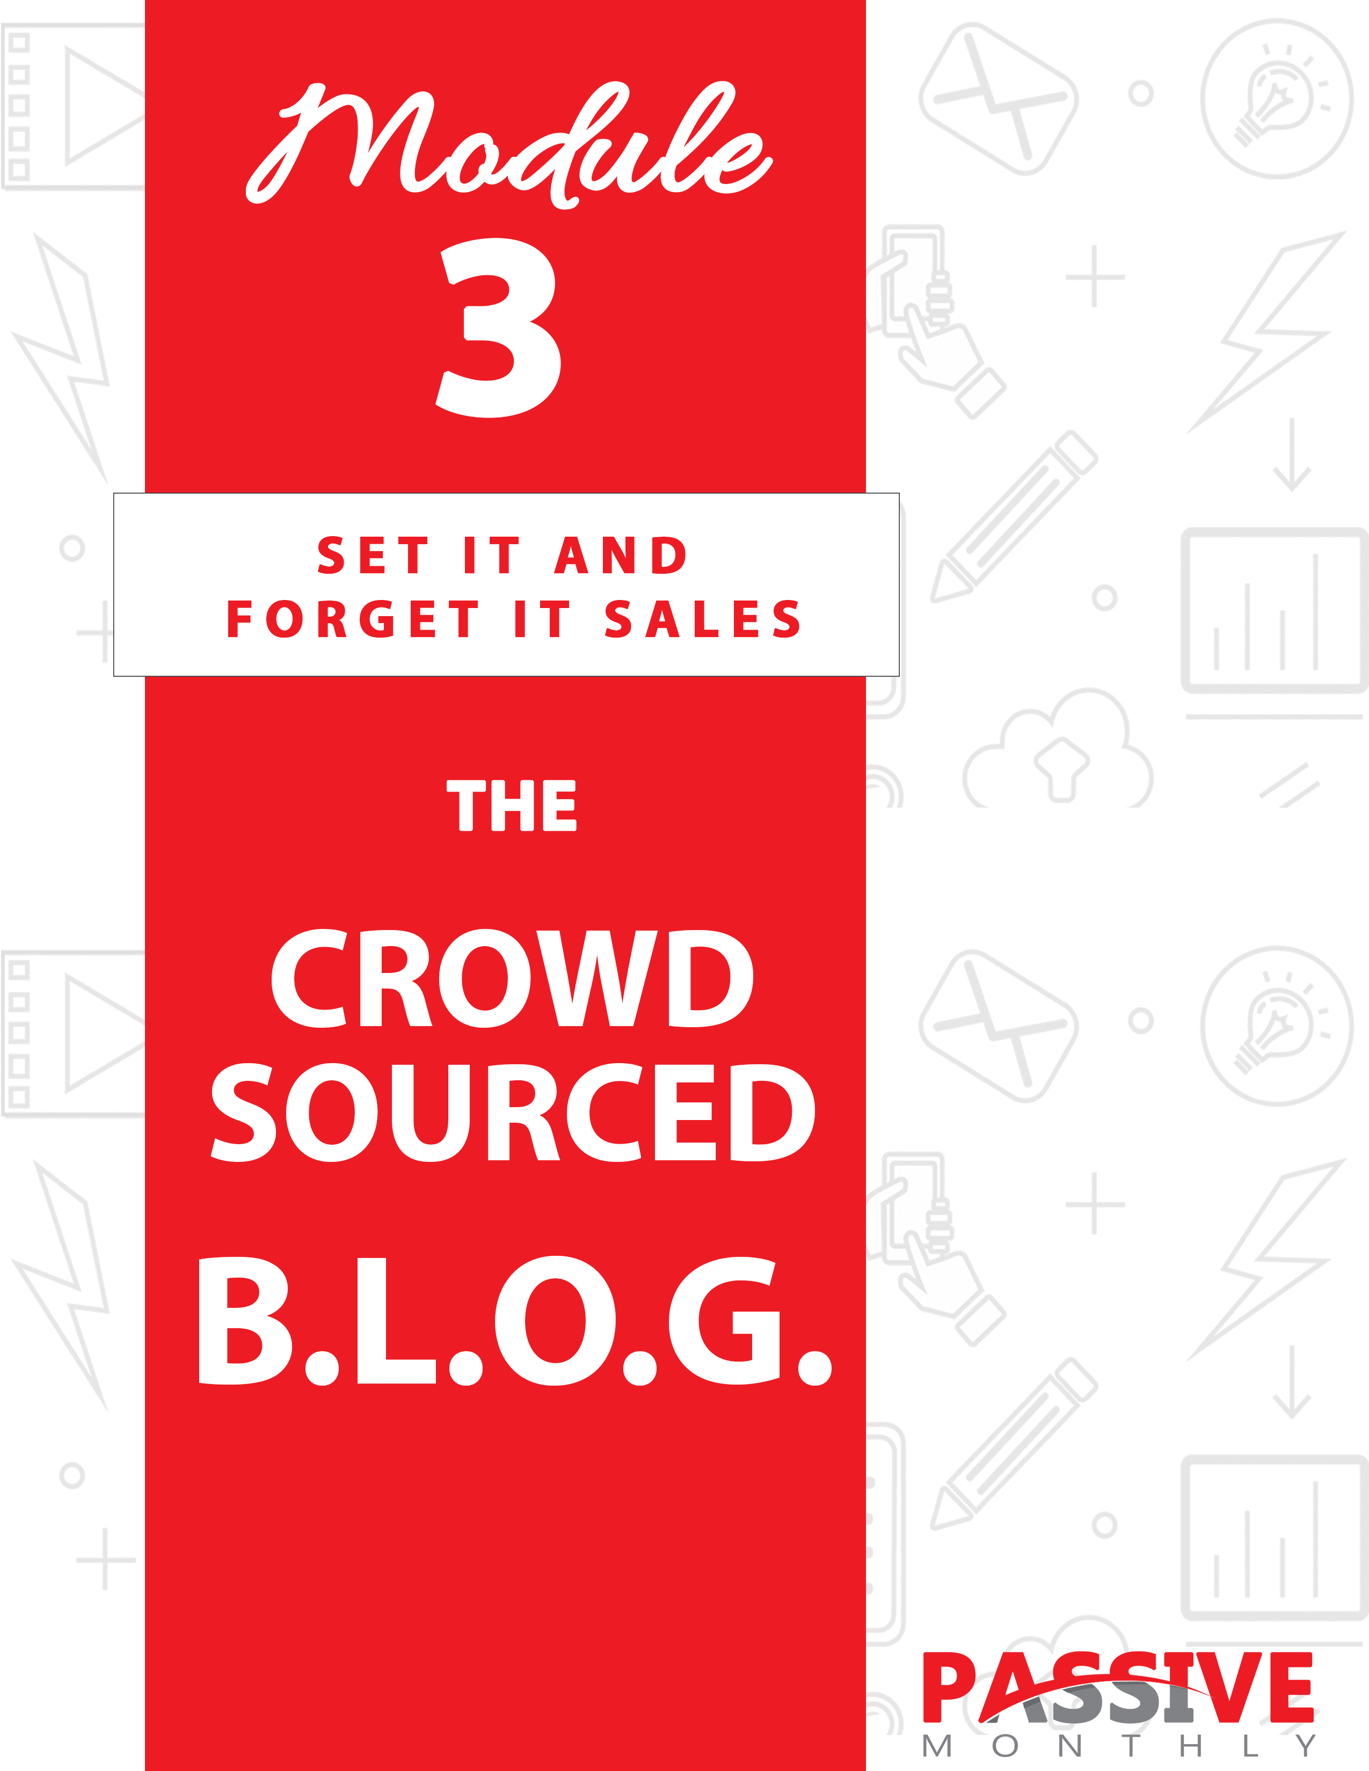

You DO NOT Have The Right To Sell Or Give Away
Any Portion Of The Content In This Document.

This Document Is For Your Personal Use Only

CLICK HERE For Additional Resources
To Help You Build Your Dream Business.

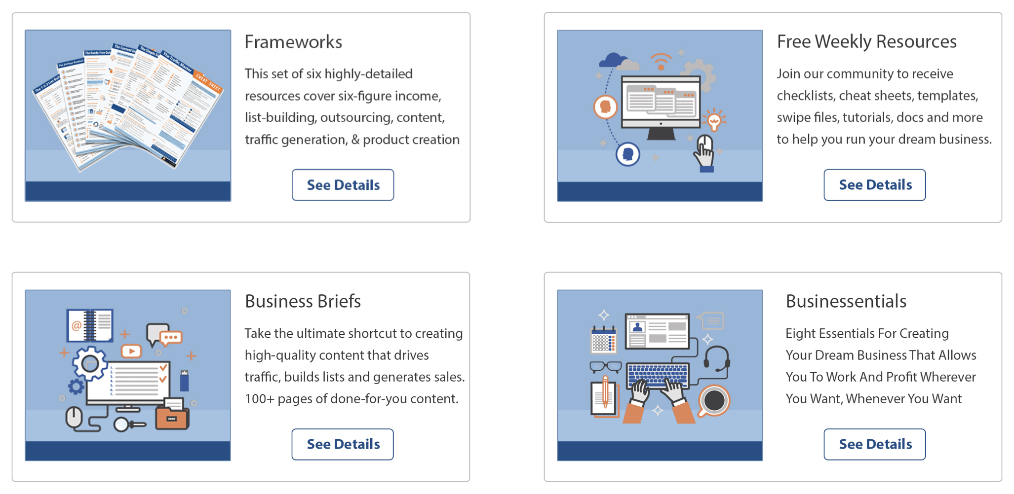

Insert Your Legal Disclaimer / Document Here

Strategy: What Is It?

Most online business owners and marketers set up a blog. But then one of three things happen:

- They spend every waking minute tending to that blog. You know why? Because in many niches, it’s simply not enough to blog once a week. Some blogs work best when the business owner blogs daily, or even multiple times per day. And so these business owners find themselves increasing enslaved by their blogs.

Alternatively…

- They invest a ton of money outsourcing content creation. Those business owners who decide they don’t want to be shackled to their blogs make the decision to outsource. That’s a wise decision. But the problem is, not everyone has the kind of money needed to outsource content creation. So, while it’s a wise choice for those who can afford it, outsourcing isn’t the answer for everyone.

- They lose interest and eventually let their blog fade away. Those who don’t have enough time or money to run a blog tend to stop posting as frequently. Traffic (and sales) drop, which in turn further lowers the owner’s interest in the blog, and then they post even less.

If you’ve ever had a blog, you can relate. And if you’re thinking about starting up a blog, then you can certainly see how each of these three scenarios might play out.

And that’s why I want to introduce you to a fourth option: The Crowdsourced B.L.O.G. System.

What is this system?

Simple: it’s one where you get plenty of content so you can post regularly. Yet you don’t need to create this content yourself, nor do you need to spend inordinate amounts of money outsourcing it.

Instead, you crowdsource the content, meaning you solicit it from other experts in your niche. Then you place your affiliate link in the author’s byline, plus you put offers in your sidebar and other parts of your blog. You might also create some of the content yourself to help establish your expertise.

End result? Everyone is happy – your readers get fresh content frequently, your guest authors get exposure and sales, and you get free content and revenue while doing hardly any of the work yourself.

Sounds good, right? And now you too can learn how to set up this incredible passive income opportunity by using the Crowdsourced B.L.O.G. system!

Read on to discover what this is and how to set it up for yourself…

System: How Do You Do It?

Here’s an overview of the Crowdsourced B.L.O.G. System:

- Build the Blog. Here you’ll get the basics of setting up your blog and preparing to monetize it.

- Load Content. The key to this system is to get free, high-quality content created by others. This step shows you how!

- Optimize Offers. Here you’ll find out how to embed offers throughout your blog for maximum conversions.

- Get Traffic. No blog strategy is complete without traffic, so here’s where you’ll get an overview of some of the best ways to bring visitors to your site.

Now let’s look at this system in a little more detail…

Build the Blog

First things first – you need to set up a content management system (CMS) so that blogging is easy. A good blogging platform means you never have to upload content to your blog via FTP, you don’t need to know how to do any coding, and you can set up a new page with just a couple clicks of your mouse.

Now if you do your research, you’ll find that there are quite a few CMS and blogging platforms available. Feel free to investigate those options if you wish. Or you can save yourself a lot of time and choose a free, well-supported, feature-rich platform: WordPress.

Indeed, because this is one of the most powerful platforms available (yet it’s very user friendly even for beginners), this is what I recommend. And it’s what we’ll be focusing on for this module. So here’s how you get it all set up…

Step 1: Install the Files

I’m going to assume for this step that you already have a domain name registered and set up with hosting. Now your next step is to set up the blog itself.

What you’ll do is go to WordPress.org to download the free files. If you’re unfamiliar with this platform, you’ll find both quick instructions as well as extensive, in-depth instructions for installing the files.

TIP: If you’re not technical at all and this task looks daunting or overwhelming to you, then keep in mind that you can always hire someone else to install the files and set up your blog. Check a freelancing board like UpWork.com or even Fiverr.com.

Once you get your blog installed, then move onto the next step…

Step 2: Pick a Theme

Now you need to choose a design (theme) that matches your niche and overall business. Here are the different ways you can do this:

- Choose a theme from within your dashboard (under themes) or go to https://wordpress.org/themes/. There you can search by color, columns and more to find the theme you want.

- Search Google for premium themes. Just be sure you’re dealing with a reputable designer (such as StudioPress.com), or you’re going to end up with a subpar theme with potential coding and updating problems.

- Hire someone to create a custom theme. Or you can hire someone to modify an existing theme. Either way, this gives you some flexibility to create something unique (even if you don’t know how to modify themes yourself).

If you’re installing the theme yourself, just follow the instructions from within your dashboard. Generally, it’s a matter of installing and then activating the theme.

Now, many (if not most) themes give you the opportunity to edit them in a point and click manner. In other words, you don’t need to have any coding knowledge in order to upload a logo, change the font colors and so on. Do compare themes, however, as some are more easily editable than others.

NOTE: If you fall in love with a theme with limited “point and click” editing options, you can always hire a WordPress developer/designer to customize the theme for you.

Next…

Step 3: Install Plugins (Optional)

This step is optional, depending on what you need your blog to do. For example, do you want a contact form? Do you want to install social media share buttons? If so, you can either install the appropriate plugins by going to https://wordpress.org/plugins/, or you can hire a WordPress developer to

help you with this step.

TIP: Don’t install a bunch of unnecessary plugins. Only install the ones you need so as not to bog the speed and function of your blog. In addition, be sure to only choose plugins from reputable developers (do your due diligence) so that you don’t end up with something that gives you coding problems.

And finally…

Step 4: Familiarize Yourself With the Dashboard

Once your blog is all set up, then spend some time familiarizing yourself with each and every link in your dashboard. Here’s where you’ll be able to:

- Decide whether people can comment or not, and whether you need to approve comments.

- Draft and publish new content. You can do basic editing such as bolding, changing the font, inserting pics or videos and so on. You can save a draft for later, publish it immediately, or schedule it to publish at another time.

- Determine whether your blog can be indexed by the search engines. (Generally, you should encourage the search engines to discover and regularly crawl your site.)

- Develop your site’s Pages, which are different from Posts. Generally, Pages are what show up in your navigation menu (such as “About,” “Contact” and so on).

Those are just a few of the things you can do from your dashboard, so be sure to explore it thoroughly so that you can customize your blog exactly the way you want it (both in terms of form and function).

Now the next step of the B.L.O.G. system…

Load Content

Now that your blog is ready to roll, it’s time to create, acquire and load content.

As mentioned, this is a crowdsourced blog. So, while you may create some of the content yourself, you can solicit the majority of it from outside sources. Here are different ways to acquire content:

- Source the Content Yourself
- Solicit Content
- Select Content from Directories

Let’s look at these more closely…

Source the Content Yourself

There are multiple ways to do this, including:

- Create it yourself. This gives you the most control, but of course takes the most time.

- Outsource content creation. In other words, find a writer on UpWork.com or elsewhere to create your blog posts for you. Saves you time, but of course costs money.

- Use PLR (private label rights) content. You’ll need to tweak this content to make it unique, but it saves you both time and money. (NOTE: Use high-quality PLR from a site such as PrimePLR.com.)

Now let’s look at ways to get free content without having to create it yourself…

Select Content from Directories

One way to get free content is by searching article directories/depositories.
This is where other authors make their content available for free. In return for this free content, you need to publish the author’s byline (which usually contains a link back to their site).

Examples of places where you can get this sort of content include EzineMark.com, EzineArticles.com and ArticlesWrap.com. You may also find directories by searching for your niche keywords alongside search terms such as “article directory” or “free articles.”

The upside of this method is that you can get an almost unlimited amount of content. Within minutes, you can copy and paste a dozen articles if you want. And since you’re choosing the content, you are also choosing the quality.

Here are the downsides of this method:

- You can’t put your affiliate link in the byline. The exception, of course, is if you ask the author and get permission to do this in writing.

- You’re getting content that’s already all over the internet. Dozens or even hundreds of other bloggers may use this exact article.

- You need to do your due diligence. Make sure the content indeed comes from a reputable source, otherwise you risk publishing plagiarized content.

Yes, you may get some of your content from these third-party sources. However, you’ll want to get the vast majority of crowdsourced content from this final method…

Solicit Content

This is the focus of the Crowdsourced B.L.O.G. system. And like the other methods mentioned above, there is more than one way to do it. Specifically:

- Solicit content from your blog. In other words, create a page on your blog (in a prominent place) where you “advertise” the fact
that you’re looking for content. If you have a high-quality, well-trafficked blog, then you’ll get more submissions than you could possibly publish.

- Solicit content directly from your partners. For example, you might ask a product vendor to create an article for you, which you then post using your affiliate link. Or you might swap content with your existing joint venture partners (meaning you give them content to post, and they do the same for you).

Here’s the scoop…

Actively nurturing partnerships and requesting content from others is time-consuming. And since we want this system to be as hands-free as possible, we’re going to focus on that first option, which is to solicit content directly on your blog. In other words, let people come to you (rather than you hunting them down, wooing them, and persuading them to give you content).

With that in mind, here’s how to set it up…

Step 1: Define Your Terms

The first thing you need to do is define your terms and submission guidelines. If you’re unsure of what to include, then you may want to view the submission guidelines from other blogs in your niche.

Here are some questions to ask yourself as you define these terms:

- Do you want queries or content? In other words, do you want people to submit the content directly, or to send you their ideas for content? (Hint: Request content, as this will make the process quicker for you.)

- Will you request exclusive content/”first rights”? If you request exclusive content from your authors, be prepared for reduced submissions. Generally, most authors are only willing to offer
exclusive content if they’re selling the article.

- How many links may authors include WITHIN the article? Be sure to put a limit, as some authors will send you articles full of links.

- What kind of links may the author include? Ideally, what you’re looking for here is an opportunity to make money with other peoples’ content. So, to that end, you’ll want to include YOUR affiliate links within the author’s article and byline. Alternatively, if you’re selling your own products, then the author will include their affiliate link to your product.

- What are your article guidelines? Be sure to give people a word count range, notes about quality, and what sorts of article topics in particular you’re seeking.

- What guidelines do you offer for the byline? Again, be specific about how long the byline may be and how many links the author may include (and what kind of links).

- How do you want people to submit their content? This may include in an email, as an attachment, via a contact form, or some other method.

Once you’ve defined your terms, then create a page on your blog where you list all your terms and submission guidelines. Then move to the next step…

Step 2: Promote Your Page

Now that you have everything set up, you need to promote the link where you solicit content.

Now keep in mind that the key to all of this is that you have a high-quality, well-trafficked blog. As such, make it a place that people compete to get published. As your blog grows, so too will your submissions. But you may need to promote your link in the beginning just to get those submissions

rolling in.

Here’s how:

- Advertise directly on your blog. Put your content submission link prominently on every page of your blog (perhaps even in the sidebar). Be sure to also call for submissions directly within your blog posts.

- Tell your social media followers about the opportunity.

- Send an email to your mailing list.

- Contact your existing joint venture partners and other colleagues directly to tell them about the opportunity.

- Tell aggregators about your opportunity. For example, if someone in your niche has compiled a list of blogs that accept article submissions, be sure your blog is on that list. (You may consider creating your own list if one doesn’t exist.)
And finally…

Step 3: Be Selective

Right from the very first article you post, be sure that you’re only accepting high-quality submissions. Don’t post junk just to have something to post. Set high standards, and don’t waiver.

The reason for this is if you focus on quality content, then quantity will come over time. Your blog will become the place where others really want their content to appear, so they’ll send you their very best content. This high-quality content attracts high-quality traffic, which in turn attracts even better submissions.

As you can see, it’s a cycle – and it all hinges on you setting high standards.

So, what’s next? Now we monetize and optimize. Take a look…

Optimize Offers

There’s no use in getting a lot of traffic if you’re not set to monetize this traffic. That’s why the next step is to optimize offers. As such, in this step we’ll look at the different ways to monetize your blog, and where to insert the offers.

Let’s start with the two main monetization methods:

- Promote your own offers. Whenever possible, you should seek to promote your own offers. You may even solicit content from affiliates – simply have them write the content and include their affiliate links in their bylines. When someone buys, both you and your affiliate make money!

- Promote affiliate offers. Choosing this option makes this system a more passive income model. Not only do you not have to create the blog content, you also don’t need to go through the hassles of creating products, customer service and so on.

IMPORTANT NOTE: Just be sure your terms make it clear that you’re looking to put YOUR affiliate links within the author’s article and byline.

Obviously, this isn’t an exhaustive list. There are other things you can do, such as insert Google AdSense ads on your site. However, promoting your own offers or affiliate offers tends to be more profitable, so what’s what we’ll focus on in this module.

NOTE: I highly recommend that you build a list and create an evergreen autoresponder series, meaning you set up another hands-free revenue stream for your blog. Check the Passive Income modules and you’ll find instructions for exactly how to do that in another lesson!

Here then are the different ways you can optimize offers on your crowdsourced B.L.O.G.:

Insert offers directly within guest content and bylines. As mentioned previously, be sure this is in your terms, and that you have express permission to do this.

Insert offers into your own content. Since you’ll be publishing your own content on your blog, you can of course promote offers from within this content. You can boost your conversions by publishing a variety of content, including:

- How to, tips, and similar instructional content. Make it useful yet incomplete, and then promote a related offer at the end.

- Product reviews and comparisons. These are great options when you’re selling affiliate products.

- Case studies. This a great type of article to post whether you’re selling your own products or affiliate offers.

- Directly promotional posts. This is a good option for product launches, sales and similar events.

- Tools. These include checklists, worksheets, templates, gear lists and similar items to help people complete a task or achieve a goal.

- Multipart blog series. This is a good way to make your blog more sticky. E.G., a five-part series called “The Five Secrets for Writing Million-Dollar Sales Copy.”

Next…

Insert offers into the sidebar. You can insert one or more semi-permanent offers in your sidebar, or you can use an ad rotator to rotate through popular offers. (This is useful because frequent visitors won’t see the exact same ad on EVERY visit, but they will get multiple exposures to each ad over time.)

Insert offers in the header and/or footer. You can post either text or graphical ads here. Again, you can use an ad rotator to randomly (yet evenly) display a variety of ads.

Insert offers within the main body of your blog. For example, you might post related offers between articles on your blog. While you may be tempted to embed ads within the content itself, it’s best to NOT do this so that people will focus on the article (which will have its own link and call to action).

Insert offers in a “featured” location. You might create a weekly “featured” product, which you post in a prominent location such as in a sticky post right at the top of your page.

As you can see, there are plenty of places where you can insert your ads – but this doesn’t mean you should post ads in ever location mentioned above.

The key is to make sure your blog doesn’t look like a circus has come to town, with bunches of blinking banners and other ads. People can and do develop “banner blindness” (or ad blindness), where they ignore things that are obviously ads. If you insert fewer ads, then the quality of your blog goes up – and people will pay more attention to the ads you have.

And now the last step of the Crowdsourced B.L.O.G. system…

Get Traffic

All the content and optimized ads won’t do diddley squat for you if you don’t have traffic coming in. Not just any ol’ traffic, but high-quality traffic who’s going to be interested in what you’re selling. Plus, once you start getting traffic, then bloggers will be even more interested in submitting content to your blog.

So with these benefits in mind, here’s an overview of five ways to get

traffic…

Ask Guest Authors to Promote

When guests publish on your blog, you may ask them to promote their article from their platforms. Obviously, this sends traffic to your blog. If you have plenty of other good content on your blog, then this traffic is going to stick around and keep reading.

Do Guest Blogging

Another way to drive high-quality content back to your site is to do your own guest blogging. You can swap content with your existing joint venture partners, or you may seek out guest blogging opportunities with a Google search.

For example, if you’re looking for gardening blogs that accept guest submissions, you may search for the following types of queries in Google:

- Gardening guest author submissions
- Gardening guest articles
- Gardening guest article submissions
- Gardening article submission
- Gardening article submission guidelines
- Gardening blogs that accept guest content

… and similar searches.

Follow these tips:

- Do your due diligence. Be sure you only submit to well-trafficked, high-quality blogs.

- Review existing content on the blog. If the blog owner seems to like certain types of content (such as tips articles), then model your own content after this favored format.

- Be sure to read and follow each blog’s article submission guidelines. This will increase the chances that your content will be published.

- Create a compelling byline. Your byline is your opportunity to drive traffic back to your site, so be sure to spend time crafting a good benefit-driven statement with a call to action.

E.G., “Discover the secrets of fast, effective weight loss. Click here to find out how to get the best body of your life!”

Next…

Place Paid Ads

Another way to get traffic to your site is to place paid ads on sites such as Facebook (which allows you to really focus in on a targeted market) or even Google AdWords (which is a pay per click platform).

The beauty of paid advertising is that you once you create a good ad and choose the right platform, it becomes a fairly hands-free, “set it and forget it” way to bring in consistent traffic. Just be sure to follow these tips:

- Attract targeted traffic. Specifically:

If you’re using Facebook, then use their ad editor to select a market with focused demographics and interests.

If you’re using a pay per click platform, then choose targeted keywords. E.G., “how to grow tomatoes” is much more targeted than the keyword “tomatoes.”

And if you’re advertising directly on niche sites, then be sure to get as much information as possible about their visitor demographics so that you know if it’s a good fit for your audience.

- Start small. Test a venue to see if it creates good results for you. If so, then you can start invest in bigger ad buys. Likewise, be sure to thoroughly test your actual ads themselves so that you can optimize conversions.

- Aim for a relatively hands-free system. Yes, you’ll need to monitor your ads to ensure everything is running smoothly. But once you have a good ad platform and proven sales copy, then you can focus on platforms (such as Facebook) which let you set up ad budgets and have your ads run on autopilot.

Next…

Optimize Content for the Search Engines

You’re already planning on creating some content for this blog – why not optimize it for the search engines in order to get more traffic?

Check out these tips:

- Use a keyword tool. A tool like WordTracker.com (or your favorite tool) will help you determine what words your market is actually typing into the search engines to find content and offers. Your job is to pick the “low hanging fruit” – these are words that may not have as much traffic as the top words, but they also don’t have as much competition either. It makes it easier for you to land a top spot in the search engines.

- Insert your keywords into your content. But do this sparingly (at the rate of one or two keywords for every 100 words of content). Be sure that you’re focused on creating content for people FIRST, and search engines secondly (a distant second).

- Optimize your other blog pages. This includes navigation menus, categories and any other content on your posts and pages.
Next…

Promote on Social Media

One of the major benefits of posting on social media (such as on Facebook) is that it’s a naturally viral platform. So, if you post your BEST blog posts on social media, there’s a good chance that you’ll get some viral traffic.

Here are tips for pursuing this strategy:

- Focus on creating great titles for your blog posts. People will decide whether they’re going to read a post just based on the title, so focus on creating compelling titles.

For example, “Teach Your Dog to Sit” is informative, but boring. Here’s something a little more compelling: “The One Weird Trick That Makes It Easy to Teach ANY Dog to Sit!”

- Post a variety of content. This includes short content, long content, how to, tips, promos, multimedia (such as videos), memes and more. This will help you figure out what sort of content most appeals to your audience, so you can post more of it.

- Make it easy for people to share. This means putting social media “like” and “share” buttons directly at the end of each post. You can do this automatically using a WordPress plugin such as the Easy Social Share plugin (or any number of others, which you can find by searching the plugin section of your WP dashboard).

- Provide a call to action. It’s not enough to put a share button in front of people – you need to also specifically tell them to share. E.G., “Click here to share this with your friends, because they’ll love it as much as you do!”

So as you can see, social media is a great place to generate traffic, especially if you work to create viral content for your blog.

Now that you know the step-by-step of the Crowdsourced B.L.O.G. system, it’s time to look into a few shortcuts for optimizing this system. That’s what’s next…

Shortcuts: What Else Can Help You?

The Crowdsource B.L.O.G. System is a proven way to get free content and generate sales. What you’ve learned so far is enough to get a profitable blog up and running. Now here are three shortcuts to further optimize this system.

Take a look…

Use Blogging Tools

We’re shooting for a fairly hands-free system, right? And that’s why you’ll want to take advantage of tools and apps that help you automate your business.

Take a look at these ideas:

- The WordPress built-in scheduler. When you go to post, WordPress gives you the option of scheduling the content for a later time. Use this feature! You can upload bunches of content today, and let the scheduler take care of the rest.

- Social Media Auto-Publish. This plugin (and others like it) posts to social media automatically whenever you post to your blog. Get it at https://wordpress.org/plugins/social-media-auto-publish/.

- Buzz Sumo. This app helps you find and select well-performing content in your niche. Check it out at http://buzzsumo.com.

Next…

Engage Readers

No matter how good the content is in terms of teaching people something they don’t know, people aren’t going to stick around if the content isn’t also engaging and easy-to-read. That’s why you need to do two things:

- Only accept crowdsourced content that’s engaging.
- Polish your own writing so that it’s engaging.

You recognize third-party engaging writing when you see it. It’s that article that grabs you from the title, and keeps you reading right until the end. But how do you develop your own engaging writing? Check out these tips:

- Write with a conversational tone. Forget that stuffy textbook-style writing. Instead, write as if you’re writing to a good friend. Be friendly, be information, and inject light-hearted humor where appropriate.

- Tell stories. A good story engages the reader, arouses emotion (which is a good thing), and gets the reader to relate to what you’re telling them about.

- Use short words, sentences and paragraphs. Big walls of text are difficult to read, and a lot of people will just bail on an article with these text walls. So insert a lot of white space (much like this lesson you’re reading right now).

Set Yourself Apart

If you’re just getting started in your niche, then you need find ways to set yourself apart from others. You need to give your visitors a good reason to visit your blog. Here are two good reasons:

- Give readers something they can’t find anywhere else. In other words, don’t just rehash the same ol’ content. Be different. Offer tools (such as checklists and worksheets), case studies, or anything else that elevates your content and sets it apart from
the average blog.

- Host influencers. If you’re looking to establish yourself in your niche, then you can raise your visibility and “borrow” credibility by associating yourself with the influencers in your niche. One good way to do that is by simply requesting interviews from influencers.

It’s a win-win situation, because they get exposure (and an ego stroke) from being interviewed, and you get free content, usually free traffic (if the interviewee helps you promote), and boosted authority in the niche.

Now let’s wrap things up…

Conclusion

Congrats – you just learned how to generate a passive income stream using the Crowdsourced B.L.O.G. System! Let’s quickly recap:

- Build the Blog. Here you’ll received the basics of setting up your blog and preparing to monetize it.

- Load Content. The key to this system is to get free, high-quality content created by others. This step showed you how!

- Optimize Offers. Here you found out how to embed offers throughout your blog for maximum conversions.

- Get Traffic. No blog strategy is complete without traffic, so here’s where you received an overview of some of the best ways to bring visitors to your site.

So, what’s your next move? It’s this: go back to Step 1 (Build the Blog) and start putting what you learned into action. Because the sooner you do, the sooner you can start reaping a healthy profit from this proven system!

