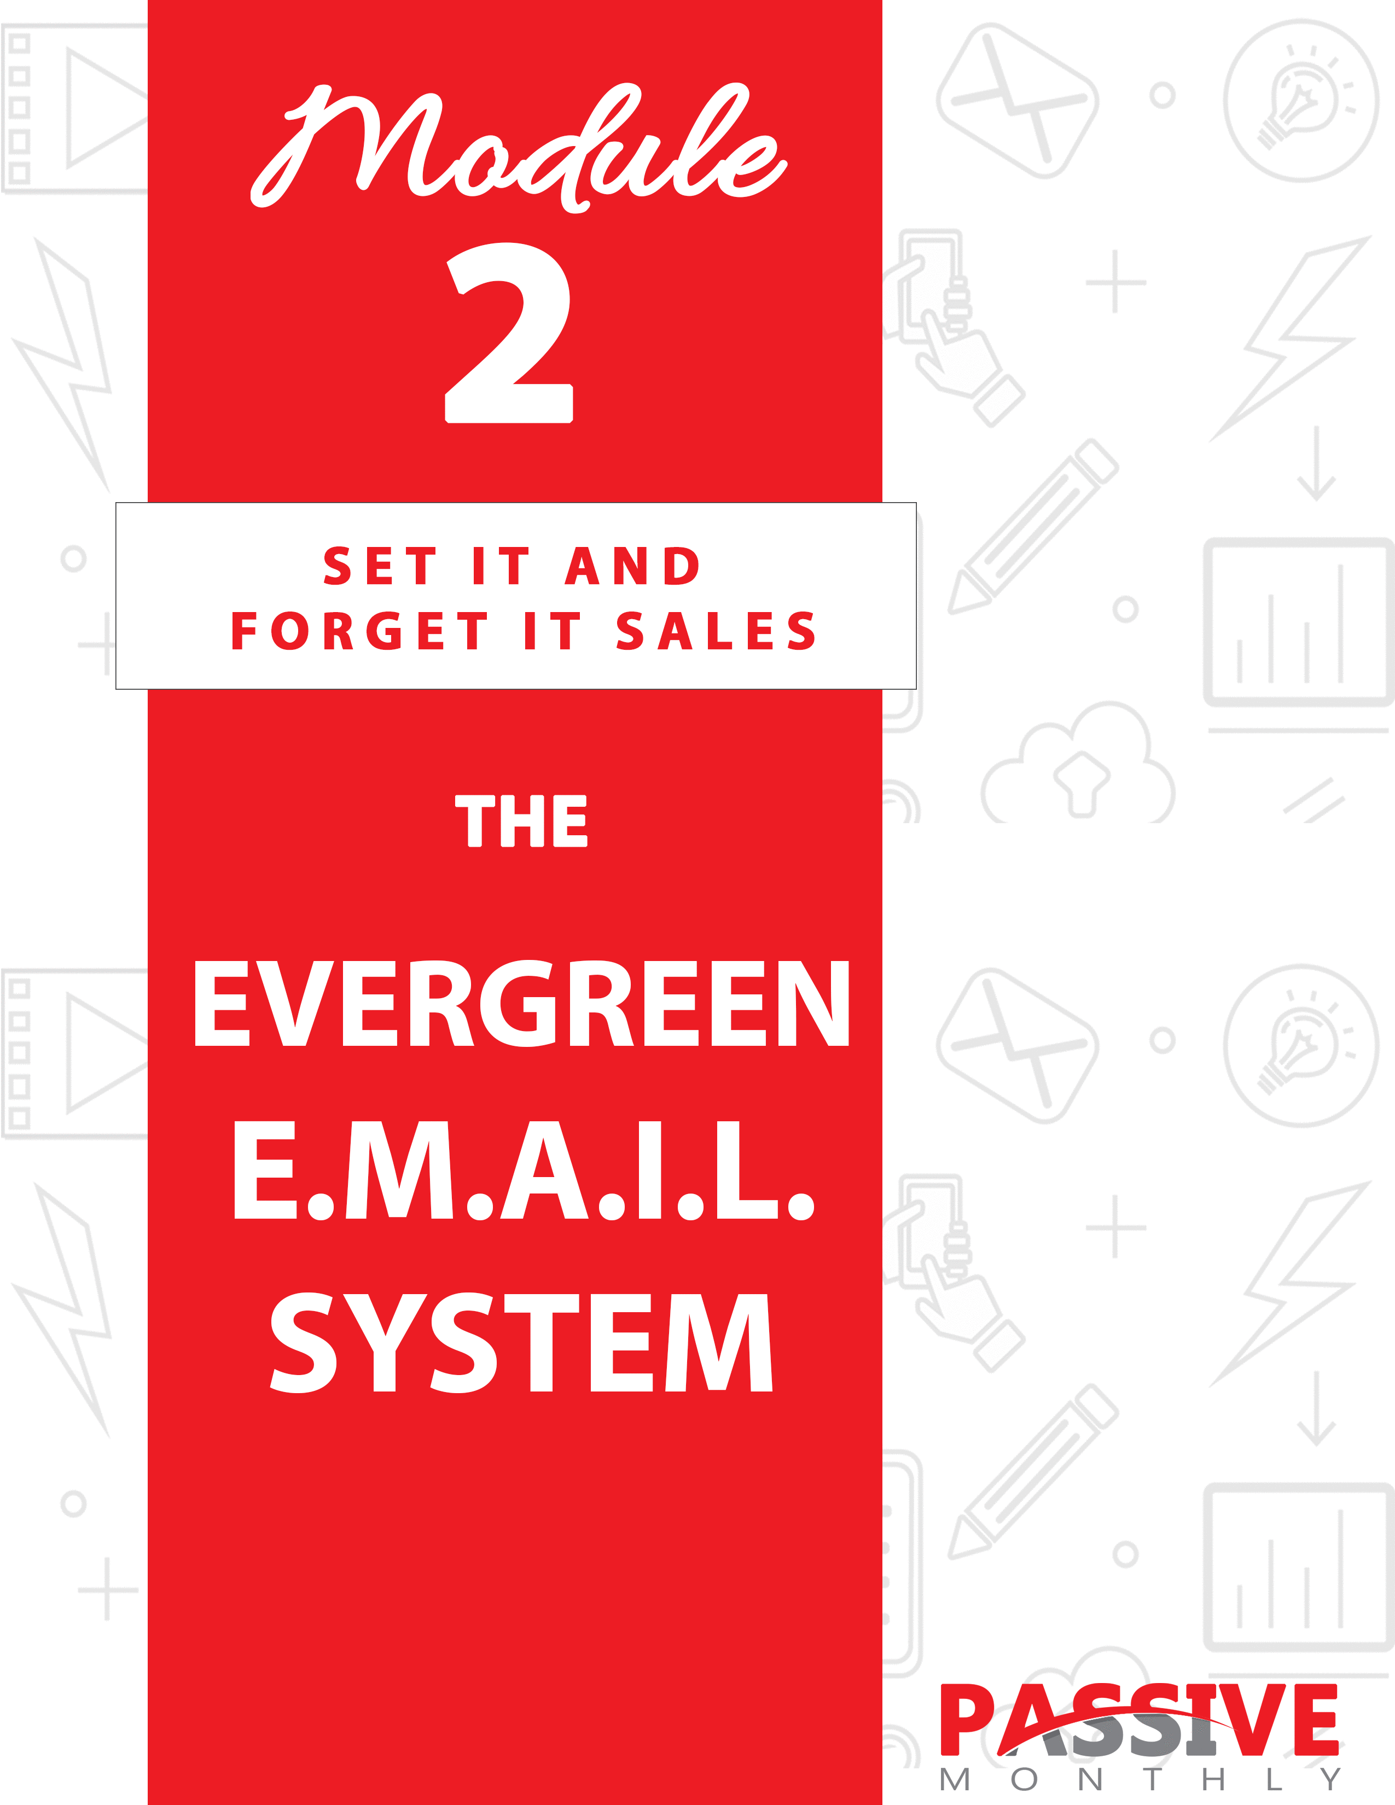

You DO NOT Have The Right To Sell Or Give Away
Any Portion Of The Content In This Document.

This Document Is For Your Personal Use Only

CLICK HERE For Additional Resources
To Help You Build Your Dream Business.

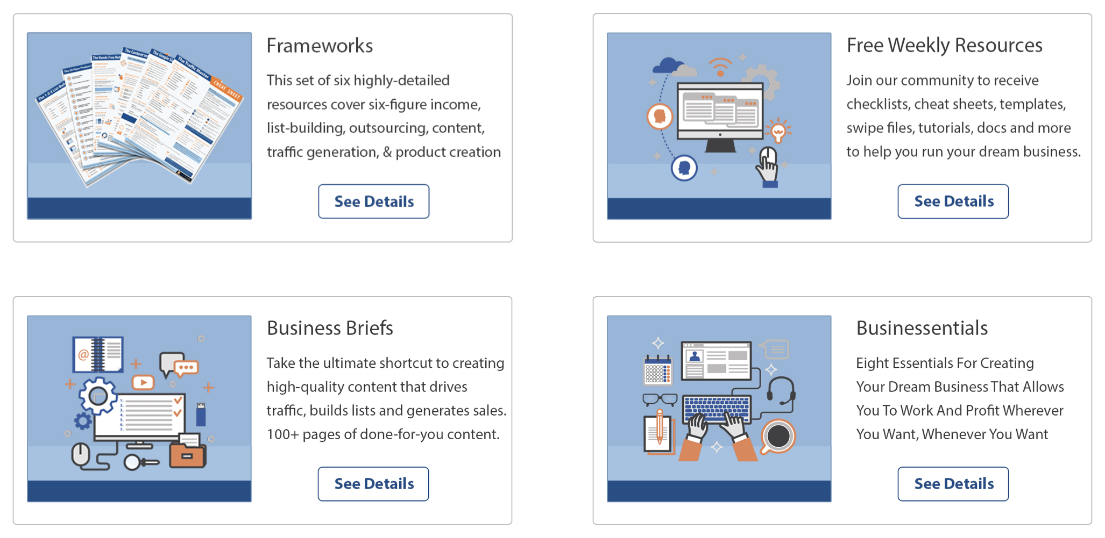

Insert Your Legal Disclaimer / Document Here

Strategy: What Is It?

You’ve heard it one hundred times, a thousand times, a million times: the money is in the list.

You know what? It’s true. And that’s why you’re going to want to add an evergreen autoresponder to your website to create a passive income stream.

First things first, a definition of evergreen. When you create an evergreen autoresponder, it means that you’re creating content that’s going to be “fresh” and useful for the foreseeable future. That way, you’re not constantly tweaking the content to keep up with the trends. (This is a PASSIVE income stream, so we’re looking at doing the work once and profiting over years.)

Let me share with you an example…

Let’s suppose you’re creating content for a weight-loss market. Evergreen content would include any information that stands the test of time, such as reducing calories, eating healthier and exercising more. This type of information was useful last year, it’s useful right now, and it will be useful two years from now. You know this because this information has been scientifically proven to work.

On the other hand, mentioning the latest fad diet strategy is NOT evergreen. It’s a fad, meaning it’s going to fade away in two months or six months or a year. And when the fad fades, then you’ll need to go back into your content and take out any mentions of that fad.

Likewise, any mentions of dates or events that give people a clue about when you created the content is NOT evergreen. For example, you don’t want to be telling people that “beach season is almost here” or “Christmas is over” or “the Olympics are starting.” Because if someone reads the content in a different month or year from those events, then they’re going to get the impression that the content isn’t fresh.

So, you get the idea. What you’re going to do is create an evergreen autoresponder series where you promote a variety of evergreen products. Once the autoresponder is set up, it ends up being a virtually hands-free, passive way to make money.

Sound good? Then let’s take a look at how the Evergreen E.M.A.I.L. system works hard to put money in your pocket (even when you’re not working) …

System: How Do You Do It?

Here’s an overview of the Evergreen E.M.A.I.L. system:

- EDUCATE Yourself. This is all about finding out what your market wants.

- MAKE a Lead Magnet. Here you’ll create a high-quality, in-demand freebie that your prospects are sure to love.

- ADD Emails. This is the step where you create your evergreen content that includes promotions for paid products.

- INSTALL a Lead Page. Here’s where you create a mini-sales page to entice your prospects to turn into engaged subscribers.

- LAUNCH. This is where you unleash the whole system and put it to work for you.

Let’s look at each of the steps of the Evergreen E.M.A.I.L. system separately…

Educate Yourself

The key to your success with this system is to give your prospects what they want at every stage of this system. This includes:

- Offering a free lead magnet that will persuade them to join your list.

- Creating autoresponder content that they’re sure to love (which keeps them reading and opening your emails).

- Promoting paid products that you know they want.

So, how do you hit the bulls eye on all three of these things?

Answer: you educate yourself. And this means you need to do your market research.

Here’s the key I want you to remember:

if you can find out what your market is already buying, then you know they’ll buy similar products from you (as well as eagerly read your free products and content on the same topic).

But heads up…

This doesn’t mean you COPY other peoples’ products. Not at all.

What it does mean is that you find out what products are selling like crazy in your market, and then create something that’s similar (yet better) than those products. You put your own twist and create something unique, but you create it on a topic that you know will sell well.

For example, if you’re selling to a weight loss market, then perhaps you discover that people in your niche are looking for information on how to get rid of belly fat. You’ll see plenty of books and other products on that very topic. You know it’s an in-demand topic. So, what you’d do is take that topic… and then create your own unique lead magnet, autoresponder series and perhaps even paid product on that same topic.

Which brings us to the question: how do you find out what’s selling like crazy in your market?

Fortunately, this step is pretty easy. That’s because marketplaces such as Amazon.com and ClickBank.com let you search for your niche words, and in return they list products in your niche ranked by bestseller status.

TIP: The beauty of using a site like Amazon to do your market research is that there are usually a whole lot of customer reviews with the bestselling products. That means you can find out directly from customers what they like and do not like about a particular product, which in turn makes it easier for you to create a similar yet BETTER product on the same topic.

You can also take note of which topics have multiple products created around them. For example, if there are quite a few products in an online marketing niche that focus on how to create high-converting sales videos—and several of these products are bestsellers—that’s a sign that the topic is popular.

Secondly, you can enter your niche keywords into Google and see what sorts of information products the top sites in your niche are selling. You can then create a lead magnet, emails, and paid product on those same topics (with each of these leading to the next piece of content).

Let me give you an example of how these pieces work together. Let’s stick with the topic of writing better sales copy. Here’s how this may play out:

- The lead magnet is a set of sales letter templates.

- The email content covers five to seven different tips/tricks/secrets for writing better sales copy.

- The paid product is an in-depth copywriting course.

In other words, if someone is interested in the lead magnet, they’ll also be interested in the email content and the paid product. And since you’ve done your research to find out what people in your niche want, then you’ll know that they’ll really want these various pieces of content.

Which brings us to the next step of the E.M.A.I.L. system, which is to make the lead magnet…

Make a Lead Magnet

If you’ve done your research as per the last step, then you know what your market wants – so you can create something similar yet better, and offer it for free as a lead magnet.

Here are the “ABCs” of creating a desirable lead magnet…

Attract Prospects

You’ve already chosen a topic that’s sure to attract prospects. Now you need to do two more things:

- Craft an attractive title. Generally, this means creating a benefit-driven title. E.G., “The Secrets of Shedding 10 Pounds the Fast and Easy Way.”

- Create professional ecover graphics. Yes, people do judge your product by it’s cover, which is why you’ll want your graphics to be polished and professional. If you can’t do this yourself, then hire a professional ecover designer to do it for you.

Next…

Be Sure It’s Valuable

Just because you’re offering it for free doesn’t mean it literally should be worth nothing. On the contrary, this is a product that you should be able to sell if you wanted to. It should rival products in your niche that are selling for $20, $30, $40 or more.

Create “Flow”

As mentioned previously, your lead magnet, autoresponder content, and the
product you’re selling should all flow together. That means the lead magnet should solve part of the prospect’s problem, the initial autoresponder series
should solve another part, and the paid product should solve still another part of the problem.

To that end, each piece should be useful yet incomplete. For example, your lead magnet is useful because it solves part of a problem (such as teaching people how to write a sales letter headline), but people need to look to your autoresponder and paid promo to solve the rest of their problem (how to craft the rest of the sales letter).

Take note: you don’t need to be selling your own product in order to use this strategy. This passive income strategy works with affiliate products too, though you’ll need to check those products on a regular basis to be sure the vendor is still selling them.

Develop Something Better

It’s a good idea to purchase the bestselling products in your niche that are similar to your intended lead magnet. That way, you can read and use the information inside to get a feel for the strengths and weaknesses of the product.

You’ll also want to read the customer reviews of the products, especially on sites like Amazon. These reviews often list what the customers both like and dislike about a product. In particular, look for a pattern of several customers mentioning the same factors, as this is an indication of how strongly the customers feel about a particular strength or weakness of a product.

Once you’ve done this research, then you’re in a good position to create something better than your competitors’ products. What you’ll want to do is be sure your product has the features that are considered strengths in your competitors’ products, and then you want to improve upon the weaknesses of those other products.

For example, let’s suppose you’re creating a set of sales copy templates for your market. And let’s further suppose that your market
noted that having a long-form sales letter is a strength of competitors’ template packages. You’ll want to then make sure your package has a long-form sales letter template too.

Secondly, maybe you notice that the competitors’ product reviews down-rate the products because they do no include video sales letter scripts. You can make your template set better than all other packages out there simply by including one or more scripts.

In the end, your product is going to be COMPLETELY unique since, in this example, the templates are all 100% original. However, your template set will be better than the competitors’ because you’ve included templates not included in those other sets.

And finally…

Encourage Action

Your lead magnet needs to “flow” towards your reader taking a specific action when they finish reading it. And this means you need to insert a link and a call to action, which is where you specifically tell people what you want them to do next (in this case, you want them to click on a link to purchase a paid product).

Let’s go back to the example where your lead magnet is a set of copywriting templates, and your paid product is a copywriting course. The templates solve part of the prospect’s problem (it helps them create a sales letter fast), and your course solves another part of their problem (it teaches them how to create high-converting sales letters).

So, within your template set you may have a call to action that looks something like this:

If you want to create a sales letter the fast and easy way, then put these templates to work for you right away! But if you want to be sure your sales letter puts a lot of money in your pocket, then you’re going to need to discover the secrets of creating high-converting, profitable

copy…

And that’s where [name of your copywriting product] comes in. This in-depth course shows you what the world’s best copywriters know about crafting million-dollar sales copy. And now you can put these same secrets and strategies to work for you to create hugely profitable campaigns that shatter sales records.

Click here to get your copy—and do it now, because your bank account will thank you for it!

As you can see, that’s a fairly long ad and call to action. If you have less room to create your call to action, no problem. Just focus on telling people exactly what they should do next and why.

Here’s an example of a shortened version of the above:

You just discovered how to create sales letters fast – now you’re about to discover how to make them more profitable. Click here now to discover the secrets of creating high-converting sales copy!

Of course the lead magnet isn’t your only chance to sell the paid product. Indeed, the lead magnet’s main goal is attracting people into your sales funnel so that you can then send them a series of evergreen emails via your autoresponder.

So, let’s take a look at the next step of the passive-income E.M.A.I.L. system…

Add Emails

Your next step is to create and add evergreen emails to your autoresponder. You’ll start off with at least five to seven emails (you can launch your system once you have at least that many), but over time you’ll want to add more and more emails to your autoresponder. That way, this truly becomes a passive, hands-free system.

Specifically:

- The first five or so emails will all focus on selling the paid product that you’ve promoted within the lead magnet. As such, the content will be an extension of your lead magnet, and a “bridge” to your paid product in that these emails will naturally lead to your paid product.

- The rest of the emails will sell a variety of products from your sales funnel. Generally, you’ll send out at least two or three emails for each product you want to promote. People rarely buy the first time they hear about a product, so you’ll get higher conversions when you send out a series for each product.

TIP: As you plan out your autoresponder, figure on sending the first five or so emails every few days as a way to build a relationship with your new subscribers. After that, you can send them out on a weekly basis. If you create 24 emails, that’s about six months’ worth of content. If you create 52 emails, then you have a full year’s worth of content that’s building relationships and generating sales for you. And all you have to do is create this content ONCE, and profit from it for years to come!

So, let’s talk now about how to create emails that both build relationships with your subscribers AND sell a product on the backend…

Generally, what you’re looking to do is create a series that’s useful yet incomplete for each product that you want to sell. Useful means that the emails solve part of the prospect’s problem, and yet they’re incomplete so that you can pitch your paid product on the backend.

For example:

- You create a five-part series called “The Five Steps to Setting Up a Profitable Blog.” This email series gives people an overview of how to set up a blog, and then you sell a blogging course at the end of each email which goes into these five steps in depth.

- You create a three-part series called “The Three Secrets for Shedding Fat Fast.” Each email talks about different ways to use nutrition to boost one’s metabolism, and then you pitch a meal planning app at the end of each email to make the nutrition part of dieting easy.

Here’s a good rule of thumb: each email will be about 80% content and 20% pitch.

Remember, your goal is to lead readers towards an order button. As such, each email should naturally flow towards promoting the paid product and end with a call to action.

Let’s take the example above of the five steps for setting up a blog. Your call to action might look something like this:

You just discovered how to set up and customize your blog. Now the next step is to monetize it. If you want a truly profitable blog, then you’re going to want to check out [name of paid product]. Click here to find out how to create the most profitable and popular blog in your niche…

Now, keep in mind that this strategy rests on your emails being EVERGREEN. That means that the content needs to be time-tested so that your instructions are fresh and relevant today, tomorrow and a year from now. You also need to avoid any references that date your content. This includes:

- References to any notable or historic events. For example, don’t mention a natural disaster as if it just happened.

- References to anything that could date the content. Don’t even refer to a season. For example, if you talk about “spring being around the corner” and someone is reading the content in fall, they know they’re not reading something fresh.

- References to pop culture. Pop culture is often fleeting, so what’s hot today may be outdated in a few months.

- References to untested products or information. If something brand new has just hit your niche (whether it’s a product or just an idea), don’t mention it in your evergreen series. If you need to talk about it, then send out a live broadcast to your readers.

You get the idea. Read through every email before you upload it, and be sure there is nothing in there that dates the content or anything that could become outdated with time.

So here’s the bottom line: you can launch your system just as soon as you have the first five emails in place which promote a paid product. Then commit to adding more evergreen emails over time (two or three emails per product you’re promoting) so that your autoresponder becomes your best hands-free selling machine.

Now the next step of the E.M.A.I.L. system…

Install a Lead Page

You’ve got an awesome lead magnet that’s sure to attract prospects. You’ve created an initial autoresponder series that both builds a good relationship with subscribers (by providing useful content) and generates sales. Now what you need to do is create a lead page that persuades people to join your list.

Here’s the thing: even though you’re giving away something for free, you still need to “sell” people on exchanging their email address for your lead magnet. That’s why you need to create a lead page, which lists the benefits of your lead magnet and encourages visitors to opt into your list to claim the lead magnet.

TIP: If you don’t already have an autoresponder, you’ll need to get one to set up this passive-income system. Choose a well-known and reputable provider such as Aweber.com, GetResponse.com or MailChimp.com. Then use the onsite instructions to set up your autoresponder and create your opt-in form.

The point here is that you need to create a mini sales letter. At a minimum, this mini-page should include a benefit-driven headline, a list of four or five of the top benefits of the lead magnet, and a call to action.

Here’s an example template you can use:

“Now You Too Can Discover the Secrets of [Getting a Desired Benefit of Result (note that this should be the top benefit of your lead magnet)]—FREE!”

If you’ve ever [tried to get some desired result] and [just ended up getting some undesired result instead], then you’re going to want to download this FREE [type of product – report/guide/video/etc.] right now!

It’s called [Name of Product], and [explain in one succinct statement what that product does for the user].

Here’s a sneak peek at what’s inside:

- You’ll find out the #1 way to [get some benefit]—and it has nothing to do with [some common task that most people think you need to do to get that benefit]!

- You’ll discover a weird trick for [getting some benefit] – you won’t believe how well it works!

- You’ll find out the #1 [type of] mistake [type of people] make when they’re trying to [achieve some goal], and how you can avoid [wasting time/wasting money/making this mistake].

- You’ll get [some sort of special tool like a checklist or some secret] that makes it fast and easy for you to [get some result].

- Plus you’ll even [get some other benefit]… even if [you don’t have some commonly required prerequisite, like a lot of time, money, some special characteristic, a special skill or experience, etc.]!

In short, [list the main benefit people will get if they act now].

And best of all, you can grab this [report/video/etc.] FREE if you act now. All you have to do is enter your first name and email address into the form below, click submit, and we’ll rush you a copy of the [report/video/etc.] to your inbox!

But hurry, this free offer won’t last long, so fill in the form below now while you still can!

[insert opt-in form]

### End Template Sample

Once your lead page is ready to go, then you can move onto the last step of the passive-income E.M.A.I.L. system…

Launch

At this point, you have all the pieces you need for this passive-income system. This includes:

- An enticing lead magnet to attract prospects.
- A compelling lead page to persuade these prospects to join your mailing list.
- An evergreen autoresponder series that’s useful yet incomplete, meaning it will build good relationships with users while generating sales.

Now what you need to do is bring traffic to your lead page so that you can start building this list. And that’s why the last step of this system is to launch your offer.

Here’s how…

Tell Your Existing Contacts

This is the most obvious way to launch – tell your existing newsletter subscribers, post on social media, and blog about your new offer. (Naturally, of course, you should only be telling existing contacts and followers that appeal to the same market as your new offer.)

Do Guest Blogging

This is a great way to bring an ultra-targeted audience to your offer. The idea is to publish guest articles on established blogs. These guest articles should be tightly related to your lead magnet, so that anyone who reads your article should naturally want your lead magnet too.

For example, if your lead magnet is a set of meal plans to help women lose weight, then perhaps you do guest blogging that outlines nutrition tips and includes at least one meal plan. You can then drop a byline at the end of your guest article that persuades readers to take advantage of your free offer.

For example: “If you liked this meal plan, then you’re going to love getting your hands on an entire month’s worth of meal plans for FREE! Click here to get your package now…”

So, how do you find these sorts of guest blogging opportunities? You can find plenty of them by doing some Google searches. Check out these suggestions that will help you uncover guest blogging opportunities in your niche:

- [Niche keyword] guest blogging
- [Niche keyword] guest articles
- [Niche keyword] blogs that accept guest articles
- [Niche keyword] article submission
- [Niche keyword] article guidelines
- [Niche keyword] guest author
- [Niche keyword] blog guest article guidelines

For example: gardening blogs that accept guest articles.

If you input all the searches above, you should come up with a list of dozens of possibilities. Just be sure to do your due diligence on each blog, so that you’re only submitting to high-quality blogs.

Next…

Place Facebook Ads

Another way to bring in targeted traffic is via Facebook ads. The reason why this tends to be so powerful is because the Facebook ad platform lets you really zero in on a targeted market. You can target by:

- Demographics. This includes age, gender, location and other common demographics.

- Interest. You can target your ad according to what people have shown an interest in. For example, if you’re catering to gardeners, then you can select people who’ve expressed a specific interest in gardening on Facebook. You can even narrow your audience by other pages in your niche that they like.

- Behaviors. Here you can target your ad to a specific behavior, such as whether your audience logs in via an Android phone. (This particular example would come in handy if you’re selling phone apps.)

Keep these tips in mind:

- Your ad’s job isn’t to sell. That’s because there isn’t enough
room in a short Facebook ad to “sell” people on your lead magnet. Your ad’s job is to get the click (and then let your lead page do the “selling”).

E.G., “Do you know #1 secret for getting rid of fine lines and wrinkles? Click here to discover it for yourself… free!”

- Use graphics to capture attention. Bold colors and simple images will help capture attention.
- Start small and scale up. You’ll need to test and track your campaigns to see what works best for you. Tweak your ad copy, graphics and audience demographics until you’re getting the best response.

To get started with Facebook advertising, go to: https://www.facebook.com/business/products/ads.

Now that you know how to set up an evergreen, passive-income stream using the E.M.A.I.L. system, let’s turn our attention to the shortcuts you can use to make this system faster, easier and more profitable for you…

Shortcuts: What Else Will Help You?

Once you get your E.M.A.I.L. system up and running, then you’ll want to deploy these tips to really ramp up the passive income…

Test Your Email Campaigns

The #1 way to make more money from the E.M.A.I.L. system is to test and track your email campaigns.

The good news is that most of the big email service providers (such as Aweber) have built-in testing tools. These tools let you randomly split test your emails and test the following major factors that will influence conversions.

- Subject lines. This is a huge factor, simply because no one will even bother opening your email if your subject line doesn’t capture attention. That’s why you’ll want to split test benefit-driven, curiosity-arousing subject lines to see which ones improve your conversion rates the most.
- Calls to action. If you don’t have a strong call to action next to your links, you’re not going to have a good conversion rate. Whenever possible, be sure to create a sense of urgency. E.G., “Click here now, because this offer ends soon…”

- Offers. Another big factor is the product you’re promoting, the overall offer, and the price. If you’re selling your own products, then be sure to optimize the sales page for maximum conversions. Then split-testing multiple similar products within the same email to see which offer your audience responds to the best.

Next…

Segment Your Lists

Another good way to boost your conversions is by segmenting your lists. When you know exactly what certain segments of your audience is interested in, then you can send them content and offers that are highly targeted.

Let’s suppose you have a dog-training list. If you’re able to segment your list by small-dog owners and big-dog owners, then you’ll be able to send highly targeted content.

For example, small dogs can be trained to go indoors on a “puppy pad.” However, this isn’t practical for those with big dogs, simply because of the amount a big dog urinates wouldn’t fit on a pad. As such, you can send content to little dog owners about puppy pad training ONLY (so as not to bore the big-dog owners on your list, who might unsubscribe if they keep receiving information about issues that
apply to little dogs only).

So, how do you segment your lists? Like this:

- Ask your list members specifically about which topics that interest them, and then segment according to those interests.

- Create additional lead magnets, and then segment your lists according to those who take advantage of those products.

- Segment your lists according to behavior (such as when someone clicks on a link about a certain topic).

These are just a few ways to segment your lists. Fortunately, many of the major autoresponders make it easy to segment your list, such as by adding “tags” to subscribers. You can then send targeted emails to those who have certain tags.

Now the next tip…

Outsource

As mentioned in the system instructions, you should seek to add plenty of emails to your autoresponder. That way, your passive-income system can run completely on autopilot and make sales for you for six months, nine months, a year or even longer.

However, creating a year-long autoresponder series (at least 52 messages if sent weekly) is time consuming. Keep in mind that you don’t need to do this yourself. Instead, you can outsource this task to a qualified freelance writer, which makes this whole system even more hands-free and passive!

Sidebar: You can find a freelancer by searching Google (e.g., “hire a freelance writer), you can ask colleagues for recommendations, you can place want ads, or you can use a freelance platform such as freelancer.com or upwork.com.

Whatever method you choose, just be sure to do your due diligence to ensure you’re choosing a reputable freelancer. It’s a good idea to do a Google search for this person’s name (and their business name) to look for any potential red flags, such as a pattern of customer complaints. Be sure to also check the freelancer’s portfolio and ask for references.

Yes, it takes a little time upfront to do this due diligence, but it will save you plenty of time and money over the long run.

Now let’s wrap things up…

Conclusion

There you have it – you just learned the E.M.A.I.L. system for creating a passive income stream in your business!

Let’s quickly recap the system:

- EDUCATE Yourself, which is all about finding out what your market wants.

- MAKE a Lead Magnet. Here you’ll create a high-quality, in-demand freebie that your prospects are sure to love.

- ADD Emails. This is the step where you create your evergreen content that includes promotions for paid products.

- INSTALL a Lead Page. Here’s where you create a mini-sales page to entice your prospects to turn into engaged subscribers.

- LAUNCH. This is where you unleash the whole system and put it to work for you.

So now that you have this system in hand, there’s just one thing left for you to do – put it to work for you! I highly suggest you take action right away, because the sooner you do, the sooner you too can reap the profitable rewards of the passive-income E.M.A.I.L. system!

