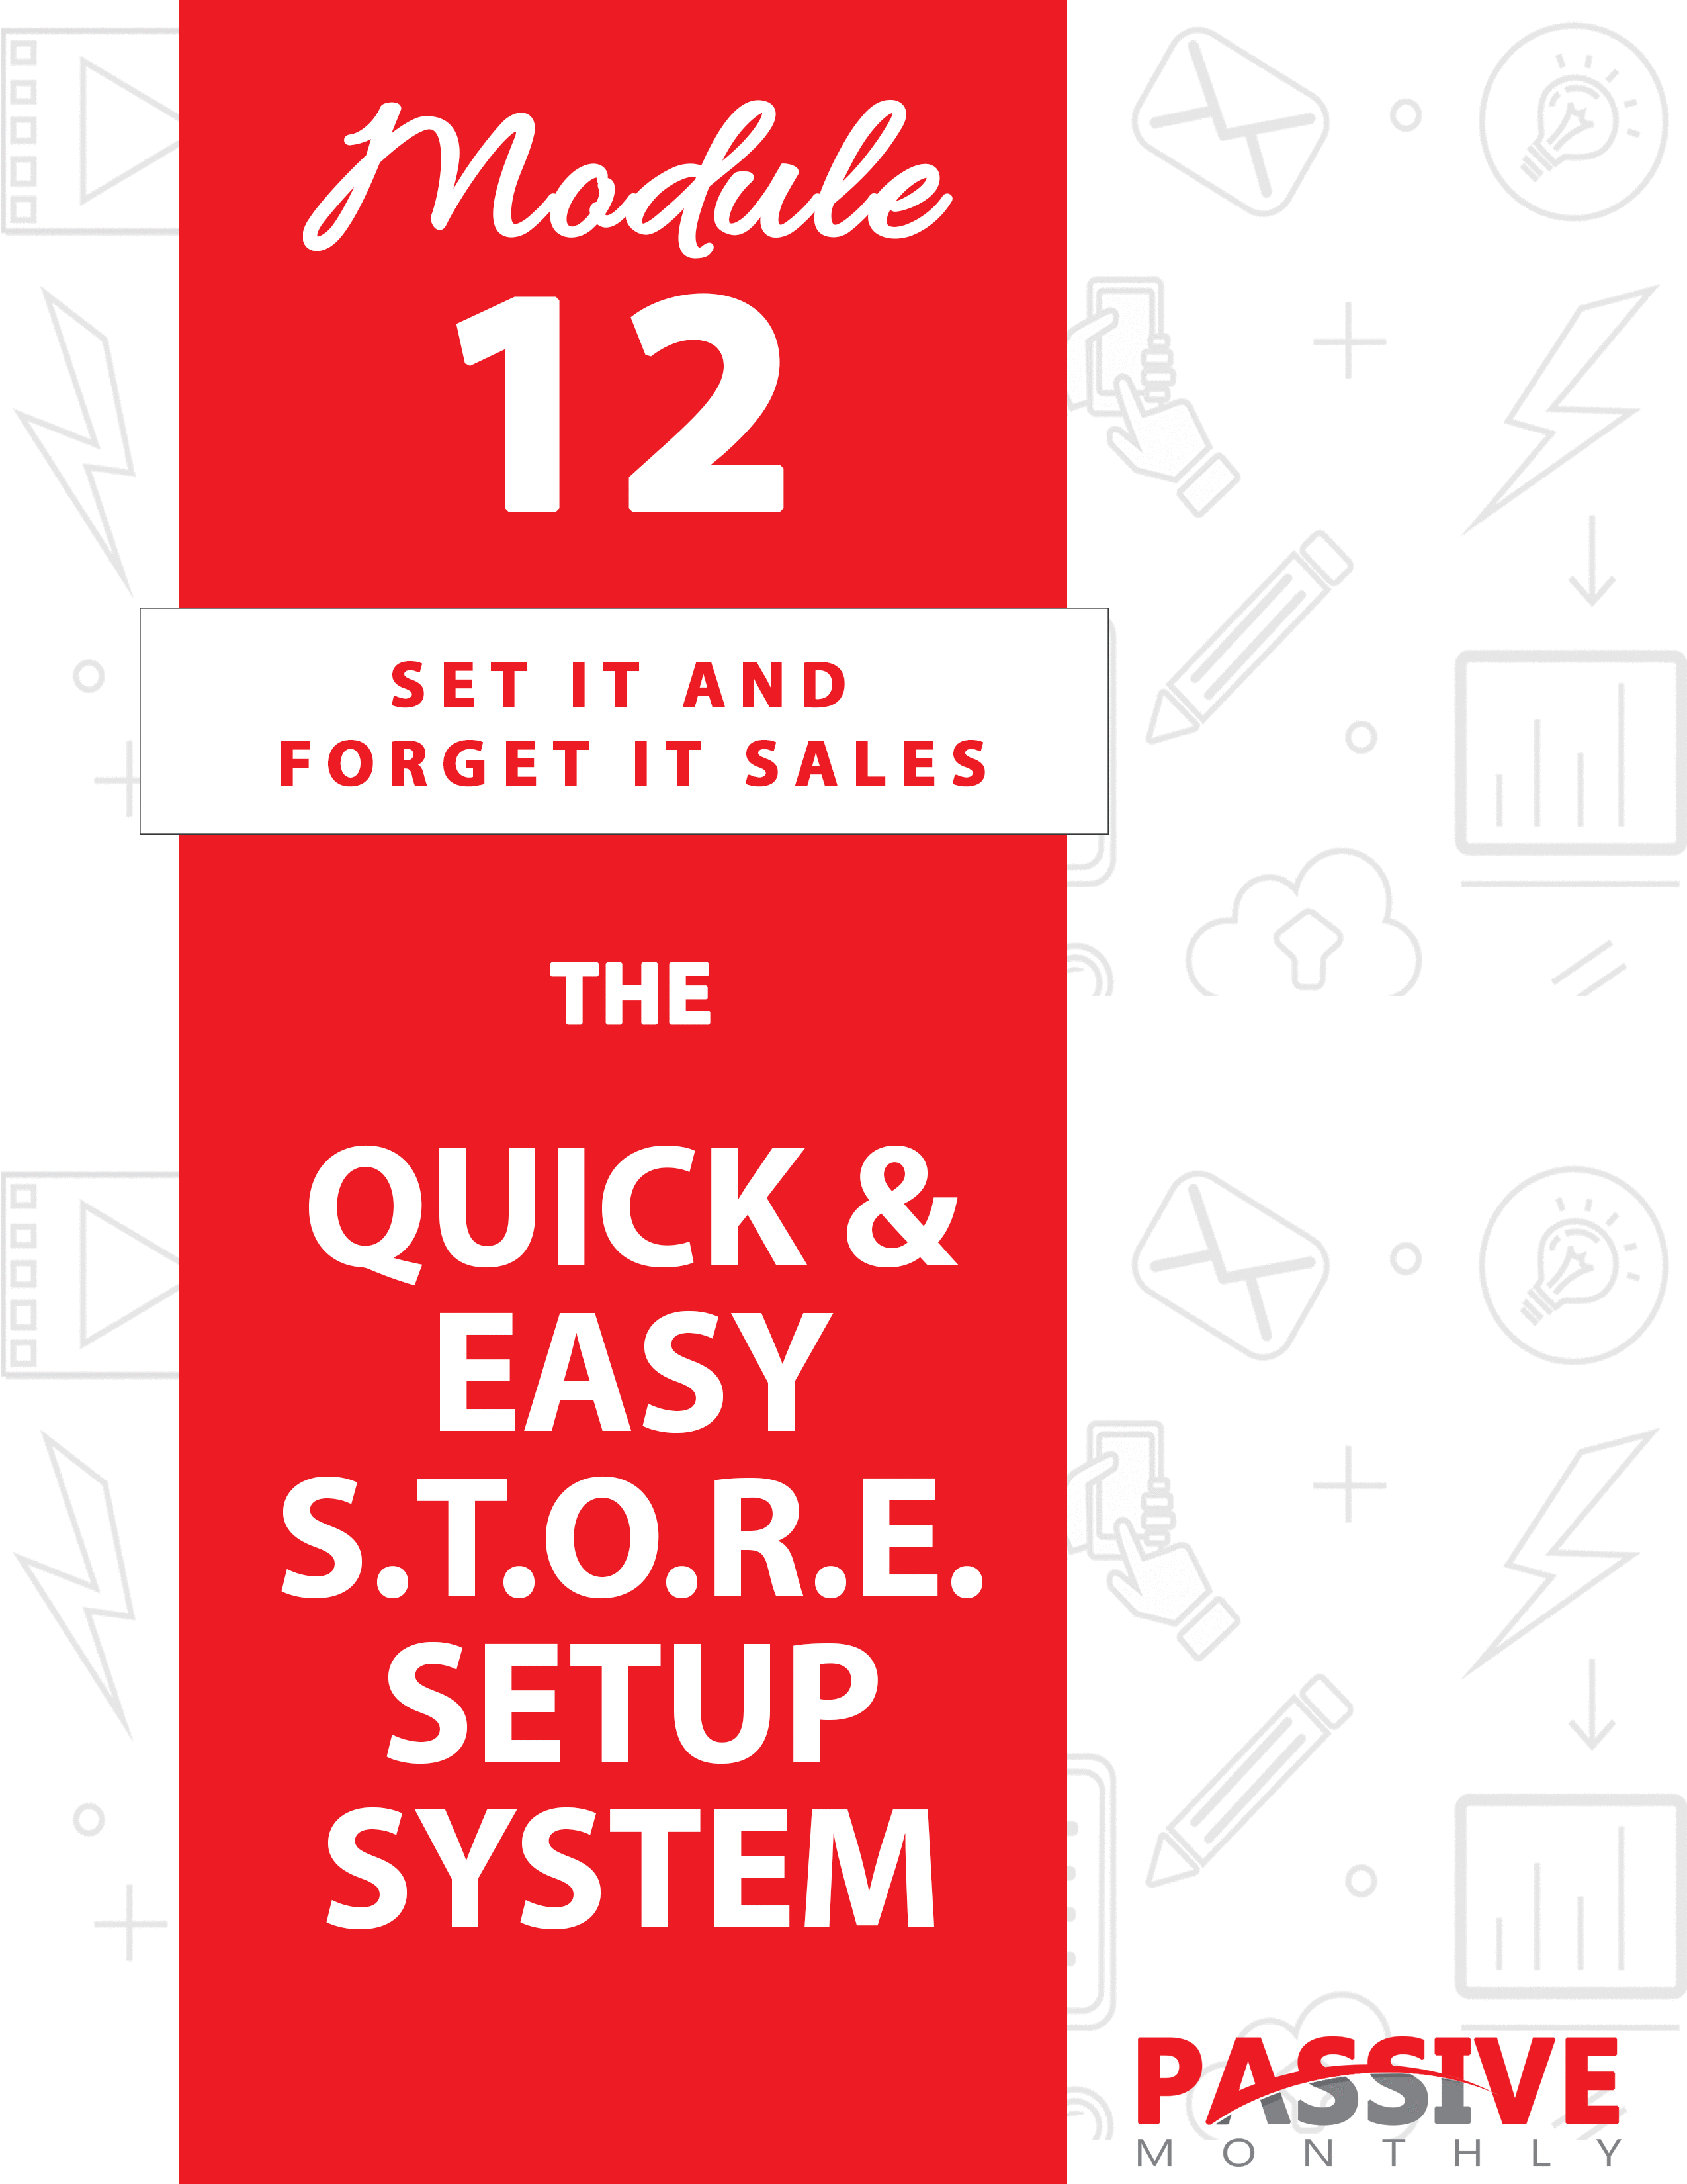

You DO NOT Have The Right To Sell Or Give Away
Any Portion Of The Content In This Document.

This Document Is For Your Personal Use Only

CLICK HERE For Additional Resources
To Help You Build Your Dream Business.

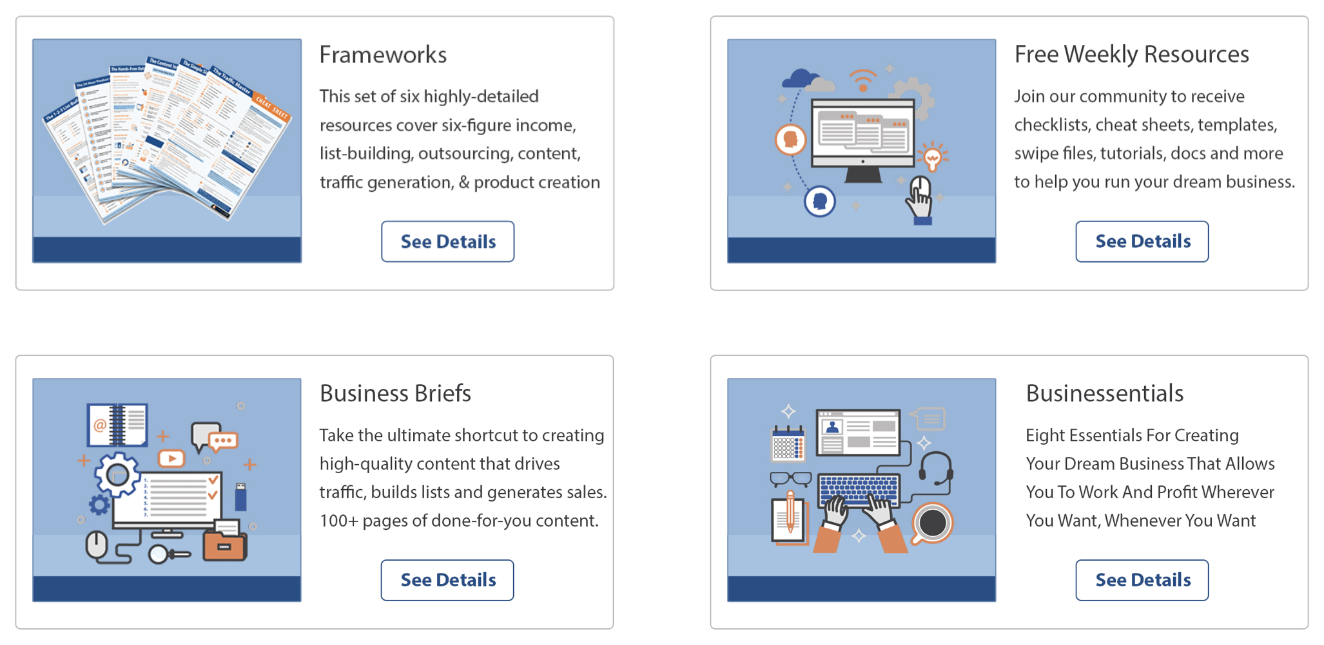

Insert Your Legal Disclaimer / Document Here

Strategy: What Is It?

Welcome to this issue of passive monthly, where you’re going to learn all about setting up a profitable storefront on your website!

You see, we’ve been talking a lot about digital products. And indeed, you probably sell your own information products (or you’re planning on it). But now I’d like too introduce to you an entirely different revenue stream that can be really profitable: selling physical products from a storefront!

Now, there are multiple ways that you can do this. For example, you could sell physical products as an affiliate. But the problem is, you don’t even know who your customers are when you do that, so you miss out on the most valuable asset: the customer list.

Another way to sell physical products is to make them and sell them on Etsy. But as you know, we’re looking for passive income opportunities, and making products (such as jewelry) doesn’t exactly fit the bill.

Still another good way to sell physical products is by setting up a storefront on a site like Shopify, and then using a drop shipper to fulfill orders. It’s a good business model, but you still have to handle customers, send the orders and payments to drop shippers, etc. And that means this isn’t a passive-income strategy either.

So, what’s the solution? This: set up a storefront on a platform like Zazzle or CafePress, which handles everything (payments, fulfillment, shipping). Once your storefront is set up, all you have to do is sit back and collect the cash!

And that’s exactly what this issue of Passive Monthly is going to teach you how to do. Here’s an overview of the S.T.O.R.E. System that you’ll be learning about in this issue:

- Select Products. Here you’ll decide what you’re going to sell.

- Team Up. Part of making this a passive-income strategy is that you can have someone else design the products – that’s what
you’ll do in this step.

- Open Your Storefront. Here you’ll pick your platform, create your products, and prepare to start selling.

- Reach Your Audience. In this step you’ll find out how to get your audience in front of your products.

- Evaluate Performance. Here you’ll learn about tweaking your storefront’s performance to maximize sales.

The best part is that you can easily add this income stream into your existing business! So, let’s take a closer look at how to do it…

System: How Do I Do It?

Now that you have a good overview of the passive-income S.T.O.R.E. System, let’s walk through each of the steps so you can set it up on your site! Read on…

SELECT Products

Ideally, what you want to do with this system is drop it into your existing business. And that means you’ll be selling products that are highly related to your main business (whether that’s an information product business or something else).

As such, for the purposes of this report I’m going to assume that you already have a market picked out. And that means that we’re going to start with the step of selecting what types of products to sell on your website.

What we’re talking about here are the types of products that you can create on sites like Zazzle.com, CafePress.com, and RedBubble.com. This includes, but isn’t limited to, products with designs you create such as:

- T-shirts.
- Hoodies.
- Pants.
- Caps.
- Jackets.
- Socks.
- Shorts.
- Scarves.
- Neck ties.
- Smart phone covers/cases.
- Tote bags.
- Wall art.
- Clocks.
- Shower curtains.
- Rugs.
- Refrigerator magnets.
- Pillow cases.
- Throws/blankets.
- Mugs and other glassware.
- Bumper stickers.
- License plate frames.
- Buttons.
- Baby items like bibs, pacifiers and burp cloths.
- Pet items like shirts, leashes, bowls and collars.
- Calendars.
- Greeting cards.
- Stickers.
- Stationary.

And similar items.

The storefronts mentioned above let you create these sorts of products and more. It’s up to you to figure out what sort of products YOU’D like to create.

As always, your market research will help you determine what types of products your market is already buying. Sites like CafePress.com sort their searches by popularity. So if you enter a search term (such as “dog collars”), it will show you the bestselling products. Enter more specific search terms, and you’re going to get an idea of what people in your niche are buying.

TIP: You can also browse marketplaces like Amazon.com and search for products in your niche such as t-shirts, pet items, baby items and more to gauge popularity.

As you do your market research, you’ll want to think about your audience in general, and your business specifically. What types of products is your audience interested in, and what types of products would your audience expect you to sell?

For example, if you’ve had a super-serious tone with your business up until now, and your audience has responded well to this tone, then trying to put out humorous content on t-shirts may backfire.

On the other hand, if you regularly inject a little humor into your communication with your audience (even if your business as a whole has a serious tone), then you can sell either “serious” or “humorous” items.

Let me give you a very basic example. Let’s suppose you cater to dog lovers. If your tone has been pretty serious up until now, then you may sell t-shirts and other merchandise with captions such as, “I love my cocker spaniel.”

If your business has a lighter tone, then you can certainly sell “I love my cocker spaniel” type merchandise, PLUS you can sell items that are funny such as, “I’d push you in front of a zombie to save my dog.”

You’d also want to take into consideration your audience’s bigger viewpoint with regards to your niche. If your dog lovers also rescue dogs, then you might create merchandise that say things such as, “Adopt, don’t shop.”

Keep in mind that these are just guidelines. Your audience may behave much differently than these guidelines would predict. That’s why the only way to know for sure what works is to TEST your ideas.

Need a quick and dirty way to test them? Use them on social media. Create memes, quotes and graphics that are similar to what you want to put on merchandise… and let them loose on platforms like Facebook and Twitter. This is a fast way to see what types of content your audience responds to the best. While a lot of shares on a meme doesn’t guarantee people will buy a similarly themed shirt (for example), it does give you a starting point.

Now, when you think about what sorts of products to create, there are two directions to go with it, depending on your niche:

- Create items that are directly useful to members of the niche. If you’re in a niche catering to those with babies, then sell baby items (pacifiers, receiving cloths, bibs, etc.). Or if you’re selling to dog lovers, then sell dog items such as bowls, collars and leashes.

- Create items that are appreciated by your audience. For example, if you sell to dog lovers, then you create shirts for the owners to wear that are funny or spread a message. In this case, you’re not creating items for the dogs – just the owners.

Now, ideally, you’d do both of these things whenever possible. Going back to the dog niche – you’d create products for both the owners and the dogs. Or the baby example – you’d create products for both babies and their parents.

TIP: If you’ve built a “tribe” (community) around your brand, then keep in mind you can also sell branded merchandise. People are proud to wear brands around which they feel they have a bond – just look at brands as diverse as Chevy, Hollinger, Apple and similar items. If you’ve built a strong community that feels bonded, then they may want to wear your logos too (and that’s good advertising).

Now let me give you a few examples of the types of merchandise you might sell to different niches:

- “I’m already planning my next vacation” type merchandise for those in the travel markets.

- “Daddy-to-be” type merchandise for new fathers.

- “My cat is smarter than yours” type merchandise for cat lovers.

- “Gardening is life” for gardeners.

- “Runs on soda, pizza and PayPal receipts” jokes for online marketers.

- Message merchandise for specific causes related to your niche (environment, animal rescue, political, etc.).

- “I’d rather be _____” merchandise for various hobbies. E.G., restoring my car, petting my dog, bowling, fishing, etc.

These are just generic examples (perhaps not even of interest to these niches), but I just wanted to kick start your brainstorming process. Let your creativity run wild here! Try to think up memes, funnies, slogans and concepts that others in your niche aren’t doing.

So, go ahead and spend some time both brainstorming and researching your niche to get a feel for what types of products they’d like. Remember, social media is a great place to see what your niche likes.

Once you’ve decided what sorts of products you’d like to create, then move onto the next step…

TEAM Up

As you might suspect, even creating a text-only piece of merchandise (like a mug with a funny message) requires a little creativity. You need to use just the right font to get the message across.

In other cases, you’ll need something more complex – a logo, a design, or some other type of graphic to put on the products. And if you don’t know the ins and outs of designing these graphics, your end product isn’t going to look good. It won’t print well on the product. And worst case, you’re going to look
like an amateur (and no one will buy your products).

The good news is that you don’t need to create these designs yourself. Instead, you can hire someone to do it for you.

You can find a potential designer in multiple ways. Depending on what you need, you can hire someone to simply turn your vision into a design to put on the merchandise, or you can hire someone to help you create the branding and designs. (If you go with the latter – someone to help with the creative aspect—then of course you can expect to pay more for their services.)

You can post your requirements on a freelancing site such as upwork.com, guru.com or freelancer.com. You can also search Google for freelancers. Here are some of the types of searches you may perform (depending on your needs):

- Graphic designer
- Brand designer
- Logo designer
- T shirt designer

TIP: To make your searches more specific, include keywords such as “freelance,” “hire” or “for hire.”

Be sure to do your due diligence to ensure your designer is professional and produces high quality work. To that end, check the following:

- Does the designer have a portfolio of polished work whose overall “flavor” matches what you’re seeking?

- Does the designer have good feedback/ratings on freelancer sites (where applicable)?

- Does the designer have all the skills you’re seeking (e.g., both creative skills for things like logo design, as well as the actual
graphical skills to render the design)?

- Does the designer have a good reputation? (Search the designer’s name in Google, and be wary of anyone who has a pattern of complaints from customers, business partners or other associates.)

- Is the designer affordable? You shouldn’t shop around just based on price, as you get what you pay for. However, you do need to make sure the designer’s pricing falls within your budget.

- How does the designer handle changes (with regards to fees)?

- How many designs will a logo or brand designer give to you to choose from initially?

Take note: when you search for a designer, be SURE to choose one who has experience with creating designs for physical products. That’s because the requirements for printing on physical products are quite different than those for rendering graphics on websites. Simply put, designs that are going to be on print products need to have higher resolutions.

TIP: You may want to jump to the next step (selecting your platform) before hiring your designer. That way, you can show your designer the EXACT requirements you’re looking for in terms of size and resolution of the graphics.

Once you’ve selected a designer, then provide a detailed brief of what you’re seeking. Let them know the purpose of the design, the “tone” you’d like to set (e.g., humorous, inspirational, etc.), and the type of person you envision using the merchandise. Be as specific and as detailed as possible, as that’s the best way to get a good end result.

TIP: Be very careful that you don’t infringe on anyone else’s trademark. For example, if you’re creating products for car restoration enthusiasts, you can’t create merchandise with other people’s
trademarks (e.g., Corvette, Ferrari, Ford, etc.).

Once you’ve created your designs, then it’s time to set up your store. That’s what is next…

OPEN Your Storefront

You now know what kind of products you want to create and you have a designer to create them for you. Now you need to choose a storefront.

What I suggest you do is stick with one of the big three, which include:

- Zazzle.com.
- CafePress.com.
- RedBubble.com.

Zazzle and CafePress are very similar in terms of the types of merchandise they offer. They both offer a wide range, from baby supplies to pet goods to clothing to home décor (and everything in between).

RedBubble is more geared towards artists, and so those who come to their marketplace to find goods are likely to be people who are looking for artwork. Nonetheless, you can still make a broad range of products on their site, including lots of clothing and home décor.

Your first task is to visit these three sites in order to determine which ones carry the products that you want to sell (e.g., t-shirts, phone cases, bumper stickers, etc.). If you’re looking to sell the widest range of products, then you’ll want to focus on Zazzle and CafePress.

In all three cases, these platforms do not charge fees, and instead they take their commissions only when you sell a product. Generally, these platforms let you choose your pricing. The commissions vary depending on which platform you choose and which features you utilize.

The basic structure works like this: the platform gives you a base price for a product (such as a t-shirt), and then you choose your markup. Everything above the base price is your profit.

For example, the base price for a long sleeve t-shirt on CafePress is $19.99. If you want to make $5 per order, then you can charge $24.99 per shirt.

To learn more about the base pricing for the products on CafePress, go to: https://www.cafepress.com/cp/info/help/pricing_policy.aspx.

To find out what RedBubble’s base pricing is for their various products, go here: https://help.redbubble.com/hc/en-us/articles/206409096.

Zazzle’s pricing isn’t as neatly laid out, but you can get their base pricing by viewing individual products. You can start your search here: https://www.zazzle.com/create. (Click through on a product until you reach the design page, at which point it will show you a price.)

You’ll need to determine your pricing strategy upfront. Are you going for lower-priced goods, but making up the profit in sheer volume? Or are you going to price your goods higher?

Keep in mind that CafePress and Zazzle tend to run a lot of sales and offer plenty of coupons, and these discounts will affect your royalties. You need to be prepared to absorb these discounts by pricing your items higher for when the site runs sales, or simply price your item at exactly what you want to sell it for, and prepare for lower royalties.

NOTE: There is only so much that people will pay for items like t-shirts, no matter how clever it is. As such, you’ll want your pricing scheme to depend on volume. Lower-priced items will make more sales… and in turn, you’ll get more repeat sales too.

If you’re not sure what sort of pricing scheme to use, then check with your competition on the platform you intend to use. There you’ll be able to see what the bestsellers in your niche are priced at – you’ll want to use similar
pricing.

Once you’ve picked your pricing and your platform, then you can start setting up your storefront on your selected platform. Each of the three sites above have extensive onsite documentation and user interfaces that makes it easy to create your products. You’ll need to create an account, and then follow the onsite instructions for creating your products.

However, if you’re uploading a lot of different designs and pricing the products, you may find this step tedious. Once again, you don’t need to do it yourself if you don’t want to. Go ahead and post a project on a freelancing site (such as upwork.com) to find someone who’s willing to set up your storefront and products.

Once you’ve created your products, the site will then give you a link to your storefront. This is the link you’ll be advertising, which you’ll learn about in the next step of the passive-income S.T.O.R.E. System. Read on…

REACH Your Audience

Now that your store is all set up, it’s time to get your shop in front of your audience. Here’s how to do it…

Optimize Your Storefront

These big platforms are well-established in the search engines. As such, if people are looking for specific types of merchandise when they’re searching Google, they’re very likely to land on these sites (especially Zazzle and CafePress). And if they’re searching for specific merchandise from the platforms themselves, you’ll want to make you’re your store turns up in those search results. That’s why you’ll want to optimize your store for the search engines.

Here’s how:

Step 1: Uncover Your Keywords

First thing, you need to figure out what words your market is using to find products similar to yours. Obviously, you can guess some of them (e.g., “dog t-shirt” or “funny dog shirt”). However, in order to discover keywords you may not have thought of on your own, you’ll want to use a keyword tool such as MarketSamurai.com, WordTracker.com or your favorite tool.

You can start with a broad search related to your niche (such as “dog training” or even just “dogs”), which will give you a good overview of what people search for. Then you can search for more targeted keywords (such as “dog shirt”) to learn about related searches and variations.

What you’ll want to do is focus on the longtail keywords. These are the keywords that may not have as many searches, but they also don’t have much in the way of competition. That means you have a good chance of ranking well – and usually, these words tend to be ultra-targeted, so they bring warm traffic to your store.

Once you’ve picked your keywords, then move onto the next step…

Step 2: Optimize Your Shop

Now you need to include your keywords in your storefront.

But heads up: don’t cram your shop’s text full of keywords. If you do this, the search engines will see it as spamming, and your shop will end up getting penalized and ranked so low no one will find your shop.

Secondly, cramming your text full of keywords makes it hard-to-read for your human visitors. Your text needs to be inviting, engaging and compelling in order to keep your prospects hooked. So be sure to write descriptions with your human readers in mind FIRST (and search engine bots second)

That’s why you’ll want to include your keywords at a 1% rate, which means an individual keyword will appear once for every 100 words of text. You can include three or four different (yet related) keywords on each page.

Here are some of the places you can insert your keywords:

- Your product title (e.g., “funny dog t-shirt”).
- Your shop description.
- Your product descriptions.
- Your bio/about description.
- Descriptions for your shop sections, where applicable.

Next…

Promote From Your Platforms

If you’re snapping this income stream into an existing business, then you already have an existing audience. That means you need to get your shop in front of this audience. Here’s how:

- Include prominent links to your shop on every page of your website. In other words, including this link in your main navigation menu.

- Blog about your store. Get readers excited about it. You can even feature a new product every week at the top of your blog, in the sidebar, or some other prominent place.

- Tell all your subscribers and followers. Send emails and tell people on social media about your store. Each week, send out emails and broadcasts that feature certain products.

And speaking of social media…

Use Social Media

If you have merchandise with funny, inspirational or clever sayings, then you can make your products go viral on Facebook, Twitter and other social media.

What you need to do is take a screenshot of your product (such as a t-shirt).
Obviously, this needs to be something that people will like, share and comment on because it’s funny, offensive, unusual, inspirational, clever, spreads a message, etc. This might be an inspirational quote, a funny saying, a meme, a comic, or something else that’s shareworthy.

You’ve probably seen some of these t-shirts crossing your Facebook feed. For example, one popular t-shirt that gets shared a lot is, “I just want to drink coffee and rescue dogs.” And of course you’ve probably seen your friends sharing plenty of political merchandise.

Those are just examples. You can get products shared across a variety of niches. E.G., imagine a t-shirt that says, “I’m an online marketer. What’s your super power?” You can bet plenty of your marketer friends would share this image.

Of course what makes this strategy work is that you include a clickable link to that product in the text that accompanies the image. Anyone who really loves the product (and shares the image) is likely to purchase the product too.

TIP: Be sure to also include the link on the image itself, just in case the image and your post get separated from one another.

This sort of viral post works really well on platforms such as Facebook, Instagram and Twitter.

NOTE: Viral marketing isn’t the only way to take advantage of social media. You can also use Facebook’s paid advertising platform. This platform lets you narrow your audience down by demographics as well as interests and behaviors.

For example, if you’re selling dog t-shirts for those who rescue special-needs dogs, you might narrow your audience down to those in the UK, United States and Canada who’ve shown an interest in various dog rescues (e.g., Blind Dog Rescue). That way, you know that you’re getting your ad in front of a highly targeted group.

And now the last step of the passive-income S.T.O.R.E. system…

EVALUATE Performance

Some of your products are going to become really popular and sell well. Others… not so much. It’s your job to keep careful tabs on your sales so you know which products are doing well and which ones are flopping. You can invest your time and resources into promoting the products with the best conversions.

For example, if you have a particular t-shirt that sells like crazy, then you may want to set up a paid advertising campaign that promotes nothing else but this particular t-shirt. You might also promote this item regularly and more frequently than other products on your blog, your social media platforms and in your newsletter.

Here’s the bottom line: about 20% of your products are going to create 80% of the profits. You’ll make more money if you invest 80% of your time and resources in promoting those 20% of products.

Now that you know how the S.T.O.R.E. System works to put a profit in your pocket, let’s take a look at some profitable shortcuts…

Shortcuts: What Else Can Help?

Are you ready to make the passive-income S.T.O.R.E. System even better, easier and more profitable? Then take a look at these pro tips, tricks and shortcuts…

Create Compelling Product Descriptions

As you already learned, it’s a good idea to include in your product descriptions the keywords your audience uses to search for that type of product. Some marketers focus on the keywords, and end up with a pretty bland product description.

Don’t do that.

Instead, you need to create benefit-driven product descriptions that evoke emotion and get your prospects thinking about what it would be like to own and use the product.

For example, let’s suppose you’re selling a rescue-oriented dog t-shirt.

Here’s an example of typical, bland description (this is a real example taken directly off CafePress):

Rescue dog is an illustrative drawing of a dog's silhouette. He wears a heart charm on his collar because dogs who are adopted are loved.

Here’s an example of a product description that gets prospects excited about buying the short, plus it includes a call to action at the end:

You’re sure to turn heads at the dog park, the vet’s office, the dog expo and at the rescue with his comfortable and beautiful illustrated dog t-shirt. Show your love for your rescue dog, and let the world know you support dog rescues by clicking the order button below now!

See the difference? The first one is literally a product description. The second one gets prospects excited about “showing off” their new shirt and showing their love and support for rescue dogs. That sort of emotionally driven copy is much more effective than a mere description!

TIP: Need help writing these sorts of benefit-driven, emotion-evoking descriptions? You can outsource this task to a copywriter.

Next…

Build a Strong Brand

You don’t want to just open a store and start selling merchandise. Instead, you need to consider first what TYPE of merchandise you’ll sell, and how these products will make your customers FEEL. Once you’ve determined the feeling behind your products, then you can create a strong brand that reflects this feeling.

Let me give you an example of what I’m talking about. Godiva Chocolates are all about giving customers a feeling of luxury and indulgence. These feelings are reflected throughout the branding, which includes the pricing, the website, the ordering process, the packaging, and more.

Another example: take a look at Pamper’s diapers. Again, the branding is reflected in the name and all throughout the website (from the colors to the graphics to the text). It elicits feelings of love and comfort (which is what parents want their babies to feel).

Point is, a brand is about a feeling. And you need to decide what feeling your products evoke, and then build a brand that reflects that feeling. Your brand will include:

- Your store name.
- A logo.
- A slogan.
- Web design that incorporates your brand colors.

You’ll then incorporate your branding all throughout your store, from the product descriptions to the colors to the products themselves.

Here’s an example of a store with whimsical products, and branding to match that whimsy: https://www.zazzle.com/tshirtdujour.

Next…

Get Affiliates

Zazzle, CafePress and RedBubble all have affiliate programs. You can find them here:

- https://www.zazzle.com/sell/affiliates

- https://www.cafepress.com/content/cp-partners/
- https://www.redbubble.com/p/12-affiliates

This means that you can encourage your existing affiliates to join the appropriate program, and start selling your merchandise. You can also recruit new affiliates by blogging about the affiliate program, telling your social media contacts, and telling your newsletter subscribers.

Take note, however – these platforms run the affiliate program entirely, so it is completely hands off for you. However, when someone joins one of these programs, they then have the ability to promote ANY product on the platforms. That means that your affiliates can promote your competitors’ products too.

As such, what you’ll want to do is make promoting your products more attractive. You can’t change commissions, because you don’t run the affiliate program. You can’t hold affiliate contests, because you have no way of verifying if a particular person sold what they said they sold.

However, what you can do is create marketing materials for your affiliates, such as banner ads and other graphics, emails, rebrandable lead magnets, videos and more. That way, any affiliate that you find through your own site will have access to these materials, which makes it “copy and paste” easy for them to start promoting your products.

Hold Contests

Earlier you learned about creating viral posts on social media with screenshots of your most clever products. Now here’s a way to turbocharge that strategy: hold a random-draw contest where the winners receive the product.

TIP: Check your local laws and regulations before you run a contest on social media or anywhere else.

What you’ll want to do is use a software called Rafflecopter.com to help you run your contest. This app gives your contestants extra entries for
performing certain tasks. That means that people who join your list, “like” your Facebook page, and share your content with their friends can get an extra entry into your contest for each of those tasks.

End result? You get MORE subscribers, MORE followers on social media, and MORE prospects seeing your products. Rafflecopter is a great way to turn a contest into a viral wave. And since you’re giving away your merchandise as products, you know that only those who are interested in your niche will be joining the contest, so your list and followers will be highly targeted!

Conclusion

And there you have it – you now know how to set up your own S.T.O.R.E. and sell in-demand products to your existing audience! Here’s a quick recap of the system:

- Select Products. Here you’ll decide what you’re going to sell (t-shirts, stickers, clocks, pet supplies, etc.).

- Team Up. Part of making this a passive-income strategy is that you can have someone else design the products – that’s what you’ll do in this step.

- Open Your Storefront. Here you’ll pick your platform, create your products, and prepare to start selling.

- Reach Your Audience. In this step you’ll find out how to get your audience in front of your products.

- Evaluate Performance. Here you’ll learn about tweaking your storefront’s performance to maximize sales.

This is a really exciting passive-income stream, especially if you aren’t selling physical products yet. That’s why you’ll want to put it to work for you ASAP – and that means taking action by starting to research and plan your store today. You’ll be glad you did!

