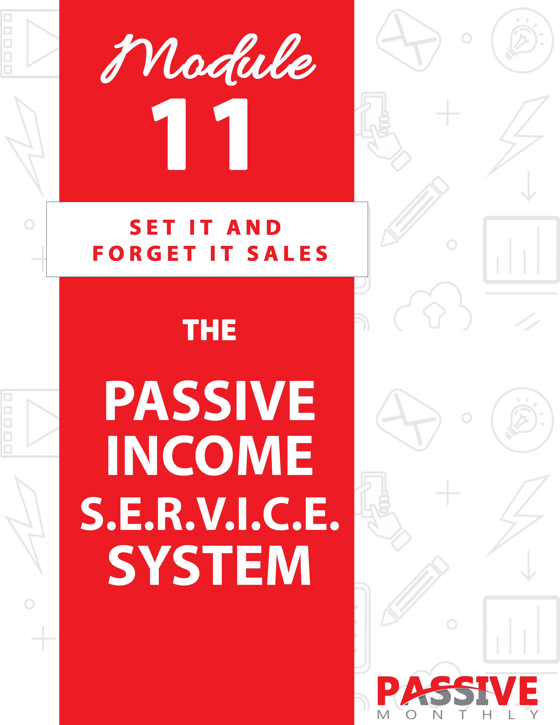

You DO NOT Have The Right To Sell Or Give Away
Any Portion Of The Content In This Document.

This Document Is For Your Personal Use Only

CLICK HERE For Additional Resources
To Help You Build Your Dream Business.

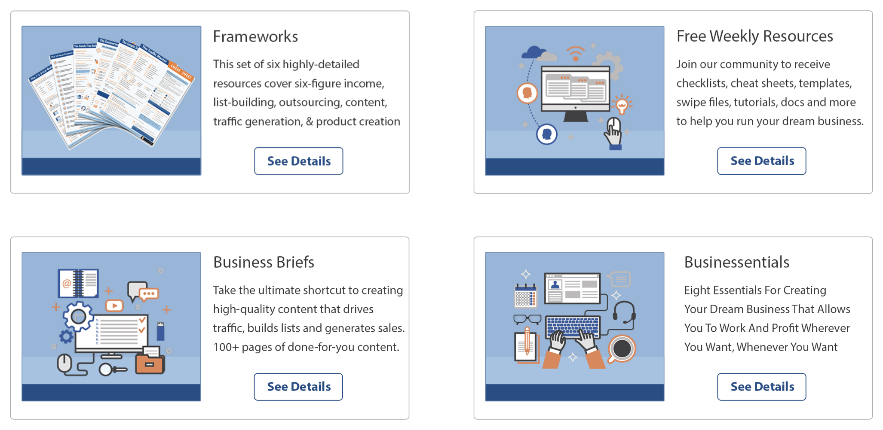

Insert Your Legal Disclaimer / Document Here

Strategy: What is it?

You’ve probably heard that selling a much-needed service can be really profitable. And you’ve also probably heard that you shouldn’t trade dollars for your time.

Guess what?

Both of those things are true.

Because think about it…

If you sell services, then your income is capped by how many hours per day you’ll be able to work. Compare that to selling products, where you can make money even when you’re not actively working.

Except here’s an idea…

What if you sold services, but you recruited
a team of freelancers to do the actual work?

Think about it – this would turn this popular money-maker into passive income stream for you. It would be virtually hands free, especially once you found several long-time clients. They’d tell you what they need, you hand off the instructions to your team to do the work, and you’d enjoy a nice pay day once the project is complete.

This is a proven system that works – and now you too can put it to work for you! Read on…

System: How Do You Do It?

If you want to make money with services, then you’ll want to put the Passive Income S.E.R.V.I.C.E. System to work for you, which is where you sell services to business owners. Here’s a quick overview of the system:

- Select a Service
- Estimate Pricing
- Research Freelancers
- Verify Expectations
- Install a Sales Funnel
- Create an Advertising System
- Empower Your Team

What all is involved in each of these steps of the system? Let’s walk through each step of the system…

SELECT A SERVICE

First off, you need to decide what service (or related services) you’d like to offer. Since you’re selling to business owners, you can focus on those services that business owners need. Examples include:

- Content creation, such as newsletters, blog posts, social media posts, etc.

- Product creation, such as lead magnets, ebooks, etc.

- Video production, which may include everything from video graphics to voice overs to editing.

- Copywriting (sales letters, ads, promotional emails, etc.).

- Graphic design.

- Web design, development and maintenance.

- App/software/plugin development.

- Logo design.

- Affiliate program management.

- Customer service.

These are some of the most common services. To get even more ideas, visit freelancing sites such as https://www.upwork.com/, www.guru.com and www.freelancer.com.

As you’re thinking about what services you’d like to offer, consider these issues…

Picking a Service in Which You Have Some Skill

This isn’t an absolute requirement, but it helps to know something about the service you’re offering. It’s even better if you have some skills in it yourself.

Here’s why…

If you have some experience, then you’ll be able to quickly recognize whether your freelancers are doing a good job. For example, if you know the difference between well-written sales copy and sales copy that isn’t likely to convert, then you’ll be in a better position to hire the best freelancers and offer the best work to your clients.

Secondly, if something should happen that one of your freelancers can’t deliver on a deadline – and you don’t have another freelancer as backup – then you may be able to step in and finish the project. Sure, this means the business isn’t hands free – but in the early days of setting up your business, it can help you develop a good reputation.

Choosing a High-Paying Service – and Clients

There are some services that naturally come with higher rates, such as software development and copywriting. Generally, the more skill a service requires, the more you can charge. And that leaves room in the pricing for you to take a cut.

But here’s the thing…

Across every service, you’re going to find clients who shop around for rock bottom prices, and those who’re willing to pay for quality. You’ll want to seek out the clients who recognize and are willing to pay a premium for quality, as here too there will be more room in the pricing for you to take your cut.

Offering Related Services

One good way to increase the earnings for your service business is to offer a set of related services. In many cases, this will mean hiring a team of freelancers who can provide these related services.

For example, you might pull together a team who’s skilled in product creation (books), content creation (blog posts, etc.) and copywriting. That way, you can offer a full-service shop that includes your team being able to both create and market the service.

So, go ahead and consider what sort of services you’d like to offer. Then move onto the next step of the S.E.R.V.I.C.E. system…

ESTIMATE PRICING

Now you need to figure out how much you’re going to charge for your service. This will require both a little research and some planning with regards to your business model.

Here’s how to do it…

Step 1: Determine how much freelancers charge for the service.

You can’t decide how much you’re going to charge for a service until you find out what freelancers will charge you. As such, you’ll need to do your research to find out what the going rates are for the service you have in mind.

What you’ll find is that there are a wide range of prices for the same service. As mentioned previously, you’re going to want to focus on the mid to high
price ranges. That’s because, as a general rule, those with low prices tend to have low skills or a lack of professionalism. You’re more likely to find skilled and reliable freelancers in the mid to higher price ranges.

TIP: Ideally, what you’ll want to do is hire a mid-range freelancer who has a good reputation and does great work, and then you charge towards the higher end of the price range. We’ll talk more about how to that later.

Next…

Step 2: Decide how much money you want to make.

The next thing you need to determine how much money you’d like to make for each project. Obviously, it needs to be within the confines of what the market will bear and what your freelancers will charge you.

For example, let’s suppose you’re looking at copywriting, where the good copywriters charge thousands per project. Let’s say they charge $2000 for an average project (and clients are used to paying fees in that ballpark).

It’s not too much more for clients to pay around $2500 – this gives you $500 for the project while the freelance copywriter gets their usual $2000 fee. The market would certainly bear that.

Now consider if you wanted to get $2000 per project – meaning you double your freelancer’s rates (and take $2000 for yourself and $2000 for the freelancer). The clients who are currently paying $2000 aren’t going to pay $4000 for the same service. So, this means you’ll need to either look for a higher-paying clientele (which is quite possible) or take a lower commission.

Point is, for this step you’ll need to do some research to understand the different types of clients and what sort of prices they’ll pay. For example, corporate clients tend to be used to paying higher prices. Mom and Pop business owners often look for bargains due to having smaller budgets.
Business owners in certain industries will also look for lower pricing due to
their thin profit margins.

So, do some research, especially in the industries and types of clients you’re interested in working with. Then move to the final step…

Step 3: Draft your pricing scheme.

Now that you know how much freelancers charge, what sorts of prices different types of clients are willing to pay, and how much money you want to make, you can now draft your pricing scheme.

I say “draft,” because for now it’s a working guideline. You may tweak this as you build your freelancing team (as different freelancers will charge you different rates), and as you recruit clients who may have different thresholds when it comes to hiring freelancers.

For example, let’s suppose your research as determined that your clients will pay around 20 cents per word for well-written content. And let’s suppose you’ve found freelancers who produce the desired level of quality for 15 cents. You can then charge clients 20 cents, which gives you a 5 cents per word “commission.” For example, if a client needs 20,000 words, you’ll make $1000 (5 cents per word) on that project.

That’s just an example. Go ahead and figure out what flat rates you intend to charge for each service you offer. Then move onto the next step of the S.E.R.V.I.C.E. system…

RESEARCH FREELANCERS

You’ve done some preliminary, general research to help you figure out your pricing scheme. Now you need to do some deep research so that you can start putting together a good team of freelancers.

NOTE: For this step, it’s a good idea to have some small projects lined up already so that you can test out your “short list” freelancers to see if you work well together. In many cases, you can test these freelancers with your own business.

For example, if you’re putting together a team of writers, then you can test these writers by having them create content for your own business (such as a blog post about outsourcing content creation).

So, here’s how to find and weed through these freelancers…

Step 1: Decide how many freelancers you need.

First, you need to think about what all types of services you’re offering. For example, if you want to offer a variety of writing services that range from blog posts to sales letters, you may need to hire both regular content writers and copywriters. (Some copywriters will do all types of writing, although most tend to specialize since copywriting is a higher-paid task.)

Secondly, you’ll likely need to have at least one or more “backup” freelancers. Since you’re hiring subcontractors (freelancers) rather than employees, you can’t control their time. This means that you may approach a freelancer about a project and find out that they don’t have any time in their schedule, in which case you’ll turn to one or more backup freelancers to see who’s available.

TIP: Plan on starting small and scaling up. For example, assemble a team of one primary freelancer and one or two backups for starters, and hire more as your business grows.

Next…

Step 2: Draft a “big list” of potential freelancers.

Now you need to find as many potential freelancers as possible. Here you create a big list of prospects, and then in the next step you’ll do your due diligence to shorten that list.

Here are ways to find potential freelancers:

- Post projects on freelancing sites. These sites include upwork.com, freelancer.com and guru.com. Those are the bigger and more well-known/established sites, which is what you should stick to in order to find higher-quality freelancers.

- Search Google for freelancers. For example, if you’re looking for writers, use a search such as “hire ghostwriter” or “ghostwriter for hire.” (Be sure to check the sponsored ads alongside the regular results.)

- Ask your contacts and colleagues. Ask on social media, ask directly via email to your closest friends, blog about your need for freelancers, etc.

- Visit business and freelancing groups. You can search Facebook for business groups, as well as searching Google (e.g., “business forums” or “freelancing forums”). Where allowed, ask for recommendations.

- Post want-ads. This is a great option if you want to work with local talent, in which case you can advertise locally (in local newspapers, via the local “swap and shop” groups on Facebook, etc.).

NOTE: Be upfront with your freelancers about the fact that you’re reselling their services (AKA they’re your subcontractors). If you’re not upfront with them or try to keep them in the dark, they may be upset later to discover that you weren’t completely straight with them about your business.

Don’t worry about freelancers trying to “steal” your clients. Most freelancers are doing what they do because they like the work, and many of them struggle to find their own clients since marketing isn’t in their wheelhouse. So if you can produce a steady stream of clients for them, they aren’t going to do anything to jeopardize your business relationship.

Now that you have a list of potential freelancers, go to the next step to shorten the list…

Step 3: Do your due diligence.

This is the step that takes some time, but it’s well worth your investment of time since it will ensure you’re only working with freelancers who produce high quality work on time. And that saves you time, money and heartache in the long run.

Here’s how to do your due diligence:

- Check prices. You want to make sure the freelancer you’re researching falls into the acceptable range of prices that you decided on earlier.

- Review portfolios. Be sure the potential freelancer produces high quality work. If no samples are readily available, ask for them. Check that the freelancer has plenty of experience completing projects similar to the sorts of projects you’ll be assigning. For example, if you expect to recruit clients who need technical writing in a certain field, then be sure your freelancers are qualified to do this.

- Ask for references. And be sure to actually contact these references to see what they have to say.

- Check feedback (where applicable). If you hired a freelancer from a freelancing site, then check the onsite ratings and feedback.

- Do a Google search. Search for the freelancer’s name, business name, website, and any other identifying information.

In all cases, you’re looking for evidence that the freelancer has a long, established history of providing good work. Be wary of any freelancer who:

- Has been offering services for less than a year. Ideally, you want someone who’s had a stable business for at least a couple years.

- Has a pattern of complaints from customers or business partners. It’s one thing to have one disgruntled customer who complains on social media. It’s another to several customers complaining. (Avoid this freelancer.)

If you follow all the steps above, you should now have a short list of potential freelancers. Move onto the next step…

VERIFY EXPECTATIONS

Now what you’re going to do is assign small projects to your top contenders. This will help you determine if you work well with these various freelancers.

In some cases, it may become immediately clear which freelancers are the best fit for your business. In other cases, you may have several high-quality choices from which to choose, in which case you can make your final primary and backup selections based on factors such as price and availability.

Now, before you hire a freelancer to do even a small project, you’ll want to walk through the following steps:

- Offer a detailed brief. Your freelancer is by no means a mind reader, so offer as many details as possible as to what you want.

For example, if you need an article, then state the word count, the intended audience, the working title, the purpose of the article, and a detailed outline. You’ll also want to provide notes on the tone (e.g., “conversational tone”), as well as provide examples of what you’re looking for. The more details you can provide, the better the end result.

- Sign an agreement. You’ll need your attorney to create a contract that you can use with all your freelancers. This contract
will include items such as the scope of the project, payment details, delivery dates, what happens if changes are needed, and anything else you and your attorney deem important.

- Discuss expectations. Finally, you’ll also want your freelancers to know about your expectations, and vice versa. For example, if you’re working on a bigger project together, then you may ask your freelancer to give you an update every three days, every week, or some other agreed-upon timeframe.

Now that you’ve picked at least one primary and one backup freelancer with whom you wish to work, you can now move onto the next step…

INSTALL SALES FUNNEL

One of the keys to creating a profitable income stream with services is to set up a sales funnel. That’s because a business owner who needs one type of service from you will often need other related services as well.

So, here’s what you need to do next – sit down and figure out what all services you can upsell and cross-sell to your existing clients.

For example, let’s suppose you’re selling writing services. And let’s further suppose that you’re focusing on creating lead magnets. You can sell related services such as:

- An autoresponder series that’s related to the lead magnet.
- The creation of a lead page to help business owners promote their lead magnet.
- Blog posts to help direct visitors to the lead page.
- Product creation for full-length ebooks. (You might even offer to create a sales funnel full of products.)
- Sales letters for the other products in the sales funnel.

Another example: let’s suppose you’re selling web development services. You might also offer maintenance contracts, where business owners pay a monthly fee for your team to update and maintain the website.

Those are just two examples. Go ahead and plan out your own sales funnel. Then move onto the next step…

CREATE AN ADVERTISING SYSTEM

Now it’s time to start finding clients. Ideally, you’ll want to create an advertising system that’s composed of several advertising methods. You’ll learn about five of the best methods below.

Once you get several good clients with ongoing needs, you won’t need to advertise as much. Depending on how many clients you have, you may not need to advertise at all (unless you decide to hire more freelancers to handle the workload and grow your business). And when you get enough clients that you no longer need to advertise, that’s when this system becomes a truly passive-income system.

So, let’s talk about the different ways that you can recruit clients. Take a look…

Respond to Want Ads

The first thing you can do is seek out clients who are actually seeking out the services your team provides. Here’s where to find these clients:

- Freelancing sites. You can find projects posted by prospective clients on sites such as Freelancer.com, Guru.com and Upwork.com.

- Local want ads. Keep an eye out in your local newspapers and CraigsList.org for clients needing services.

- Business and freelancing groups. Join Facebook groups and online forums to start networking with business owners, some of whom may post about needing services.

Next…

Release Advertisements

You can place your own advertisements seeking out clients. And one of the best ways to do that is by using Google AdWords, which is a pay per click platform.

Here’s why: if you place advertisements on websites and in other general locations, then you’re hoping that someone who just happens to need your service will see your ad. In other words, it’s not very targeted.

PPC advertising is very targeted, because you can bid on keywords from prospects who are directly searching for freelancers to provide services.

For example, if you’re selling writing services, then you might bid on keywords such as:

- Hire ghostwriter
- Ghostwriter for hire
- Writer for hire
- Hire ebook writer
- Hire blog post writer
- Best ghostwriters
- Affordable ghostwriters

As you can see, people who search for the terms above are, in most cases, actively searching for a writer. That’s why this type of adverting is so effective. (Just make sure you have a compelling sales page for these visitors to land on when they click on your ad.)

Next…

Reach Out to JV Partners

Still another way to get clients is by joining forces with other service providers who are catering to business owners. You then each recommend your partner’s services to your current clients.

For example, if your team provides writing services, then you might swap recommendations with a web developer. The web developer can send his clients to you for writing services, and you can send your clients to the developer for web services. Just be sure that you only work with other reputable service providers, as sending your clients to someone who provides subpar work will not reflect well on you.

Recruit Clients Directly

The idea here is to approach business owners directly and offer your services to them. You can do this in multiple ways, including:

- Contacting a business owner online via email or through a social media channel. (Note: It’s better if you’ve already developed a business relationship first before you contact someone via online channels, as this can be construed as spam.)
- Calling a prospect.
- Sending a postcard in the mail.
- Visiting a prospect in person (at their place of business or at a trade show or other event).

In all cases, you need to focus on the benefits your prospective client will receive if they work for your team. This works even better if you have hard numbers or at least testimonials from other clients that backup your claims.

Let me give you an example script of what you might say to a business owner after you’ve introduced yourself:

“… The reason I want to talk to is because I manage a team of very talented sales copy writers who can boost your ROI, build your mailing list, and generate more sales for you.”

For example, last month we had a client who was struggling with a 1% conversion rate. My team was able to turn that around, and this business owner now has a very respectable 4% conversion rate. We were able to quadruple his profits virtually overnight.

So let me ask you – would you prefer to boost your conversion rates too, or do you want to keep doing what you’re doing?”

Next…

Request Referrals

One of the best ways to get new clients is by asking your existing clients to recommend you to their colleagues and friends. This is very effective, because satisfied clients are happy to refer you, and their referrals are very likely to hire you.

TIP: You can really super charge this method by creating a referral program in your business. That’s where you offer both the referral and your current client a reward if the referral places an order. For example, you might offer the current client and the referral 25% off their next order.

Another way to request referrals is ask your current subscribers, followers and visitors to refer their friends. In this case, the people from whom you’re asking referrals aren’t clients of your service business. Nonetheless, if they’ve grown to know, like and trust you, then they too will be happy to recommend your services to their friends.

In sum: once this advertising system is set up, you should have a nice steady stream of prospective clients coming into your business. Eventually, your best clients will have ongoing needs, which reduces or even eliminates the need to advertise regularly.

To keep things running smoothly, you’ll want to be sure to put in place this last step of the S.E.R.V.I.C.E. system:

EMPOWER YOUR TEAM

Even though you’re not actually doing the “heavy lifting” in this business since you’re not personally providing the services, you may find that you still have a pretty hands-on business. Maybe too hands-on. After all, you’re
looking to create a passive-income stream, so you’re doing yourself no favors if you find yourself tied to your computer just to keep your business running.

So, what’s the solution?

It’s this: you need to empower your team. This involves one or more of the following:

- Giving your team members the authority to make certain decisions. Once you’ve worked with your team and you’ve come to trust them, then you can give them the authority to make decisions.

For example, you might give your copywriter the authority to work with your graphic designer and make the final decision on layout options.

- Creating easy communication among team members. A good way to do this is to set up a work channel on Slack.com that you can monitor. That way, your team members can communicate and send files to one another, without you having to be the middleman.

For example, your copywriter will be able to send a finished letter directly to the graphics designer, who will complete the layout of the sales letter for the client.

- Putting a manager in place to manage the team. As your business grows, you may hire a project manager to oversee everything. This would completely remove you from the day-to-day decisions and the need to touch base with your team.

In sum…

So as you can see, this S.E.R.V.I.C.E. System can become a truly hands-free way to make money! Now let’s look at ways to grow this revenue stream
even more…

Shortcuts: What Else Can Help?

At this point you know how to set up and start running a profitable, passive-income S.E.R.V.I.C.E. business as parts of your existing business. Now let me share with you tips, tricks and shortcuts for making this business easier, better and more profitable! Read on…

Focus on Providing Great Customer Service

There are a lot of freelancers on the market who are providing the same type of services that your team is providing.

But here’s the thing: many of these freelancers are skilled at what they do, but they absolutely stink when it comes to customer service. They don’t prioritize it. And so their clients often leave them to find an equally skilled freelancer who’ll treat them better.

That’s where you come in. If your team provides great work AND you prioritize good customer service, your business is going to be in-demand and profitable. To that end, follow these tips:

- Under-promise and over-deliver. This means doing things such as finishing projects ahead of the deadline, or throwing in bonuses/extras for free. For example, if you’re creating an autoresponder series, toss in an extra email or two.

- Keep clients in the loop. Frequent communication is a key part of customer satisfaction in a service-oriented business. As such, make it a point to touch base frequently with clients to assure them their project is on track.

- Take responsibility if you or your team screws up. The buck stops with you. If a client is unhappy, don’t blame your team. You need to take responsibility –and then seek to make it right by offering a re-do, offering the project for a discount or for free, or whatever else will satisfy the client.

Next…

Nurture Relationships With Freelancers

A good team of freelancers are worth their weight in gold. That’s why you’ll want to nurture your relationship with your team members, and do everything you can to keep them happy and on your team. Here’s how:

- Praise your freelancers. While they obviously work for money, well-placed praise will make them feel like valuable, respected members of your team.

- Reward freelancers. When your team does something extra special, such as beating a deadline or putting out extraordinary work, reward them. One of the most appreciated ways to reward them is by simply offering a bonus on top of their regular pay.

- Offer retainers. As this passive income stream grows, you’ll want to be sure your best freelancers are available to you. That’s why you’ll want to talk to them about retainers (or any other agreement that ensures you are able to reserve some time on their project calendar each month).

Next…

Ask About Discounts

Your freelancers are professionals, so you don’t want to mercilessly try to haggle their prices down. If they’re good at what they do, they’ll turn you down and move onto another client who pays their asking price.

However, this doesn’t mean you can’t inquire about discounts. Some freelancers offer introductory discounts so that you can give their services a try at a reduced rate. Other freelancers offer volume discounts, which you
may be able to obtain if you’re able to send enough work their way. Still others offer more random discounts, such as special pricing during sales events.

In all cases, be sure to inquire as to whether your freelancers offer any discounts, and ask them to tell you whenever they run specials. It’s also a good idea to sign up for their newsletters or follow them on social media, where possible.

Design a USP

As mentioned, there are plenty of freelancers and agencies from which to choose. That’s why you need to develop a USP (unique selling proposition) that tells your prospects why they should work with your team instead of the competitors. That is, you need to tell your prospects why your services are better and different than the competitors’ offerings.

For example:

- Do you offer something in customer care that your competitors don’t offer, such as free phone consultations?
- Do you offer something unique with regards to your guarantee?
- Do you offer unique pricing?
- Do you offer services that are different than your competitors?
- Does your team specialize in some particular service, or in some particular niche?

Whatever it is that sets your services apart from the competitors, let your prospects know. Put it on your sales page, list it in your ads, and of course tell your prospects about this unique quality when you speak in person. Basically, this is your “reason why” prospects should choose you, so be sure you emphasize this point whenever you communicate with prospects.

Now let’s wrap things up…

Conclusion

You just learned yet another passive-income system. This time you found out how to sell a S.E.R.V.I.C.E.

Let’s quickly recap the system:

- Select a Service: This is where you decide what you’re going to offer clients.

- Estimate Pricing: this is where you determined how much freelancers will charge you, and in turn how much you’ll charge your clients.

- Research Freelancers: here you found out how to do your due diligence to select the right freelancers for the job.

- Verify Expectations: this is where you sign agreements and create briefs so that you have smooth experiences with your freelancers.

- Install a Sales Funnel: here you build profits into your business by creating a sales funnel of related services.

- Create an Advertising System: this is where you learned how and where to get clients to grow your business.

- Empower Your Team: here you learned about giving more authority to your team so that this truly becomes a passive income opportunity for you!

Now that you know how to sell a S.E.R.V.I.C.E. the hands-free way, your next step is to take action by implementing this system. Go ahead and start planning and researching today, because you can get this income opportunity up and running fast once you get started!

