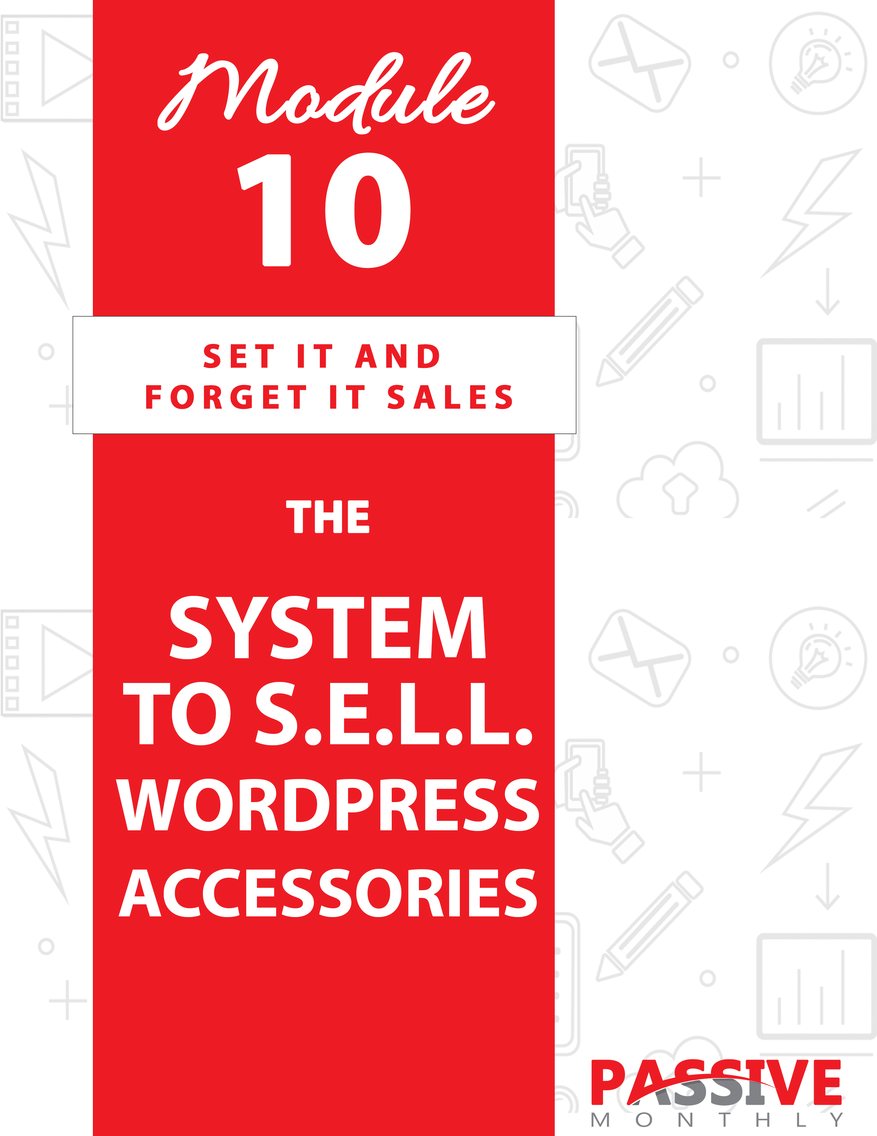

You DO NOT Have The Right To Sell Or Give Away
Any Portion Of The Content In This Document.

This Document Is For Your Personal Use Only

CLICK HERE For Additional Resources
To Help You Build Your Dream Business.

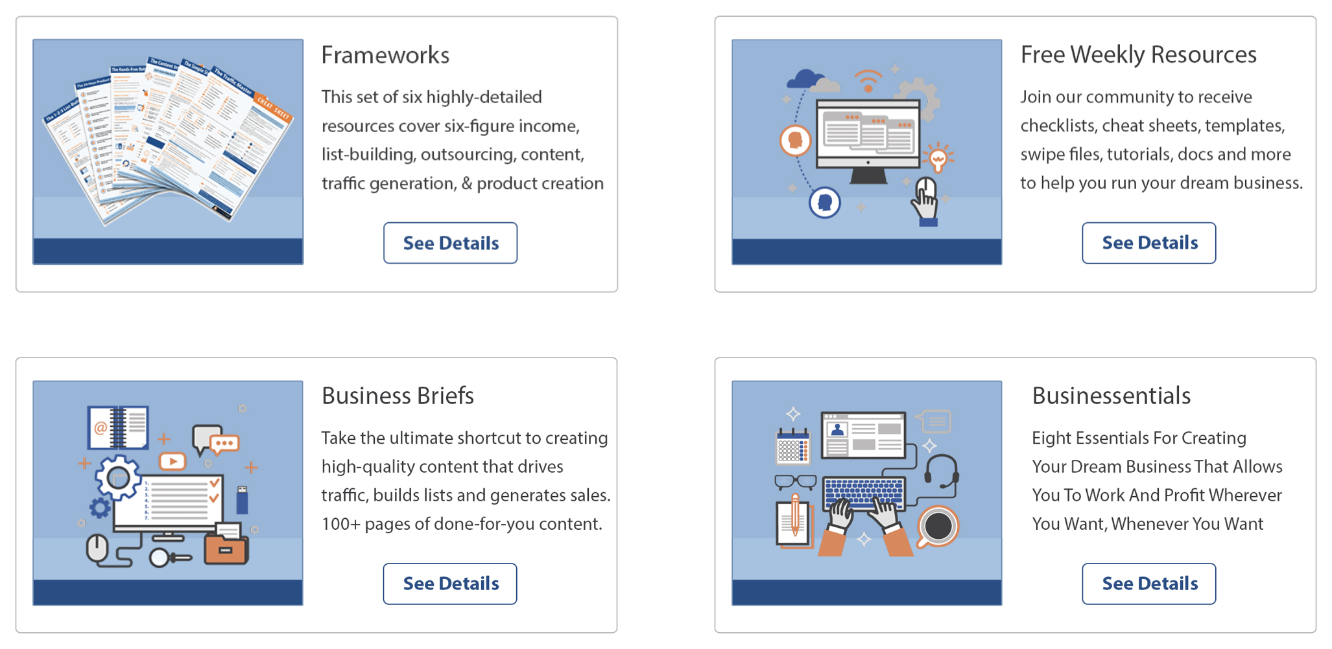

Insert Your Legal Disclaimer / Document Here

Strategy: What Is It?

Unless you’ve been living under a rock for the past 15 years, you’re probably familiar with the content management and blogging system called WordPress (also known as “WP” for short).

It’s no secret that WordPress is extremely popular. Experts estimate that WordPress powers about 27% of websites around the world – including 14.7% of the top 100 sites in the world (according to WhoIsHostingThis.com). That means about 75 million sites use some version of WordPress, with about half that number (37 million) using the self-hosted version from WordPress.org.

That’s a big number – 37 million. And many of these users are professionals and business owners who are looking for faster, easier, and better ways to manage their websites. And they’re willing to pay good money for these advantages.

That’s where you come in. What you’re going to do is step into this steady stream of money and pick up your fair share. How?

By creating and selling in-demand WP accessories,
such as plugins, themes, and templates.

And what makes this a great strategy is that you don’t even have to know how to create these items yourself. If you don’t know a thing about coding – no problem. You’ll just outsource it to a professional plugin developer.

And that’s exactly what you’re going to learn how to do in this issue, as we examine How to Create and S.E.L.L. WP Accessories. Let me give you a quick overview of the S.E.L.L. system:

- Select: Here you’ll select which types of in-demand products to sell to WP users.

- Evaluate: At this step you’ll learn how to evaluate plugin developers and other freelancers so that you choose the best
one to suit your needs.

- List: Here you’ll find out how to list your project requirements so that you end up with a product that looks and works exactly the way you imagined it would.

- Launch: Here you’ll put in place the marketing pieces you need to launch this passive-income system!

Sounds exciting, right? Read on…

System: How Do You Do It?

Now that you’ve received a good overview of this passive-income strategy, let’s take a closer look at each of the four pieces of the S.E.L.L. system…

SELECT

The first thing you need to do is select what type of products you’re going to sell to bloggers. For the purposes of this report, we’re going to focus on three different types of tools for people who use WordPress. These three tools include:

- Plugins.
- Themes.
- Templates.

Let’s take a closer look at these three items…

Plugins

These are pieces of software that plug into WordPress in order to add functionality to the platform.

Here’s why plugins are in-demand: WordPress is a naturally “lean” platform. It seeks to stay lean, so the developers only include the bare functionality needed to make it run. Anyone who wants added functionality (such as a contact form) can do one of the following:

- Code the functionality themselves (as the WordPress files are completely editable).
- Use a plugin to create the functionality.

Since your average WordPress user isn’t a coder, most people choose to install a plugin rather than code in the functionality themselves. And that’s why plugins are so popular.

What kind of functionality are users looking for? You can get a sense of what’s popular by going to https://wordpress.org/plugins/. Examples of popular plugins include:

- Contact forms or other forms.
- Social media plugins.
- Plugins that help optimize the blog for the search engines.
- Membership site plugins.
- Advertising plugins (e.g., a plugin that rotates ads on the blog).
- Tracking/testing plugins.
- Shopping cart/commerce plugins.
- Security plugins.
- Backup/site maintenance plugins.
- Autoresponder plugins.
- Multi-media and gallery plugins.
- Event calendar plugins.
- Survey/polling plugins.

And so on. You can browse the plugins link above to get more ideas about what’s popular in plugins.

If you decide to pursue this idea, then you’re going to need to figure out what type of plugins people want. There are two directions to go with this:

- Create something that’s already popular, but make it BETTER than the
current offerings. In some cases, this means adding more functionality than what’s available in the current offerings on the market. In other cases, this means creating “leaner” (less bloated) plugins than the current offerings.

For example, let’s suppose you discover that social media plugins are really popular, but most plugins offer functionality for a dozen or more social media platforms. If you find out that your audience is only using Facebook and Twitter, then you can create a leaner plugin that appeals to your audience.

- Find out’s missing from the market and develop it. In other words, create a plugin that’s not currently available. You’ll need to do plenty of market research, as you’ll have to survey your audience to find out what they want, and then check the market to see if anything like that exists.

NOTE: If you’re an inexperienced marketer, then Option #1 is usually the better option. That’s because the best predictor of what people will buy tomorrow is to see what they’re already buying today. Simply choose a plugin that’s already in demand and make it better. You can figure out how to make it better by reading customer reviews, polling users, and using the plugin yourself to see what would make it better.

So, how do you find out what’s popular? Walk through these steps:

- See what’s popular on WordPress.org/plugins/. You can browse the popular section, or search for specific types of plugins to see how many downloads they get.

- Search for WordPress plugins on Google. Pay attention to what your competitors are selling. Be sure to look at the sponsored ads as well.

- Check freelancing sites for ideas. In other words, check sites like guru.com, upwork.com and freelancer.com to see what types of plugins people are hiring developers to code.

- Ask your audience. You can ask questions on WordPress forums and groups. (Search for “WordPress forum” in Google, and/or “WordPress” on Facebook to find groups.) You can also survey small online business owners, many of whom likely use WordPress.

NOTE: You’ll want to ask open-ended questions about sorts of plugins your audience is currently using, and what features they’d like to see. You’ll also want to ask what sort of plugins or functionality they want (which aren’t available).

- Research. Run Google searches to uncover your audience’s desires. E.G., “I wish there was a WordPress plugin that…” or “Is there a WordPress plugin…” These sorts of open-ended queries will help you uncover discussions about plugins and your audience’s wants/desires.

- Brainstorm. If you use WordPress, then spend some time brainstorming what sort of useful functionality you’d like to see. Of course, you’ll want to confirm that others want the same thing as you by doing research and polling as described above.

Next…

Themes

Another item to sell to WordPress users are themes – in other words, web designs for WordPress.

A theme is a multi-page, editable set of pages that make it easy for anyone to quickly change the look of their WordPress site. Themes include designs for posts, pages and more. Users can directly edit the code, plus you can create “drag and drop, point and click” methods for editing certain parts of the theme, such as the font style, size, and color, the header, the footer, the navigation menus and more.

To see what a theme looks like, check out the WordPress directory at https://wordpress.org/themes/.

Take note that you can find out what’s popular at the above link by browsing the “popular” section.

You’ll also want to run a Google search for “WordPress theme” to find out what sorts of themes your competitors are selling. Take note of the layout, colors and other features.

TIP: No matter what type of theme you create, be sure it’s a responsive theme for easy viewing across devices.

Another way to decide what sort of theme to sell is to focus on one specific niche. For example: writers, online marketers, medical professionals, animal lovers (dog trainers, vets, etc.), personal trainers, realtors, coaches, and so on. You can create themes that appeal to each of these niches (e.g., pawprints on themes for dog trainers).

Again, you’ll need to do your research in order to determine what sort of themes are popular and what your audience wants. You can poll them to figure out what sort of layouts and features they’re looking for in a theme.

And finally, let’s take a look at the other tool you can sell to WordPress users…

Templates

Templates are usually included as part of an overall theme, and these templates are used to render the parts of a WordPress website, such as an individual post or page. However, you can create individual templates and sell them as separate from a theme.

For example, you can create a sales letter template. Your users can use it as part of their overall WordPress theme, or they can upload it separately to their website. (This all rests on how you code it, of course.)

Alternatively, you can create HTML templates that are completely separate from WordPress (and indeed, you can design them for people who don’t use WP). Generally, your template would be a set that includes popular pages such as a home page, “about” page, and “product” page.

Again, you’ll need to do your research to determine what’s popular in terms of layout, as well as what types of professionals are seeking templates and what they want. (You’ll do your research as described above, both by searching Google to see what’s popular, as well as surveying your audience to understand their needs.)

Which should you choose?

You can choose any of these three products, or you can choose to sell two or even all three of them.

In some cases, you may sell “packages” of tools to the same audience. For example, you might sell themes and plugins to realtors. The themes would include touches that realtors would like, such as small houses as icons in a navigation menu. You might also include plugins for functionality, such as a plugin that makes it easy for realtors to add a property to their onsite listings.

So, go ahead and do some research to determine what you’d like to sell. Then move onto the next part of the S.E.L.L. system…

EVALUATE

The next step is for you to find and evaluate freelance coders who can create your plugin, themes or templates. Here’s how to do it in two steps:

Step 1: Find Prospective Freelancers

Your first step is to look far and wide to find as many potential freelancers as possible. (Then in the next step you’ll shorten this list to the most qualified and best to suit your needs.)

Here’s where to find these freelancers:

- Search Google. Your search terms will vary depending on what type of tool you’re creating. Here are some terms you can use:

WP plugin developer
WP plugin coder
WordPress plugin development
WP theme developer
WP theme developer
WordPress template coder

Be sure to not only check the organic search results, but the sponsored ads in Google.

- Post a project on a freelancing site. These sites include guru.com, upwork.com and freelancer.com.

- Create a want-ad. Still another way to find a freelance coder is to post a want-ad in a local newspaper or website. For example, you can post an ad in your city on a site like CraigsList.org.

- Check WordPress developer sites. Not every developer you meet on a developer site is interested in freelancing. Some are. It’s up to you to determine who freelances by visiting their websites (which are usually listed in their signature links).

Here’s the official WP support forum: https://wordpress.org/support/view/all-topics/

You can find additional forums and groups by searching for “WordPress developer forums” in Google, and/or Facebook.

- Ask for recommendations. You never know if someone you know is a developer or at least knows one, so ask around your circle of friends and colleagues. Blog about it, send an email to your list, and ask for recommendations on social media.

Now that you have a big list of potential freelancers, move onto the next step…

Step 2: Evaluate These Freelancers

Not every freelancer on your big list is worth hiring. That’s why you want to now evaluate each freelancer on your list. Ask yourself these questions, and get the answers by doing research as required:

Does the freelancer speak your language (such as English) well?

Plenty of developers live around the world, and they may speak languages other than English (or your language) as a primary language.

When it comes to coding, your developer doesn’t need to speak English as a first language. However, you need to be absolutely sure that your potential developer and you are able to communicate well. That is, can this person understand what you’re saying in order to turn your vision into a reality? And can you easily understand this person to answer his or her questions?

Point is, if the person clearly has English as a second language, then spend some time talking to this person about complex concepts to be sure you understand each other well enough to do this project together.

Does the freelancer have a lot of experience with projects similar to yours?

In other words, make sure that your freelancer is very experienced. For example, if you’re looking for someone to create a WordPress plugin, then don’t just hire any ol’ software developer off the street. Instead, hire someone who specializes in creating WP plugins (and has the portfolio to prove this).

Is the freelancer capable of doing all parts of the project, or will subcontractors be involved?

This question tends to come up when you’re creating plugins. Some developers can create the code for functionality, but they’re not able to
create the dashboard layout and design (or other user interfaces). When you’re evaluating freelancers, be sure to discuss the scope of the freelancer’s skills and whether that freelancer would be hiring subcontractors (or if you need to hire them) to complete the job.

Will the developer be available after the project is complete for small changes?

You’ll also want to find out how involved the developer will be during the beta testing phase, and what he/she will do to test the product.

Does the freelancer have a good reputation for providing quality work on time and on budget?

Finally, you’ll want to research the freelancer to be sure he has long, established history of providing good work. Ideally, you’ll want to choose someone who has been freelancing for at least a couple years and has plenty of successful projects under his or her belt.

To that end, do the following:

- Check the freelancer’s references.
- Browse the freelancer’s feedback ratings on freelancing sites (where applicable).
- Search for the freelancer’s name, business name and website in Google. Be wary if you see a pattern of complaints from either business partners or clients.
- Ask for a project proposal. When you find a freelancer that you’re seriously interested in working with, then ask for a project proposal. The freelancer will give you information about the budget, timelines and similar details. This will help you narrow down and choose the best freelancer for your needs.

Once you’ve answered the above questions, then you should have significantly shortened your list of prospective freelancers. Now you can pick the one whose prices best match your budget, and who you also think will work well with you and your team.

Then move onto the next step of the S.E.L.L. system…

LIST

Now that you’ve selected a developer for your project, you need to List your requirements clearly so that you get a good end result.

NOTE: For the purposes of this report, we’ll focus on a project brief for a plugin, as that’s the most complicated. If you’re having themes or templates developed, you’ll likewise need to provide as much detail as possible.

Before you begin creating your brief, you’ll want to ask your developer if they have any sort of template brief that they’d like you to fill out. If not, then you’ll need to create your own brief. Keep in mind that this brief is a starting point, as most developers are going to have questions so that they can get your project just right.

To create your brief, answer the following questions:

- What is the purpose of your plugin? (Here you can give an overview of the plugin in one or two succinct sentences.)

- Who are the intended users?

- How do you envision the plugin will work? (Here you offer a more detailed account of what the plugin will do… be as specific and detailed as possible.)

- Which features/functionality are absolutely required?

- Which features/functionality are on your wish list, but not absolutely required?

- What sort of creative guidelines can you offer? This is the layout/design side of the plugin. Specifically, you need to tell your developer what the user interfaces should look like in terms of color,
graphics, font, and overall design.

- Do you have any drawings/graphics to make your vision clearer?

- Can you provide examples of both plugin functionality and user interfaces that you like? Be specific about what you like about these plugins. E.G., “I like the form on this plugin because it’s simple and clean.” Or, “I like the overall design of this plugin in terms of colors, font and graphics…”

- What other details can you provide that will help your freelancer create your plugin?

Again, consider the above as a starting point, and encourage your developer to ask lots of questions. You’ll also want your developer to show you the project at various points along the way so that you can fix any problems as they come up (rather than having to fix something after the project is complete).

Depending on the complexity of your project, you and your developer may go back and forth for several months between initial development, beta testing, and bug fixing. When you’re getting close to completion, then you can start thinking about the final point of the S.E.L.L. project, which is to launch your offer. Read on…

LAUNCH

Now that your product is ready to go, it’s time to plan your launch and overall marketing. Here are the pieces you need to put into place, and the issues you need to consider…

Create a Sales Funnel

As always, you’ll do better with this passive-income stream if you create a sales funnel of related products.

Take note: you may already have the related products as part of your existing business, and your plugin just drops nicely into this sales funnel. If so, great! If not, you’ll need to plan your sales funnel.

One of the keys to a good sales funnel is to have a free lead magnet in place. If you’re selling templates or themes, you can offer a template or theme for free.

If you’re selling plugins, then consider offering a “lite” version of the plugin for free. You can even get this tool listed for free on the WordPress page in the plugins directory. The more people who download and rate your plugin favorably, the more exposure you’ll get in the directory.

For those who like what they see and want full functionality, they can pay to upgrade to the full version. This makes a great lead magnet, because it sells your plugin by directly showing people how useful it is.

TIP: If you don’t offer a lite version of your plugin, then be sure that you offer a demo on the sales page. You want potential buyers to be able to log into a WordPress site and see exactly what your plugin does.

In addition to your lead magnet, you’ll also want one or more products to sell to people who buy your main plugin, theme or template. You’ll do best if you sell additional related tools. A good way to do this effortlessly if by cross-selling related tools in your plugin dashboard, as well as in follow-up emails you send to customers.

Here’s the next piece you need…

Craft a Sales Letter

Here’s a mini sales letter template you can use to sell a plugin:

“Finally, Here’s a WordPress Plugin That [Insert the Top Benefits Of This Plugin]”

With just a couple clicks of your mouse, you can turn your WordPress site into [explain what the plugin does] with [name of plugin].

Take a look:

[Insert screenshots of the plugin along with a more detailed description of what the plugin does.]

Here’s the full feature list:

[insert a list of all the features/benefits of the plugin]

Check out the full demo here: [insert link to demo along with password and username].

Here’s why so many others love [name of plugin] – and why you will too!

- Now you too can [get some benefit]!
- You’ll enjoy [some other benefit of this plugin]!
- No more [bad thing your audience is experiencing]!
- You get [full support, upgrades, etc.] for [some time frame – e.g., a lifetime].

All you need to get started is WordPress Version [XX.XX] or higher [and list any other requirements where applicable].

Best of all, it’s only [price]!

If you hired a developer to create this for you, you’d be shelling out [list how much money it is]. But act now, and you can save yourself a bundle of money. Click the buy button below now to get started:

[insert buy button]

Order now, because [list a big benefit, an introductory discount, or other compelling reason the prospect should order now]

### End Template

Choose Your Traffic Sources

Now that you have a lead magnet and a product to sell, it’s time to start driving traffic. Ideally, you’ll want to drive traffic to your lead page and then follow up to sell the product. However, in some cases you may send traffic directly to the sales page.

Here are three good traffic sources to start you off…

Set Up an Affiliate Program

You can use a platform like ClickBank.com to sell your WordPress tool. Be sure to offer your affiliates at least 50% commissions, and consider even higher commissions for your best affiliates and joint venture partners.

Once you’ve set up your affiliate program through ClickBank or another platform, then do the following to get affiliates:

- Announce your affiliate program to your existing contacts on social media, your newsletter and on your blog.

- Place a link to your affiliate program on your sales page.

- Ask your existing joint venture partners to join your affiliate program.

- Get your affiliate program listed in the ClickBank directory (where applicable).

- Consider hiring a JV broker to find new affiliates for you.

When you launch your product, hold an affiliate contest to get affiliates excited about promoting. Be sure to offer valuable cash prizes to motivate your team.

Next…

Do Guest Blogging

Be sure to blog on sites related to your niche. For example, if you’re selling an SEO plugin, then do guest blogging on sites whose main focus is search engine optimization.

You can find blogs in your niche that accept guest submissions by searching for your keywords (such as “SEO”) alongside the following search queries:

- Blog that accept guest authors.
- Blogs that accept guest articles.
- Guest blogging.
- Guest articles.
- Article submission.
- Article submission guidelines.
- How to submit a guest article.
- Guest author queries.
- Guest blogging submissions.

Follow these tips:

- Be sure to do your due diligence so that you’re only submitting guest articles to high-quality blogs.

- Model your article after other articles on the blog. For example, if there are a lot of “tips” articles, then submitting a tips article has a good chance of getting accepted. (Naturally, though, you should present a topic that’s not completely saturated on the blog, so that the editor can give the readers something new.)

- Follow all submission guidelines. Editors of popular blogs in particular will weed out submissions just based on who followed the guidelines.

- Invest time creating your byline. This is the part at the end of your article that serves as a mini advertisement to get people to click through to your lead page or sales page. E.G., “If you liked these SEO tips, then you’re going to love getting your hands on this free SEO plugin for WordPress. Now you too can get to the top of the search engines just by posting on your blog! Click here to find out how…”
And finally…

Use Paid Traffic Resources

Just be sure to focus on high-quality traffic, and test your ads for maximum conversions. Here are two proven places to invest your money:

- Facebook.com: The benefit of this platform is that you can narrow your audience down by a variety of demographics (such as age and location), as well as by interests and behaviors. For example, if you’re selling a WP SEO plugin, then you can narrow your audience down to those who’ve expressed an interest in both WordPress and SEO.

- Google AdWords: Here you can narrow your audience down somewhat by demographics, as well as what words they are using to search for information in Google. For example, “buy [type of] WP plugin” is a strong keyword that shows you have a buyer on the other end.

No matter what platform you choose, be sure to start small – and scale up once you’ve optimized your ads for maximum conversions via tracking and testing.

Summary

You just learned the S.E.L.L. System (Select, Evaluate, List, and Launch) for creating WP accessories with the help of freelancers, and then inserting this income stream into your business. Now let’s look at ways to ramp up this strategy…

Shortcuts: What Else Will Help?

If you’re like me, you’re always looking for way to make any system faster, easier, better and more profitable. That’s what the following shortcuts and tips will help you do with the S.E.L.L. system. Take a look…

Offer a Great Customer Experience

There are a lot of people who sell WP plugins, themes and templates. But there are very few who really EXCEL at it. Sure, part of that has to do with selling what the audience wants. But the other factor that separates those who do well from those who fail is customer service. If you can offer a great customer service experience, then you’ll be light years ahead of your competition.

Because here’s the thing…

A lot of customers who’ve purchased software, apps and plugins have had one or more bad experiences. They buy the software, they can’t get it to work, and it takes forever to get customer service to answer their request for support. Or worse yet, the plugin “breaks” during the next WP update, and no one can get ahold of the developer. What a nightmare.

That’s why you’ll stand out if you offer a really good customer experience. Here’s how:

- Offer plenty of documentation. This includes a user manual (with screenshots), as well as a video that walks users through the plugin.

- Provide troubleshooting and other help on your site. Offer a FAQ, a troubleshooting guide, and other documents to help people
with any issue that arises.

- Keep your plugin up-to-date. Be sure to plan how to provide updates (within the plugin) so that you can get them out quickly to users. You’ll also want to be sure your plugin doesn’t “break” during WP updates.

- Offer good customer service. This may include a peer-support forum, live chat, and/or telephone support. No matter how you offer support, be sure that it’s prompt and cheerful.

Next…

Sell in a Related Marketplace

When you’re first getting started, it’s a good idea to sell your plugins or templates in a marketplace where there are similar products available. One good example is CodeCanyon.net. You don’t want to sell exclusively through this site (since they take a cut of your profits), but it is a good place to get exposure to the type of people who’re likely to buy what you’re selling.

Next idea…

Add Useful Bonuses

Another way to boost sales is to add value to your plugins or templates. In other words, bundle your product with useful bonuses.

For example, if you sell a social media plugin, then you might offer the following as bonuses:

- WP themes (because anyone who is buying plugins may have a need for themes as well).

- Social media guides and tools. E.G., you might offer a Facebook advertising guide as a bonus.

And finally…

Craft a Strong Brand

A good brand helps you build trust in the marketplace and develops “top of mind” awareness. This means when your prospects and customers have a need for additional WP accessories, they’re going to check with you first.

Take the example of Yoast, which is a well-known company that specializes in search engine optimization (SEO). They’ve worked hard to build their brand, so most people who are interested in SEO also instantly recognize Yoast’s branding across WP plugins.

Another example that really cares about their branding: MonkeyWebApps.com. While these apps aren’t WP plugins (save for a few that include WP plugins as part of the app), take a look at their site and you’ll see the monkey and gorilla theme carried throughout all the products, sales letter and marketing. Again, their brand is easily recognizable and trusted in their niche.

Point is, you need to develop a strong brand too, and then work to build brand recognition in the WP community. This includes:

- Integrating your branding into your plugin so it’s always visible to users. Whenever possible, you can brand it so the end users (your customer’s visitors) also see your branding.

- Creating a strong USP (unique selling proposition) and integrating it into all your marketing materials. This is a statement that tells users why your plugins and themes are different and better than the competition. (E.G., maybe you offer free lifetime updates, or perhaps you offer phone support while your competitors only offer online chat.)

- Putting your logo and other branding on your website, on ecover graphics, in marketing materials, in directory listings and everywhere else that you post about your plugin.

Let’s wrap things up…

Conclusion

If you’ve heard that selling WP accessories (such as plugins, themes and templates) can be very profitable, you’ve heard right! And now you have in your hand a blueprint for how to do it.

Let’s recap the S.E.L.L. system:

- Select: Here where you selected which types of in-demand products to sell to WP users (templates, themes and/or plugins).

- Evaluate: At this step you found out how to evaluate plugin developers and other freelancers so that you choose the best one to suit your needs.

- List: Here where you learned how to list your project requirements so that you end up with a product that looks and works exactly the way you imagined it would.

- Launch: Here you’ll put in place the marketing pieces you need to launch this money-making opportunity!

As mentioned, you can snap this system right into your existing business. But this system won’t work for you unless you put it to work. So go ahead and get started planning today – because the sooner you do, the sooner you’ll be able to reap the profitable rewards!

