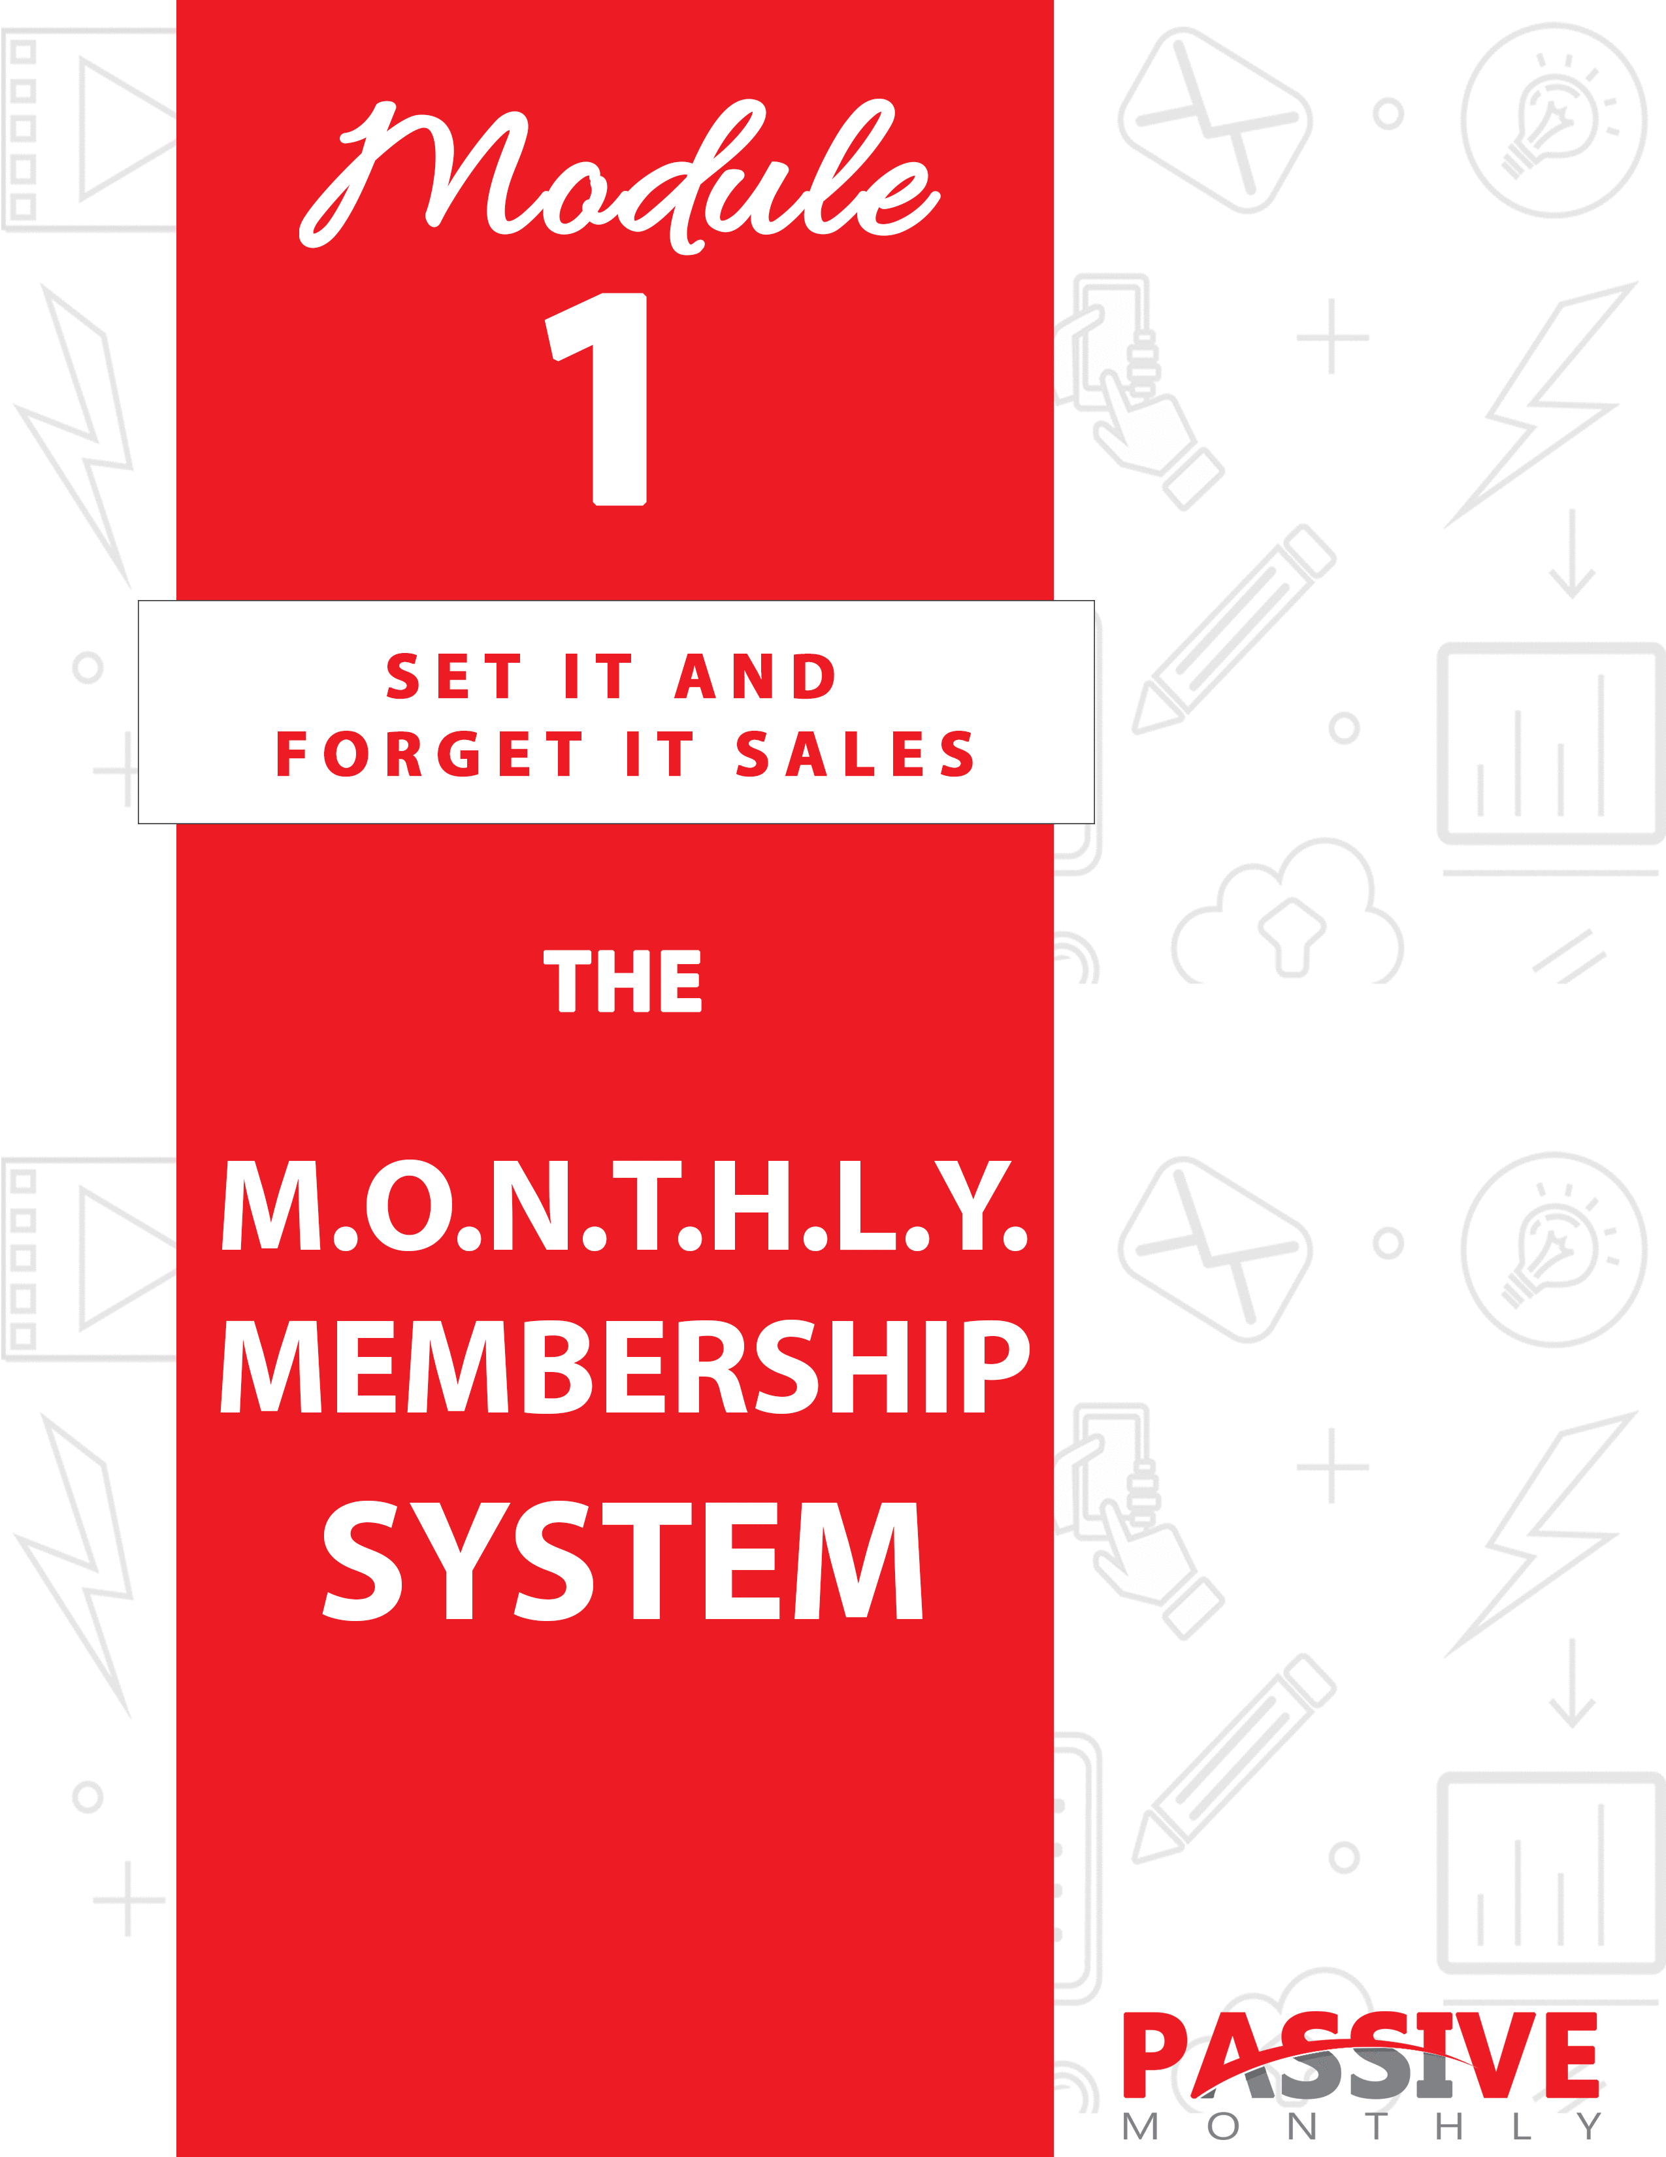

You DO NOT Have The Right To Sell Or Give Away
Any Portion Of The Content In This Document.

This Document Is For Your Personal Use Only

CLICK HERE For Additional Resources
To Help You Build Your Dream Business.

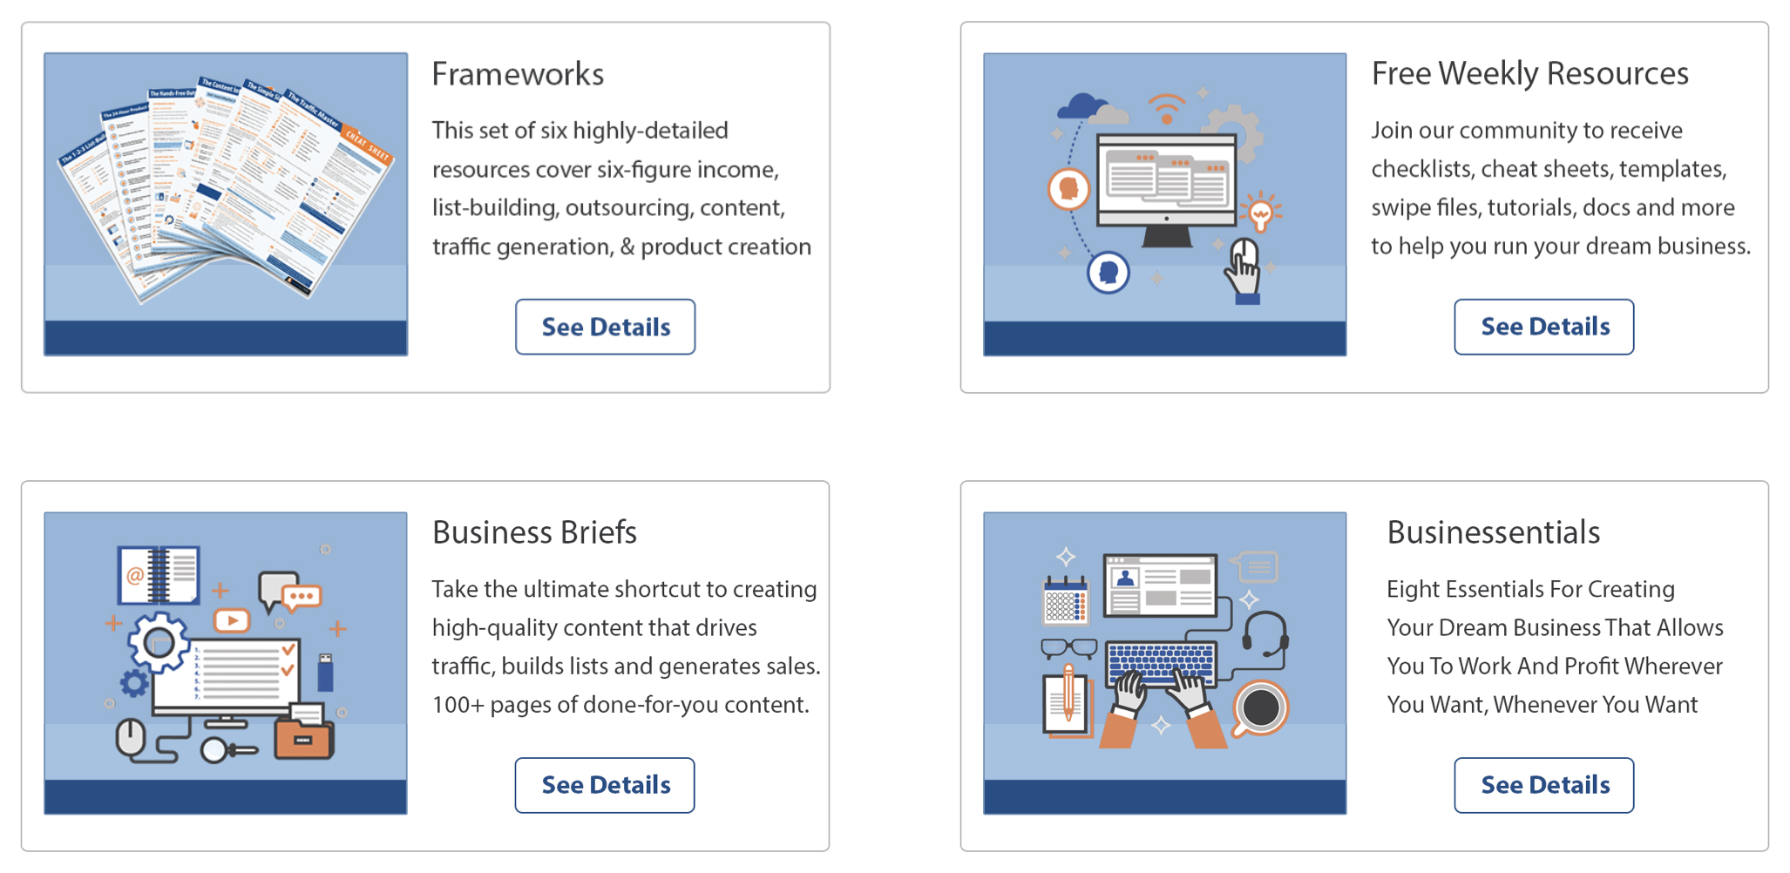

Insert Your Legal Disclaimer / Document Here

Welcome to Passive Monthly!

Over the next 12 modules, you’re going to get all the details and instructions you need start generating a passive income in multiple ways from just ONE website!

This isn’t guesswork. This isn’t fluff. What you’re about to discover are the exact same strategies I use to build uber-profitable websites – and now you can use these same strategies for yourself!

Each Passive Monthly issue covers these three areas:

- Strategy: Here you’ll get an answer to “What is it?” as we walk through the overview for this month’s strategy.

- System: Here you’ll get an answer to “How do I do it?” as you’ll get step-by-step instructions so you can put each of these strategies to work for you!

- Shortcuts: Here you’ll find out how to make the system even better, faster, easier and more profitable with these shortcuts, tips and tricks!

So, let’s jump right in with the M.O.N.T.H.L.Y. system for making a passive income with a membership site…

Strategy – What Is It?

As mentioned, you’re about to discover my M.O.N.T.H.L.Y. system for setting up the content and backend for a profitable fixed-term membership site.

One note: You CAN set up a “never-ending” membership site. However, I prefer a FTM (fixed term membership) site because retention tends to be higher. That’s because people who see an “end point” in sight will stick around to reach that finish line. That means more profits in your pocket!

Here’s how this membership site fits into your sales funnel…

- You’re going to offer it at a low cost in order to get a lot of members. Then you’re going to sell your membership site as an add-on, upsell or backend to all your other offers. (And if you don’t have any other offers yet, no worries – you will once you’ve completed these 12 months of training!)

- You’re going to sell other offers on the backend to all your members. You can sell other memberships, ebooks, videos, webinars, tools, apps, ecourses, coaching and more. You can even sell affiliate offers, if there is something your customers would really love that you’re unable to provide (like physical products).

Sounds good, right? Once you get it all set up, it’s a passive, hands-free way to generate a nice income.

So, let’s take a look at what you’re going to learn in this module, where you’ll get my M.O.N.T.H.L.Y. system for creating an awesome fixed-term membership site.

Here are the steps of the system:

- Map Out Your Topic
- Organize Your Outline
- Navigate Creation Options
- Tend to the Backend
- Help Your Customers
- Limit Cancellations
- Yield More Profits

In short – you’re going to find out how to create membership content that puts a profit in your pocket and keeps your customers coming back for more. Plus, you’ll find out how to mine the gold that lays hidden in the backend of your membership site!

System: How Do You Do It?

Now that you’ve got a great overview of the system, it’s time to look at each step in a little more detail. Let’s jump in, starting with the “M” of our M.O.N.T.H.L.Y. system…

Map Out Your Topic

I’m going to assume that you’ve already picked out your niche. If not, you’ll need to do some market research in order to determine which niches are profitable and popular.

Do you need to focus on any particular type of niche in order to ensure this system works for you?

Nope.

While I’m going to refer to Passive Monthly as an example throughout this training, by no means does that imply that you need to work within an online business niche. Not at all. You can do anything from health and fitness to hobbies to travel to home remodeling to finance – and anything in between. If you find a niche where people are already buying information to solve their problems, then it will work great to set up a fixed-term membership within that niche.

So, you have your niche… but what topic should you pick? Here are two guidelines to follow:

1. Pick something profitable.

Again, you’ll need to turn to your market research in order to discover what is popular and profitable. One very simple way to do this is to find out what types of information products people in your niche are already buying. If they’re buying ebooks, videos, etc. on a particular topic, then you know they’ll purchase memberships as well.

To find out what’s profitable, go to marketplaces such as Amazon.com, ClickBank.com, and JVZoo.com. Search for your keywords, and take note of the bestsellers in your niche. Also look for topics where there are multiple products on the same topic (especially if they’re all selling well), because that’s a sign of healthy niche.

You can also search for your keywords in Google, and take note of what the top sites in your niche are selling. Be sure to look at sponsored (paid) ads as well. If a marketer is consistently paying money to advertise a certain type of information product, that’s a good sign that the topic is popular and profitable.

Next…

2. Pick something “precise but prolific.”

The general rule here is to pick something that everyone wants, but the topic can’t be too general. It needs to precise so that you can solve a very specific problem.

Let me give you a few examples…

- Everyone is interested in “generating an income online,” but that is too broad. For Passive Monthly, I used the precise topic of generating a PASSIVE income. That’s an in-demand, very popular topic – but also very precise.

- A popular topic such as “email marketing” is way too broad. To be more precise, you might offer list-building for affiliates, or email marketing on social media.

- A popular topic such as “dog training” is way too broad. You can choose a more precise topic, such as obedience training for small dogs, or training deaf dogs.

- A popular topic such as “traveling to Europe” is too broad. You can choose a more precise topic such as “traveling to France on a budget,” or “eco-friendly destinations in the UK.”

You get the idea. Choose something with a lot of demand, yet something very precise so that you can attract a targeted market.

Now the next step in our M.O.N.T.H.L.Y. formula for setting up a profitable fixed-term membership site…

Organize Your Outline

At this point you have your topic. Now you need to create an outline for each of your monthly lessons. And if you’re going with my suggestion of creating a 12-month fixed-term membership site, then that means you’re going to need 12 monthly lessons in all.

Use these tips and best practices to help you create your outline…

Scope the Competition

One way to start compiling a list of popular topics is to take a peek inside current bestselling information products in your niche. Just take a look at the table of contents or the sales letters for these bestsellers, and you’ll get plenty of ideas about what all topics to include in your membership site.

Read Reviews

Another way to get topic ideas is by reading the reviews of the bestselling products in your niche. (Hint: Amazon.com is a good place to do this.) You’re looking for two things:

- A pattern of reviewers who say one particular topic in a book or other information product is the BEST part of the product. (That’s a hint that you’ll want to include that topic in your product too.)

- A pattern of reviewers who say they wish a product would have included a particular topic. That’s a hint to you to include that topic in your product. (And it’s a good way to make your product better than the current solutions

Next…

Collect Other Popular Topics

The idea here is to go to niche communities (including your own platforms) and see what topics are popular. That is, which topics always get a lot of traffic, comments, likes and shares? Check these places:

- Social media pages and channels (Twitter, Facebook, Google+, LinkedIn, YouTube).

- Social media groups, such as on Facebook and LinkedIn.

- Niche blogs.

- Niche forums.

- Question and answer sites such as Quora.com.

Next…

Consider Your Backend Offers

At this point, you should have a pretty good idea of what topics you’d like to

include in your lessons. Now you’re going to want to start thinking about your backend offers and how they’re going to fit into these lessons. That way, you can create an outline that both serves your customers’ needs while also naturally leading to a backend sale.

TIP: The “T” of the MONTHLY formula is “Tend to The Backend.” That’s where you’ll learn more about how to choose offers and insert them into your website and content.

Next…

Organize Your Outline

Once you have all your topics picked out for your 12 monthly lessons or modules, then you need to organize this content. Keep these two tips in mind:

Organize logically. For example, order information in a step-by-step format. Or order it from beginner to advanced information.

Frontload the beginning lessons with your BEST content. Yes, every single lesson you put out should knock your customers’ socks off and keep them coming back for more. However, you’ll want to be sure to put some of your very best content right in the first few lessons so that customers get “hooked” and stick with you. So, don’t hold back – fill those initial lessons with a lot of gold that your customers can’t find anywhere else!

TIP: You can create text-based lessons in downloadable .PDF form, or you can create videos (talking head videos, demo videos or even slide-share videos). If you create videos, then you can offer the transcripts to the videos as a free bonus to your customers.

Now the next step in our M.O.N.T.H.L.Y. system…

Navigate Creation Options

Now that you know WHAT you’re going to create as far as your monthly
content, the next step is to decide HOW you’re going to create it. Fortunately, there are plenty of options to suit your needs, your skill set and your budget.

Check out these five ideas…

1. Do it yourself.

If you have the time, skills, and inclination, then you can certainly create your content yourself. If you have a special qualification for teaching this topic (such as a degree in the niche), then you may decide to create the content yourself even if other options are appealing.

For best results, set aside a block of time every day to work on your content. Be sure to clear out distractions (such as social media and your phone) so that you can focus on the task in front of you. A thorough outline and a daily to-do list will help you stay on track.

Next…

2. Outsource.

Hiring a freelancer to create your content is a good investment, as it frees up your time to work on the more high-value tasks (such as marketing).

Follow these tips and best practices for producing a good outsourcing experience:

- Create an initial big list of potential freelancers. You can find these freelancers by searching Google (e.g., “freelance writers”), using freelancing sites such as Upwork.com, and asking your colleagues and friends for recommendations.

- Do your due diligence. Spend some time researching each potential freelancer to ensure they have an established history spanning several years of providing high-quality work. Check feedback ratings, ask for references, view their portfolio, and
research them in Google.

- Create detailed project briefs. Your freelancers aren’t mind readers, so you need to be as detailed as possible about what you want. This includes offering details such as:

- Word count.
- Outline of what you want.
- Who the intended audience is.
- The overall purpose of the piece.
- Exactly what you want the audience to do when they’re done with the lesson.
- The style of writing you prefer (give examples so that your freelancer understands what you want).

3. Crowdsource.

The idea here is to bring guest authors or experts to your site and ask them to contribute content in exchange for backlinks and exposure. You can bring on one guest per month. For example, if you’re doing a 12-month fixed-term membership site, then you’d invite a minimum of 12 guest experts to contribute. Here are different ways to do this:

- Interview 12 guest experts via live webinars. You can sell your memberships with live monthly events as you complete these interviews, and then you can offer the recordings after that.

- Interview the 12 experts at non-live events. In other words, you won’t have audience. This format allows you to edit the interview so that it’s a polished piece that includes only the best parts of the interview. You can offer this as a video (preferable) or as an audio.

TIP: Naturally, you can also do text-only interviews if you prefer.

- Ask your guest expert to contribute an article on a specific topic, which then becomes your lesson. For example, you might ask a personal trainer the best way to lose a quick ten pounds.

One of the benefits of crowdsourcing is that your guest experts will often help you promote your membership site. The downside is that each guest gets to promote their products and services, which dilutes your own promotions. This isn’t a problem, however, if you can use your affiliate link. That way, both you and your guest expert make money.

Next idea…

4. Use PLR content.

Ideally, what you want to do is buy a big package of private label rights content so that you have enough content to create your 12 lessons. For example, you could easily create 12 lessons if you used a package like the one at www.contentaire.com.

TIP: Even if the content is well-written and well-researched, it’s still a good idea to rewrite it or tweak it to make it unique. Here are other ways to make it unique:

- Compile multiple pieces to create something entirely new. For example, compile multiple reports or articles to create your monthly lesson.

- Take excerpts out of large pieces (such as ebooks) to create smaller lessons.

- Turn the content into a different format. For example, turn an ebook into a slide-share video.

Next…

5. Repurpose existing content.

The final method is to use your own existing content to create your lessons. There are numerous ways to do this, including:

- Compiling multiple smaller pieces. For example, using blog posts or lead magnets to create your lessons.

- Excerpting content out of bigger products, such as ebooks or even home study courses.

- Transforming text content into video content, or vice versa.

- Turning content into other formats, such as turning articles into checklists.

If you use this method, be sure to use your most popular content. For example, pull out your 12 most popular blog posts, expand on each one, and use them for your 12 monthly lessons.

TIP: You can add value to your existing content by expanding on the content, adding in tips and examples, sharing stories to make it more engaging, and offering tools such as checklists, planners, gear lists and worksheets.

Now that you know how you’re going to create your content, it’s time to tend to the backend of your business (which is where the profits lay hidden). That’s next…

Tend to the Backend

As mentioned before, you’re going to price your memberships low to get as many people as possible into the site. That means you’ll then have a customer base who’ll be eager and willing to purchase related products and services. This includes:

- Other memberships.
- Ebooks and reports.
- Videos.
- Audios.
- Webinars and other live events.
- Ecourses.
- Coaching.
- Done-for-you services.
- Apps, plugins and software.
- Tools such as checklists, worksheets, templates, planners, and cheat sheets.
- Physical products.
- Support forums.

For example, let’s say you’re selling access to a weight-loss membership site. You might offer products and services like this on the backend:

- Personal nutrition coaching/customized meal plans.
- Access to a support forum.
- Memberships in a weight-loss-maintenance site.
- Exercise videos.
- Cooking videos.
- Cookbooks.
- Ebooks on specific topics/problems, such as overcoming plateaus.
- Physical products such as vitamins, exercise equipment and similar.
- Weekend (offline) workshops.

You get the idea. The point is to offer products and services that are highly related to your membership site content. Indeed, while your membership site should solve part of your customers’ problems, it should also be incomplete. That way, you can pitch related products on the backend to solve those problems.

For example, a dieting site may offer plenty of meal plans and recipes. However, people tend to get bored eating the same thing. Solution? You can offer a cookbook with low-calorie recipes.

Another example: your diet site may offer complete instructions for weight loss. But some people don’t want to do the calculations required to figure out how much to eat. Solution? You can offer personalized nutrition plans.

Make sense?

So now that you know what types of items to sell on the backend, the next step is to figure out how and where to sell these related products and services. And the answer to that is “everywhere.”

Here’s a list of places to promote your backend offers to your membership site members:

- Offer as an upsell or add-on on the order form.
- Position as a one-time offer during the ordering process.
- Promote an offer on the download/thank you page.
- Embed offers within each of your lessons (.PDF or video).
- Pitch products in emails when you announce that new lessons are ready.
- Promote products in solo emails to members.
- Embed offers within bonus products and accessories.
- Place offers within the membership site (where applicable).
- Place offers in other parts of the site, such as on a members-only blog or members-only forum/group (where applicable).

In short – whenever you communicate with your customers, you have an opportunity to pitch a related product or service.

Now let me share with you five different ways to pre-sell your members on a specific product or service:

- Directly promote an item. Here you place an advertisement in your content, such as a promotion at the top of lesson.

- Use the sales page or product as an example within your lessons. For example, if you run a copywriting site, then you can point to one of your own sales pages as an example of some concept. (E.G., “Look at this page to see how I embedded testimonials…”)

- Embed the promotion within the content. For example, if you’re talking about setting up a mailing list, then you can recommend your favorite autoresponder.

- Offer a case study. Here you actually show proof that a specific product works. For example, when talking about how to lose weight, you might offer a case study on the effectiveness of kettlebell training. (And then pitch the exact training product you used to achieve the results.)

- Create useful yet incomplete content that naturally leads to a paid offer. For example, if Facebook marketing site talks about using Facebook’s paid advertising platform, then you can link to a product that shows people how to write effective ads (or you can promote a done-for-you service).

As you can see, there are plenty of ways to promote and pre-sell products. You’ll want to use a mix of all these methods across your content, emails and website.

Now that you know what you’re going to promote on the backend of your membership site and how you’re going to do it, you can move onto the next step of our M.O.N.T.H.L.Y. formula…

Help Your Customers

The next bit of content you need to create are your bonuses or accessories that you offer for free to anyone who purchases a membership. You should create a set of accessories for each of your monthly lessons.

These accessories do two things:

- Boost your conversion rates, because everyone likes getting valuable material as a bonus.

- Help your customers achieve their goals.

TIP: You can also create extra bonuses that members get access to after a period of time, such as every three months.

Here’s how to select these accessories:

- Be sure they’re highly related to the monthly content. For best results, the accessories should enhance the use and enjoyment of the monthly lesson, and make it easier for people to take action or achieve a goal.

For example, if you have a site that helps people write better sales copy, then you might offer useful accessories such as sales letter templates.

- Create something valuable. Just because you’re offering them for free doesn’t mean they should be cheap. On the contrary, offer something valuable to impress your members and boost the value of your offer.

- Offer something your prospects really want. You’ll want to do your market research if you’re not sure of what your prospects want. Taking this step helps ensure you create bonuses that boost conversions and increase retention.

Let me give you examples of accessories across different niches:

- You have a site about setting up a profitable blogging business. Your accessories might include WordPress plugins, article templates, and a checklist for setting up the site.

- You have a bodybuilding memberships site. Your accessories may include a set of meal plans, a bodybuilding cookbook, and a lifting-routine planner.

- You have a gardening site. Your accessories may include a zone map, a report with pictures of common garden pests, and a video that depicts how to build a raised flower bed.

- You have a traveling site. Your accessories may include an itinerary planner, a packing checklist, and a report about how to stay safe from pick pockets and other thieves.

NOTE: As mentioned, your goal is to create accessories that are specific to each lesson. For example, if you’re sharing a lesson in a traffic-generation site about how to optimize a blog for the search engines, then you can offer an SEO WordPress plugin as an accessory for that particular lesson. If the next lesson talks about how to use Facebook advertising to drive traffic, then you’d offer tools such as ad templates and an ad-budget planner.

In short, your accessories should make it easier for your members to take action on what they’re learning in the lessons.

Once you’ve planned your accessories, then you can move onto the next step of our M.O.N.T.H.L.Y. system…

Limit Cancellations

One reality of running a membership site is that people are going to cancel. And that means that not only do you lose your front-end income in the form of monthly subscription fees, but you often lose your backend income as well if the person removes themselves from all of your mailing list.

As mentioned at the beginning of this lesson, one way to help boost your membership retention rate is by setting up a fixed-term membership site. That’s because people are more likely to stick with the site when they see an end in sight.

But no matter what sort of membership site you’re running, people will cancel their memberships. Your goal is to make this cancellation number as small as possible by using the following tips and best practices…

Offer Quarterly Bonuses

These should be valuable, in-demand products and services that your members will really look forward to receiving. Just as with the accessories, they should enhance the use and enjoyment of the membership site, and help members achieve their goals.

For example, a quarterly bonus in a copywriting site might include a valuable set of sales letter templates and swipe files.

Send Out Unadvertised Bonuses

These are the same types of items as the quarterly bonuses, except they come as a complete surprise to members. Sending out valuable members-only bonuses increases member satisfaction, boosts the value of the memberships, and helps limit cancellations.

For example, you might surprise members of a “how to run a profitable blog” membership site with a free pack of premium WordPress themes.

Next…

Build Anticipation for Upcoming Content

You should be constantly building anticipation for upcoming lessons. At the close of each lesson you can whet your reader’s (or viewer’s) appetite for the next lesson.

For example: “That’s it for this time. But you’ll want to stay tuned, because in the next lesson you’re going to discover a crazy trick for doubling your conversion rates. Only 2% of marketers use this trick – but it works amazingly well for those who do!”

Offer Group Coaching

You can field questions from your members, and then answer these
questions on a regular basis. You can do this in several ways, including:

- Via a live webinar. (And then you can offer the recordings/replay as a nice bonus to those who didn’t attend the live event.)

- Via email. Just send out the question-and-answer format coaching through email. You can even compile it into a PDF if you prefer, or as a “talking head” video.

- Via a group, such as a private Facebook group. People will appreciate the live interaction.

Which brings us to the next method…

Set Up a Support Group

When people cancel a membership that includes a support group, they’re not just losing access to information – they’re also losing access to a network of support. That’s why setting up a private group on Facebook is a great strategy for boosting retention rates.

TIP: Be sure to encourage people to start using the group right away, such as by encouraging people to introduce themselves. That way, your members start to develop a sense of community right away, which will make them reluctant to leave the group.

And now for the final step of our M.O.N.T.H.L.Y. system for setting up a profitable membership site…

Yield More Profits

At this point, you’ve received a nice framework for setting up your own profitable membership site with in-demand content that keeps people coming back for more. But now it’s time to kick things up a notch with these additional tips and tricks for yielding even more profits. Take a look…

Craft a USP

When you were doing your market research, you may have noticed that you have some competition. One of the keys to getting a good share of the market is differentiate yourself from these competitors. And you do this by crafting a USP (unique selling proposition), which tells prospects why they should join your membership site rather than going to your competitor.

Now in order to figure out what your USP should be, you need to take these three steps:

- Determine how you’re different than your competitors. What makes your offer stand out? For example:

- No one else is offering this information in “bite size” chunks (via a monthly membership site).

- You offer an unusually strong guarantee.

- You have a particular qualification/background for teaching this material.

- You’re the first/original to offer some particular strategy/method.

- You stand out based on price.

- You offer exception customer service.

- You offer accessories not found anywhere else, such as group coaching or a support forum.

…and so on. Brainstorm all the ways your offer and your site is different.

- Figure out which of these characteristics your market values. There’s no use in picking a USP that isn’t of interest to your market. You may
need to do some market research/surveying to determine what’s important to your audience. (See the accompanying USP worksheet for more information on how to do this.)

- Make sure your competition isn’t already using the USP you have in mind. Your USP is about being different than your competitors – so be sure you’re not overlapping your USP with anyone else in your market.

Once you have your USP figured out, then you need to integrate it into your sales materials. You’ll also want to condense it down into succinct phrase (a slogan). For example, look at these real-life USPs and how they’re conveyed in just a few short words:

- Mountain grown. (Folger’s coffee.)
- When it absolutely, positively has to be there overnight. (FedEx.)
- We try harder. (Avis.)
- The fresh-maker. (Mentos.)

So now it’s your turn to craft your USP as a way to signal to your prospects why they should do business with you. If you need a little extra help, use the USP worksheet included with this month’s materials.

Then move onto this next idea for pulling more profits out of your membership site…

Install a Referral Program

Your satisfied members are among some of your best advertisers – so you can reward them for it by installing a referral program. Here are different ways to do it:

- Offer cash rewards. In other words, set up an affiliate program and encourage your existing members to participate. You can do this easily using a platform such as ClickBank.com or JVZoo.com for your payment processing.

- Offer rewards to member and the referral. For example, if Suzy refers her friend Bob to the site, then both Bob and Suzy get one free month in your membership site. If Suzy refers enough paying members (12), she’ll get her membership completely free.

- Offer “points” for every referral. Then members can exchange their points for valuable products and services.

Which brings us to the next point…

Offer Loyalty Rewards

We’ve already talked about offering quarterly bonuses, which is one type of loyalty reward. However, you may consider expanding your loyalty program, as a way to retain members, engage them, and encourage them to purchase more backend offers.

One way to do this is by setting up a “points” program, where members get points for participating in certain activities. People can then exchange their points for rewards such as products.

TIP: You can purchase a loyalty program script or plugin to create this program on your site. You can also hire a software developer if you want something really customized.

Here are examples of activities for which you can reward points. You can give points for:

- Initially joining.

- Every month that the member remains a member (with points going up each month).

- Purchasing backend offers.

- Participating in the membership group or forum.

- Referring a friend who joins.

- Simply telling others about the site using social media (whether anyone joins or not).

- Answering surveys or taking polls.

And similar activities. You can then let people exchange these points for extra free months in the membership site, free products or free services. Primarily you can offer you own products for free, but you might also offer your joint venture marketing partners’ products for free (with their permission, of course).

In Sum…

You just discovered the M.O.N.T.H.L.Y. system for setting up your own fixed-term membership site. Now I’m betting you want to get it up and running as quickly and as profitably as possible, right? In that case, read on…

Shortcuts: What Else Will Help You?

Let’s make sure you hit the ground running with your fixed-term membership site. Below you’ll find two shortcuts:

- A fill-in-the-blank sales letter that you can copy, tweak and put to work for you.
- A set-up checklist to ensure you take all steps necessary to run a profitable site.

Here they are…

#1. Fill-In-The-Blank Sales Letter for Your Monthly Training Membership

Get your sales letter up the quick and easy way by using this fill-in-the-blank template. Just tweak to suit your site, past in your PayPal payment button

code, and you’re good to go!

=====

“Who Else Wants [to Get a Great Result] the Fast and Easy Way?”

Now you too can discover the secrets of [getting some benefit] WITHOUT getting overwhelmed, over[something, like “overworked”] or [some other unpleasant side effect]! Read on to find out how..

Dear [Type of Niche Person],

Do you remember the last time you thought, “This is it – I’m finally going to [get some good result]?”

You’ve thought about it quite a few times over the last several months or years. You get [all excited or some other pleasant emotion] just imagining [what it will be like to get some good result]. You just know this is it… this time you’re going to do it.

But then [some bad thing happens].

[Describe how progress stalls.]

Seems like no matter what you do, [you keep getting some poor result]. It’s frustrating. And it just makes you want to give up on the whole idea of ever [getting some good result].

But here’s the thing…

It’s Not Your Fault!

Here’s the problem…

[Describe a reason why the person can’t get good results – this should be a problem that your membership site fixes. If it’s simply due to overwhelm or
complexity, then one point is that your membership offers step-by-step instruction on a monthly basis. This leaves enough time for the member to complete the steps without feeling rushed or overwhelmed. Also, list any other reasons here that are specific to the type of information your site teaches.]

Now here’s the good news…

Introducing [Name of Site]: [Explain succinctly how your site overcomes the problem you just described a moment ago/offers benefits to counteract those problems]!

That’s right, [elaborate on how your site solves a specific problem – including overcoming the obstacles that has kept your prospect from achieving good results].

At last, now you too can [get some great result]!

Now let me back up a moment and introduce myself…

[Introduce yourself with your name and a little bit about why you’re qualified to teach this information. You’re building your credibility here. You’re explaining why prospects should listen to you.]

I get great results every time [you perform some task or set out to achieve a goal] – and now I’m going to share exactly how I do it… and how you can too!

Here’s how it works…

Every month for the next 12 months you’re going to get a package of content that’s designed to [help you achieve a goal]. This package includes:

- A step-by-step [report or video] that [helps you get some good result]. [Explain a little more about how this content helps the prospect achieve their goals/get a good result].

- Four accessories to help you [take action on a specific task]. You’ll find tools such as [insert what you’ll be offering, such as bonus reports, checklists, worksheets, planners, etc… be specific here.

Pretty exciting, right?

Let’s take a closer look at what you get every month for as long as you remain a member…

[List the topics and accessories you’ve selected for each month, along with the benefits.

For example:

Month 1: [Name of Topic]. Inside this month’s [report/video] you’ll [list the biggest benefit of this month’s lesson]. Plus:

- You’ll discover the #1 best way to [get some benefit].
- You’ll get an easy step-by-step method for [achieving some task].
- You’ll find out how to avoid [some common mistakes].
- [Insert other benefits here.]

Plus, you’ll get [list your accessories here and what they do].

Continue on with the rest of the monthly topics and accessories, listing the biggest benefits of each monthly lesson/module.]

[List any bonuses, such as access to a private Facebook Group along with the benefits of these bonuses.]

[Insert testimonials that support your claims]

This all sounds pretty good, right? But I know what you’re thinking…

How Much Is It?

This is the part that’s going to make you feel relieved. Because when you act now, you can lock in a low monthly price of just [$ price].

Think about it…

[Justify the price. For example, if someone ordered these as ebooks separately, they’d pay twice as much – and wouldn’t even get bonuses such as access to a group. Or you can compare the price of this to something common to help people see this is a great deal. E.G., “That’s less than the cost of a small pizza.”]

Tell you what, if these [type of] secrets help you [achieve just one small thing], then I think you’ll agree that [low monthly price] is well worth the admission price!

And best of all…

Your Membership is Completely Risk Free…
Your Satisfaction is GUARANTEED!

You don’t even have to say “yes” today – just say “maybe.” Click the join button now, and you’ll get instant access to the first month’s worth of materials, which include [list what is included].

If you’re not 100% satisfied, just let me know within 30 days and I’ll refund your first month’s membership fee – no questions asked.

If you like what you see (and I know what you will), then do nothing… and you’ll get automatically rebilled every month for [low price]. Cancel at any time, there is no obligation. Or remain a member, and [keep getting great benefits]!

Lock in Your Low Monthly Membership Fee Now

There’s a price jump coming soon, so lock in the low monthly fee now to avoid paying more later. Click the buy button below now to get started:

[insert your buy button]

[sign off]

P.S. You won’t find a better way to [get some great result], so order now to lock in your low monthly subscription. Hurry and order now before the price jumps!

#2. Setup Checklist

For this checklist, I’m going to assume you’re setting up the recommended type of membership site, which is a fixed-term membership site. Here you don’t need any membership scripts, as you can deliver all your content via autoresponder. Use the following checklist to get your site set up…

Get a domain name at www.godaddy.com.

- Use the naming checklist to help you decide on a name for your site.
- Choose a .com name.
- Consider securing the .org and .net versions to protect from competitors.
- Be sure it’s something memorable and brandable.
- Select automatic renewal so that you don’t accidentally lose your name.

Secure hosting at www.godaddy.com.

- Set up automatic monthly rebilling so you don’t lose access to your site.
- Be sure your domain name servers point to GoDaddy as the host.

Set up your site using WordPress.

- Go to WordPress.org and download the WordPress files for free. (Note: this is a more secure method of setting up your WP site versus using your webhost’s dashboard.)

- Follow the onsite instructions at WordPress.org for installing the files.

- Search for a fitting theme at https://wordpress.org/themes/.

- Follow the onsite instructions at WordPress.org for installing and activating your new theme.

- Log into your dashboard to edit, tweak and customize the theme.

- Set up your site with your sales letter as a static home page.

- If needed, go to https://wordpress.org/plugins/ to install any necessary plugins (such as a contact form if you intend to use one).

Note: While setting up a site using WordPress is fairly simple due to the extensive documentation available on the site, those who are new to installations like this may have some trouble. If you’d rather not deal with it, you can certainly outsource his task to a WordPress developer. Search for a developer in Google, or use a freelancing site such as Guru.com or Upwork.com to find someone suitable to complete the work for you.

Get an autoresponder.

- Choose a reputable, well-established company such as Aweber.com, GetResponse.com, MailChimp.com, iContact.com, etc.

- Read the terms of service before you sign up.

- Once you have an account, set up a new autoresponder.

- Create an opt-in form and copy the code so you can paste it into your sales letter. (Note: most major autoresponders have opt-in form templates, so you can point and click to design your form.)

- Upload your content to your autoresponder. For example, upload your welcome message for new members, which would include the link to the first lesson. Then upload all other messages announcing new lessons.

- Be sure to back up your list regularly.

- Rinse and repeat for any other autoresponders you plan to set up. Generally, you’ll have at least two lists set up – your prospect list, and your customer (members) list.

Secure your payment processor.

- If you don’t already have a PayPal account, register now at www.paypal.com.

- Log into your account and set up your PayPal button. In order to do this, you’ll need to know the link to your sales page and the registration/confirmation page (which is where new members will first land immediately after they complete their payment).

- Be sure to set it up as a monthly subscription.

- Copy this button code so that you can paste it into your sales letter.

Create your sales page.

- Use the included sales page template to create your sales page.

- Paste your PayPal button code into the appropriate place in your sales letter.

Craft your registration/confirmation page.

This is the page where your new members will land right after they complete their payment. This page includes:

- An opt-in form for your autoresponder. You have people “register” for the membership site via your autoresponder, so that all lessons get delivered automatically via email. As soon as they register, they’ll get access to the first lesson and the first month’s accessories.

- Thanking new members for choosing your site.

- Encouraging members to white list your autoresponder’s email address.

- A link to your help desk, contact form or other contact method in case members need help.

Create your delivery pages (optional).

While you can certainly link directly to your PDF lessons or videos from within your emails, the alternative is to create and link to 12 delivery pages (one for each month). So, each month’s delivery page would include download links for that month’s lesson and its accessories.

The advantage of this method is that you can embed “recommended offers” on these delivery pages.

NOTE: when you create delivery pages using this method, WordPress lets you upload media (such as your videos or PDFs) directly as you create this page. If you’re not using delivery pages, then you’ll need to upload your lessons separately.

Check that everything works.

Now go through and check that everything is in good working order.

This includes:

- Testing the payment button to be sure it charges the right price, its set as a subscription, and it brings people to the confirmation/registration link when payment is complete.
- Testing the registration/confirmation page opt-in form to be sure it works and that all messages are delivered correctly.
- Checking that all download and delivery page links work.
- Giving the site a once-over to proof for any errors.

NOTE: You may consider having a neutral third-party check the site content for errors, as you may be too close to your own work to catch them all.

Now let’s wrap things up…

Conclusion

So, there you have – you just learned how to snap into place the framework for your own profitable membership site using my M.O.N.T.H.L.Y. system. Let’s quick review the steps:

- Map Out Your Topic
- Organize Your Outline
- Navigate Creation Options
- Tend to the Backend
- Help Your Customers
- Limit Cancellations
- Yield More Profits

It’s all about creating in-demand content, selling these memberships behind your other products, back-ending these memberships with other desirable offers, and limiting cancellations to keep both your frontend and backend profits flowing in.

Now your next step is to take action on what you’ve just learned – because the sooner you do, the sooner you’ll start enjoying a passive income stream! Also, be sure to use the accessories in this package to help you plan and set up your website!

